

ACE Exam Report Mega-Thread:

<https://acloud.guru/forums/gcp-certified-associate-cloud-engineer/discussion/-LHq7ia97ot7POrc6Nw7/exam_report_mega-thread>

Console.cloud.google.com

Admin Account: [timkeatinggcp@gmail.com](mailto:timkeatinggcp@gmail.com)

69CurUQ1Vb@&

User Account: [timkeatinggcpuser@gmail.com](mailto:timkeatinggcpuser@gmail.com)

O83s4I3%ft*n

A **Project** is a high-level Google Cloud Platform entity. It is a container for ACLs, APIs, App Engine Apps, VMs, and other Google Cloud Platform resources. ... The unique, user-assigned ID of the **Project**. It must be 6 to 30 lowercase letters, digits, or hyphens.

**We use Projects to manage groups of resources.**

You can export billing information to BigQuery automatically throughout the day to a BQ dataset you specify. You can then access your billing data from BigQuery.

<https://cloud.google.com/billing/docs/how-to/export-data-bigquery>

Billing information:

<https://cloud.google.com/billing/docs/how-to/manage-billing-account?visit_id=637147065073623400-2038895386&rd=1>

**set up billing export (lab)**

Things to remember:

**Export must be set up per billing account**

**Resources should be placed in an appropriate project**

**Resources should be tagged with labels**

**Billing export is not real-time**

* Delay is hours

Set Up Billing Alert (lab)

Set up budget alerts:

<https://cloud.google.com/billing/docs/how-to/budgets>

setting a budget lets you track how your spend is growing toward that amount.

You can apply a budget to either a billing account or a project and you can set the budget at a specific amount or match it to the previous month’s spend. You can also create alerts to notify billing administrators when spending exceeds a percentage of your budget.

Set Up Non-Admin User Access (lab)

Creating a new user account to limit $ risk while we’re learning

Role: Billing Account User

Roles are collections of permissions to user or manage GCP resources.

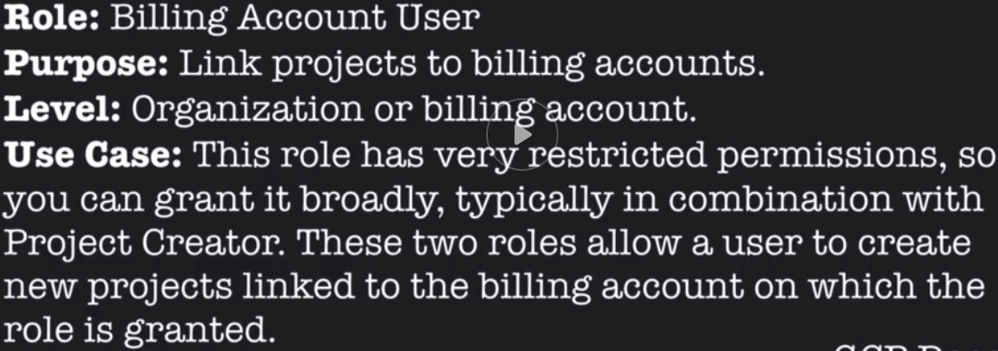

<https://console.cloud.google.com/projectselector2/home/dashboard?organizationId=0&supportedpurview=project>

Explore Cloud Shell and Editor (lab)

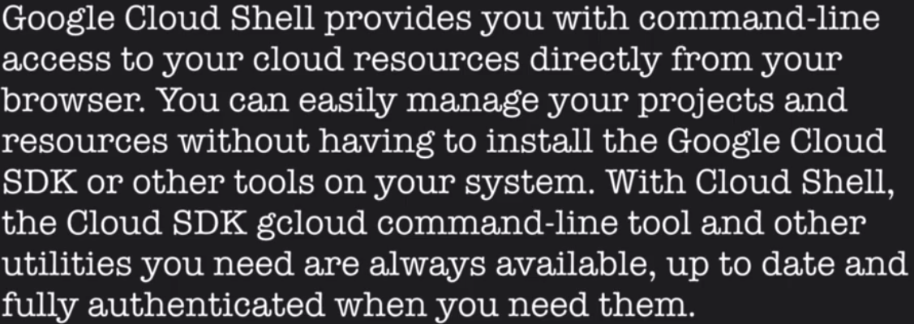

**Highlights:**

Web Browser Access

No need for local terminal

* No putty!!!

Automatic SSH Key Management

5GB of persistent storage

Easy access to preinstalled tools

Gcloud, bq, kubectl, docker, npm/node, pip/python, ruby, vim, emacs, bash, etc.

Pre-authorized and always up to date

Web preview of web app running on local port

Welcome to Cloud Shell! Type "help" to get started.To set your Cloud Platform project in this session use “gcloud config set project [PROJECT_ID]”timkeatinggcpuser@cloudshell:**~**$ gcloud config set project my-user-project-265218Updated property [core/project].timkeatinggcpuser@cloudshell:**~ (my-user-project-265218)**$

README-cloudshell.txt

Welcome to Google Cloud Shell, a tool for managing resources hosted on Google Cloud Platform!The machine comes pre-installed with the Google Cloud SDK and other popular developer tools.Your 5GB home directory will persist across sessions, but the VM is ephemeral and will be resetapproximately 20 minutes after your session ends. No system-wide change will persist beyond that.Type "gcloud help" to get help on using Cloud SDK. For more examples, visit<https://cloud.google.com/shell/docs/quickstart> and https://cloud.google.com/shell/docs/examplesType "cloudshell help" to get help on using the "cloudshell" utility. Common functionality isaliased to short commands in your shell, for example, you can type "dl <filename>" at Bash prompt todownload a file. Type "cloudshell aliases" to see these commands.Type "help" to see this message any time. Type "builtin help" to see Bash interpreter help.timkeatinggcpuser@cloudshell:**~ (my-user-project-265218)**$

Data Flows

Data Flows are EVERYTHING!

If you learn to identify and control data flows then you will succeed. If you try to memorize situations and responses then you will fail.

3 Core Components:

Network ------------- Moving

Processing ---------- Compute

Remembering ------ Storage

**Mental Model**

Using logic instead of memorization

Predictive capability

Use double loop learning

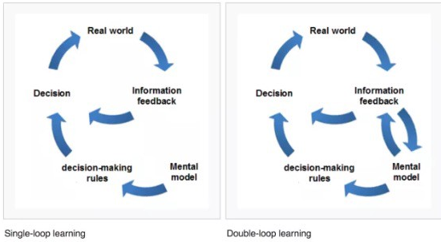

**Gcloud command-line overview:**

<https://cloud.google.com/sdk/gcloud/>

**Syntax of Gcloud:**

<https://cloud.google.com/sdk/gcloud/reference/>

**Properties in Gcloud:**

<https://cloud.google.com/sdk/docs/properties>

**Configurations in Gcloud:**

<https://cloud.google.com/sdk/docs/configurations>

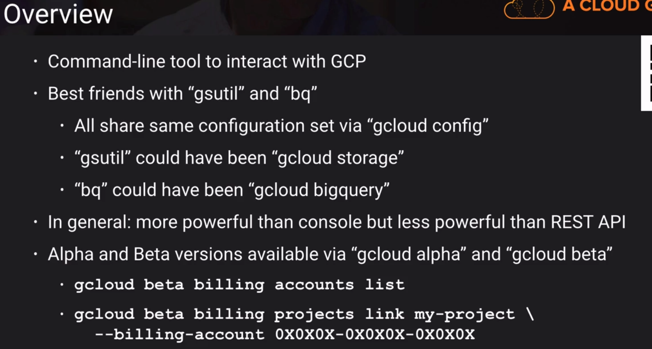

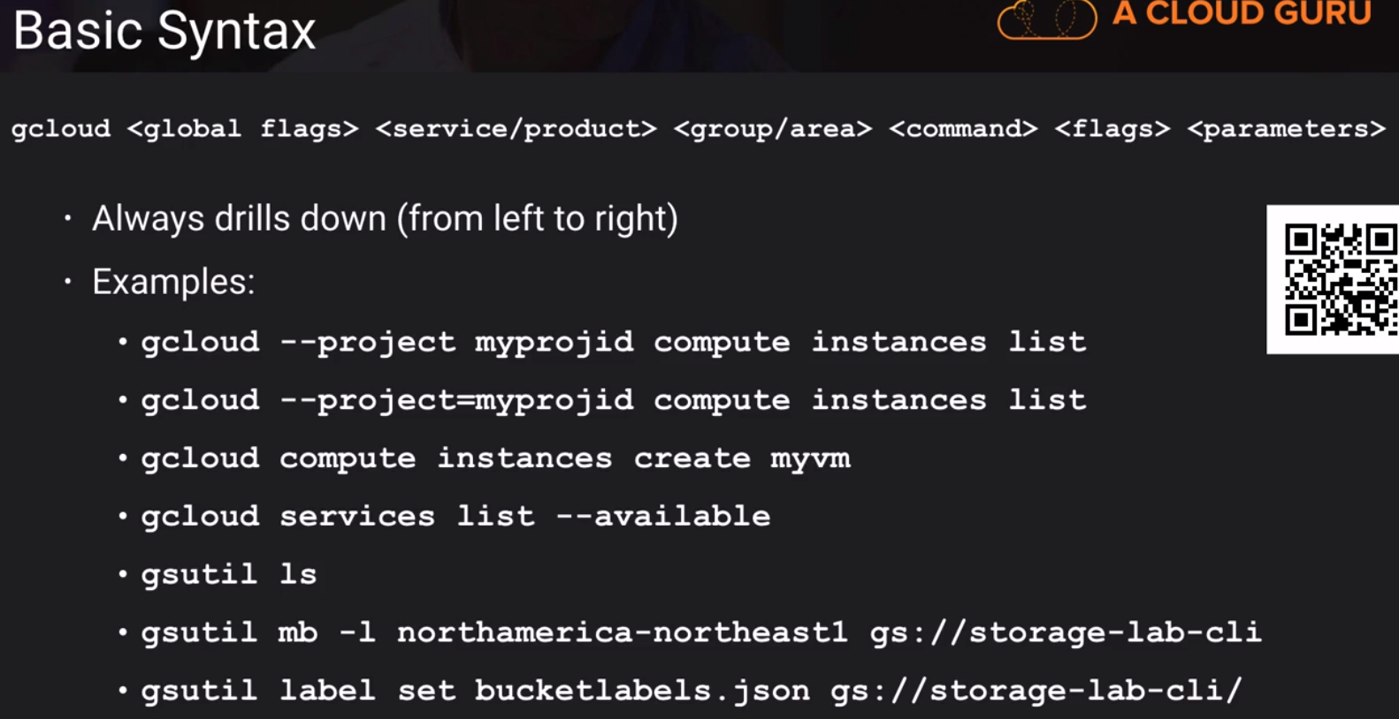

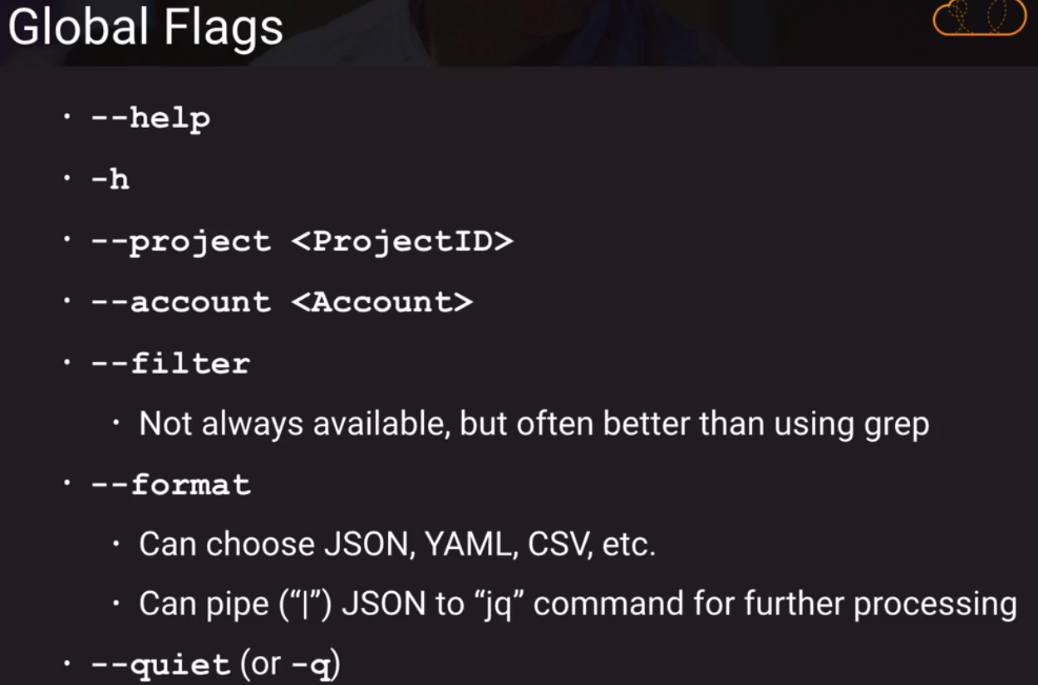

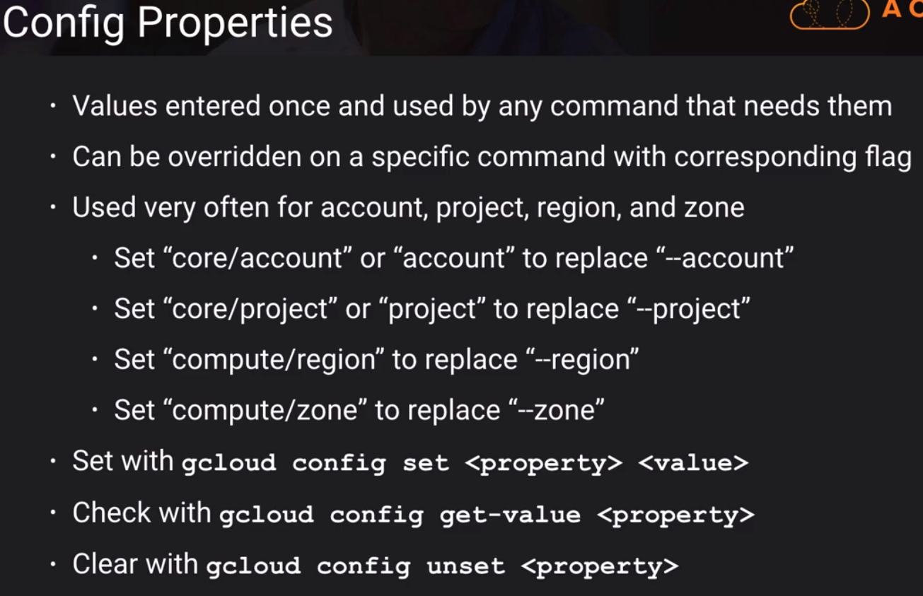

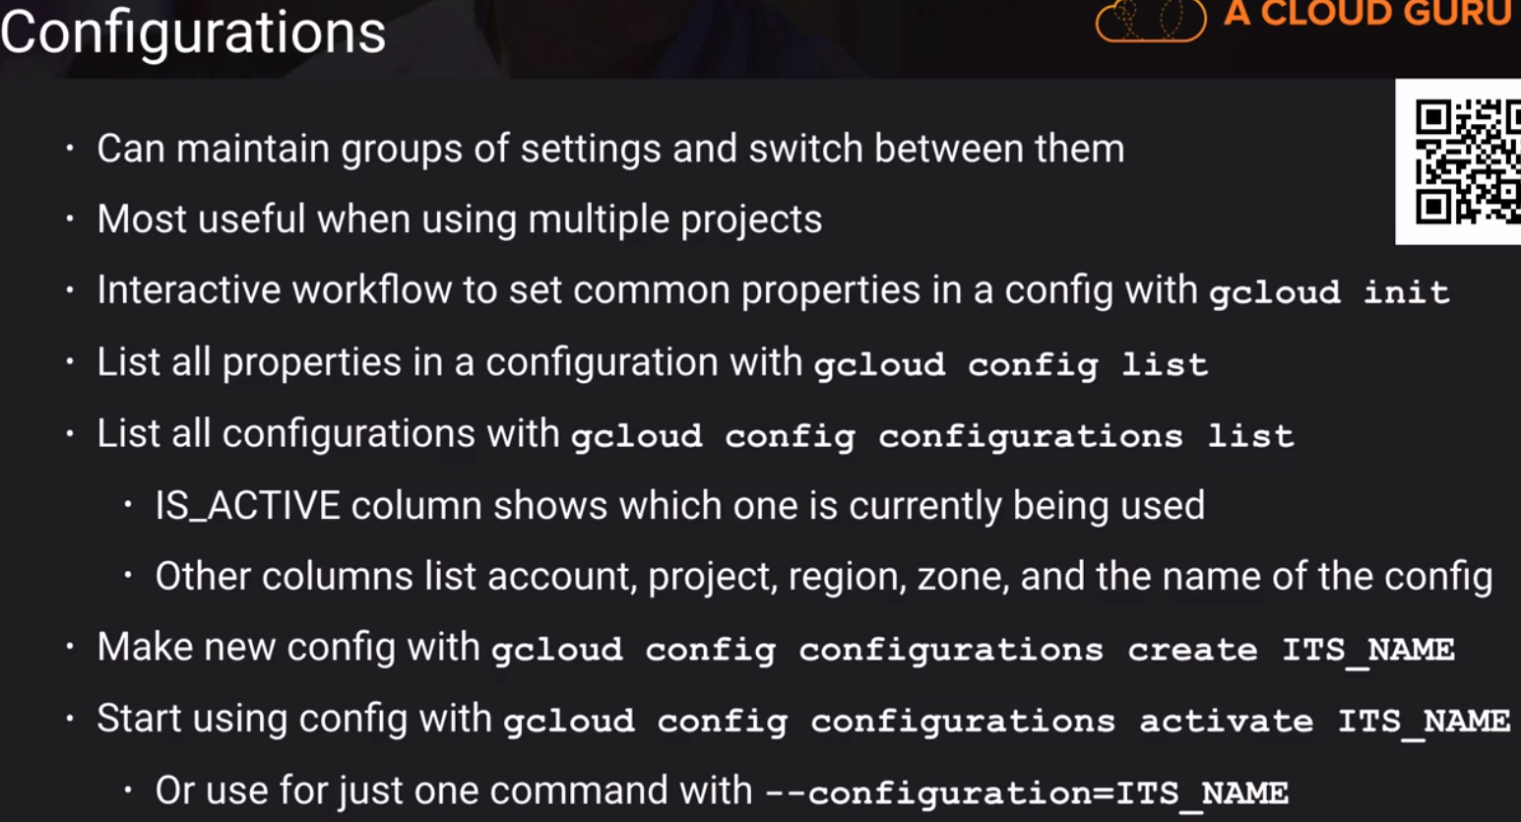

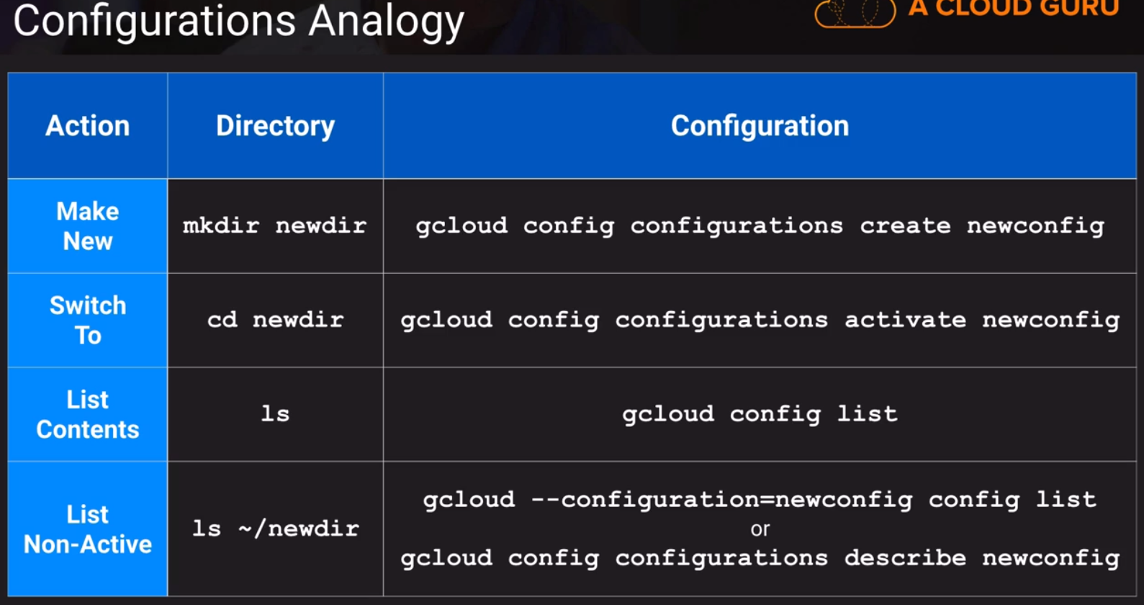

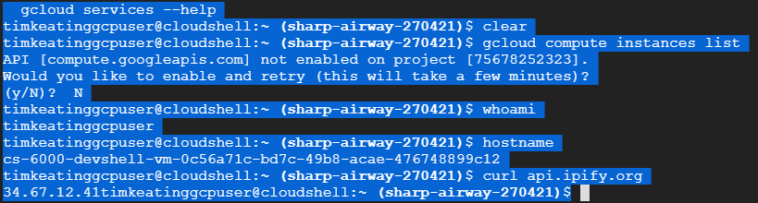

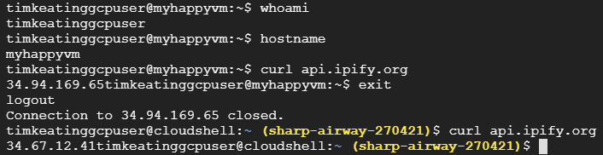

Creating and Starting a VM Instance

<https://cloud.google.com/compute/docs/instances/create-start-instance>

Creating and Starting a preemptible VM instance

<https://cloud.google.com/compute/docs/instances/create-start-preemptible-instance>

Running startup scripts

<https://cloud.google.com/compute/docs/startupscript>

Creating and enabling service accounts for instances

<https://cloud.google.com/compute/docs/access/create-enable-service-accounts-for-instances>

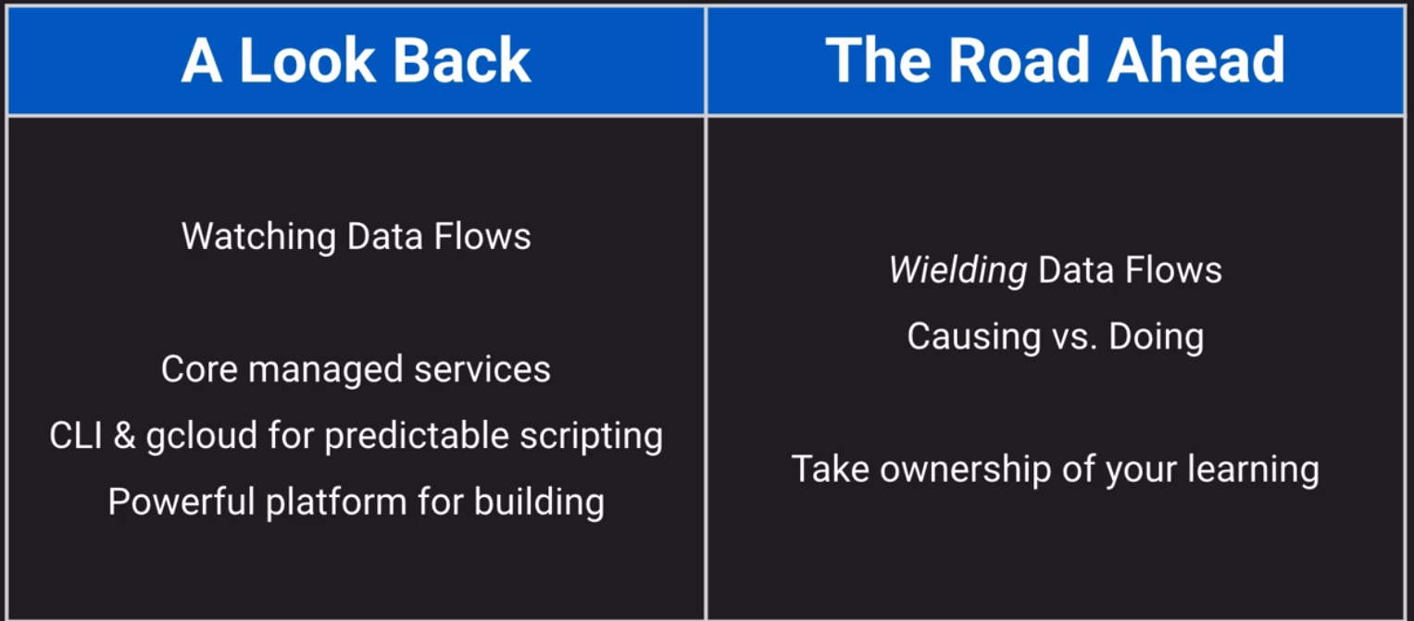

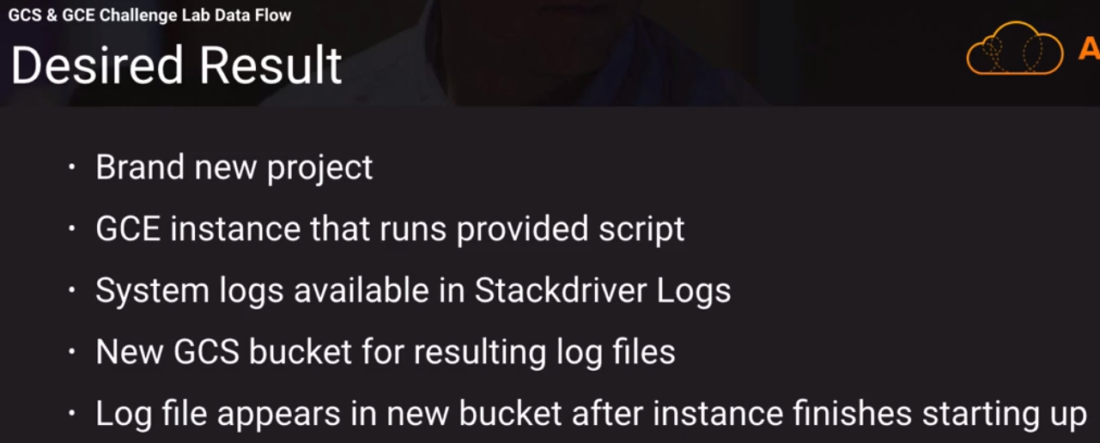

Our actions:

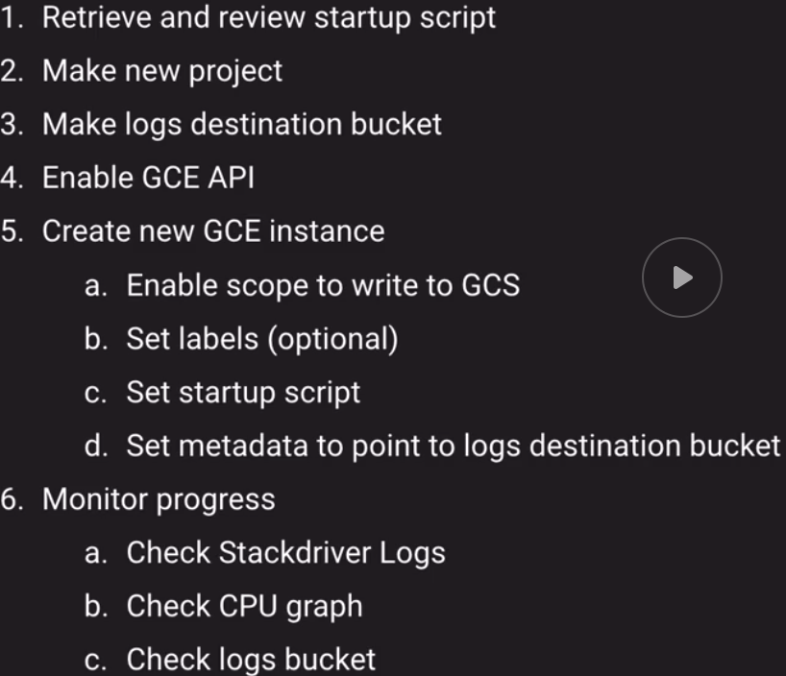

logbucketkeating

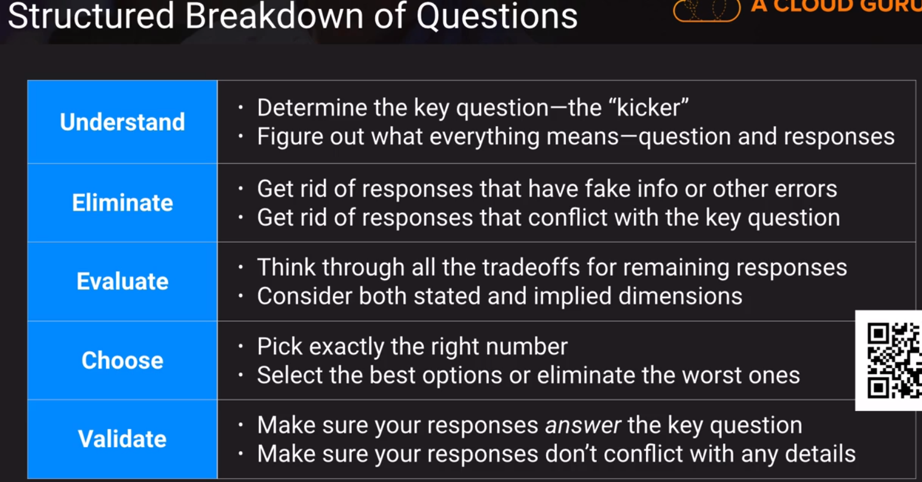

Managed Instance Groups (Lab)

(MIG)

Lab Startup Script

<https://raw.githubusercontent.com/ACloudGuru/gcp-cloud-engineer/master/compute-labs/worker-startup-script.sh>

Instance Templates

<https://cloud.google.com/compute/docs/instance-templates/>

Instance Groups

<https://cloud.google.com/compute/docs/instance-groups/>

Autoscaling

<https://cloud.google.com/compute/docs/autoscaler/>

**Instance Template**

Instance Templates are GLOBAL so you don’t select a region

Instance Templates are IMMUTABLE. You don’t ever change them.

You CAN copy them to make new if you like.

Autoscaling policy and target utilization

<https://cloud.google.com/compute/docs/autoscaler/?hl=en_US&_ga=2.44047201.-417258991.1583765526#policies>

**scale based on:**

CPU Utilization

HTTP Load Balancing Utilization

Stackdriver Monitoring Metric

Cool down period

(this is telling Google to EXCLUDE any newly created instances from the metrics it’s using to measure CPU and Target. You want this cool down period to be LONGER than the total amount of time it takes to start up the instance and run it’s start up script.

<https://cloud.google.com/compute/docs/autoscaler/?hl=en_US&_ga=2.249492418.-417258991.1583765526#cool_down_period>

Key Takeaways

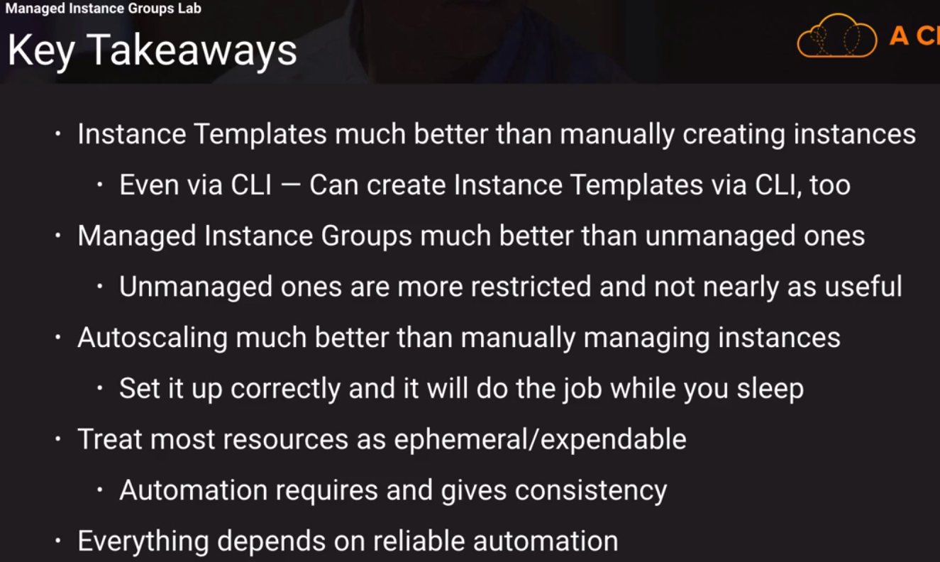

Elasticity (cloud computing)

<https://en.wikipedia.org/wiki/Elasticity_(cloud_computing)>

**Robust Mental Model**

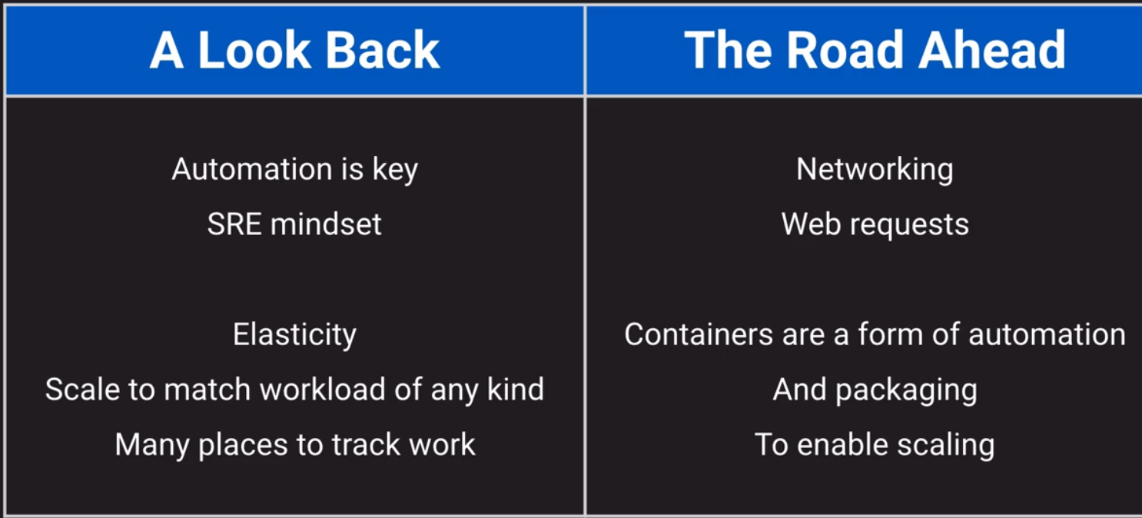

**What is Security? (Data Flow)**

Information Security

<https://en.wikipedia.org/wiki/Information_security>

Security by Design Principles –OWASP - <https://owasp.org/>

Open Web Application Security Project (OWASP)

<https://wiki.owasp.org/index.php/Security_by_Design_Principles>

OWASP Top 10 – 2017 – the 10 most critical web application security risks.

**Information security**, sometimes shortened to **infosec**, is the practice of protecting [information](https://en.wikipedia.org/wiki/Information) by mitigating information risks. It is part of information [risk management](https://en.wikipedia.org/wiki/Risk_management_information_systems). It typically involves preventing or at least reducing the probability of unauthorized/inappropriate access, use, disclosure, disruption, deletion/destruction, corruption, modification, inspection, recording or devaluation, although it may also involve reducing the adverse impacts of incidents. Information may take any form, e.g. electronic or physical[[1]](https://en.wikipedia.org/wiki/Information_security#cite_note-:0-1), tangible (e.g. paperwork) or intangible (e.g. knowledge). Information security's primary focus is the balanced protection of the **confidentiality, integrity and availability** of data (also known as the CIA triad) while maintaining a focus on efficient policy implementation, all without hampering organization productivity.[[2]](https://en.wikipedia.org/wiki/Information_security#cite_note-AndressTheBasics14-2) This is largely achieved through a structured risk management process that involves:

* Identifying information and related assets, plus potential threats, vulnerabilities and impacts;
* Evaluating the risks;
* Deciding how to address or treat the risks i.e. to avoid, mitigate, share or accept them;
* Where risk mitigation is required, selecting or designing appropriate security controls and implementing them;
* Monitoring the activities, making adjustments as necessary to address any issues, changes and improvement opportunities.

To standardize this discipline, academics and professionals collaborate to offer guidance, policies, and industry standards on [password](https://en.wikipedia.org/wiki/Password), [antivirus software](https://en.wikipedia.org/wiki/Antivirus_software), [firewall](https://en.wikipedia.org/wiki/Firewall_(computing)), [encryption software](https://en.wikipedia.org/wiki/Encryption_software), legal liability, security awareness and training, and so forth.[[3]](https://en.wikipedia.org/wiki/Information_security#cite_note-3) This standardization may be further driven by a wide variety of laws and regulations that affect how data is accessed, processed, stored, transferred and destroyed. However, the implementation of any standards and guidance within an entity may have limited effect if a culture of [continual improvement](https://en.wikipedia.org/wiki/Continual_improvement_process) isn't adopted.[[4]](https://en.wikipedia.org/wiki/Information_security#cite_note-Schlienger,_Thomas_2003-4)

Security is ensuring proper data flow.

(more simple definition).

What is PROPER DATA FLOW? (CIA data flow model)

* You cannot view data you shouldn’t (confidentiality)
* You cannot change data you shouldn’t (Integrity)
* You CAN access data you should (availability)

Triple A model of security (AAA)

* Authentication – Who are you? (passwords, MFA, single sign on)
* Authorization – What are you allowed to do? (view bank balance but not change it)
* Accounting – What did you do? (writing, deleting, viewing data)
* Resiliency – keep it running

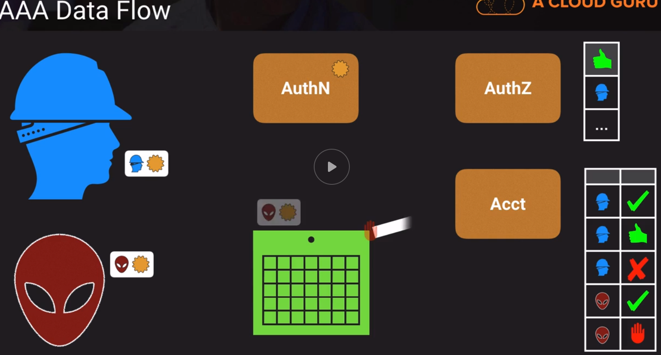

What enables security in GCP?

* Security Products
* Security Features
* Security Mindset
  + Includes Availability Mindset

Key Security Mindset (Principles)

* Least Privilege
* Defense in depth (layers)
* Fail securely

Read OWASP’s “Security by Design” Principles

**Key Security Products/Features – AuthN**

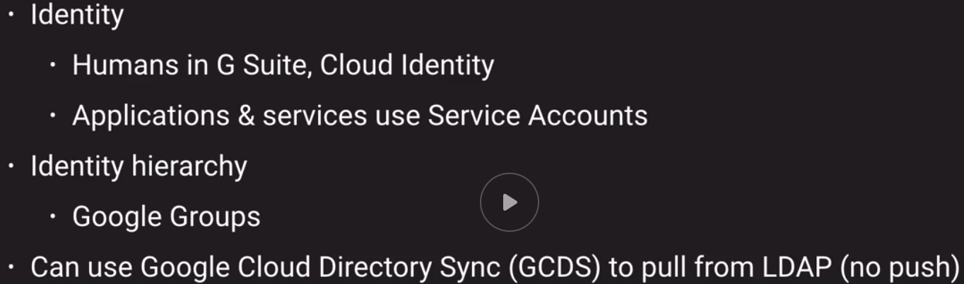

Key Security Products/Features – AuthZ

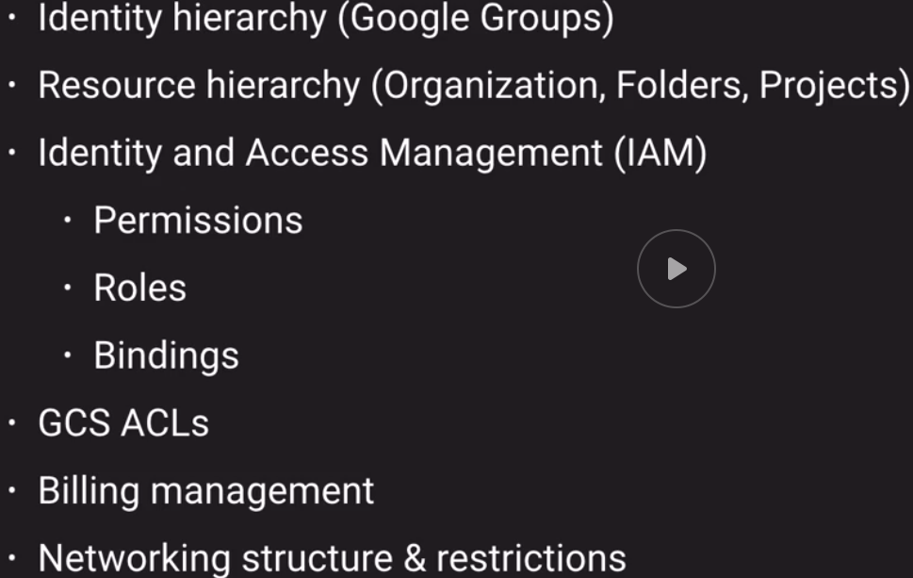

Key Security Products/Features – Acct

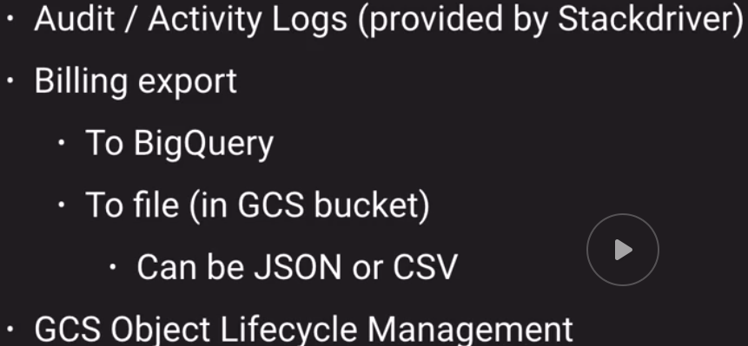

Identity and Access Management (IAM) Breakdown (this is about AuthZ, authorization)

* Resource
  + Something you create in GCP
* Project
  + Container for a set of related resources
* Folder
  + Contains any number of Projects and Subfolders
* Organization
  + Tied to G Suite or Cloud Identity Domain

Cloud Identity and Access Management (Cloud IAM)

<https://cloud.google.com/iam/docs/overview>

Using resource hierarchy for access control

<https://cloud.google.com/iam/docs/resource-hierarchy-access-control>

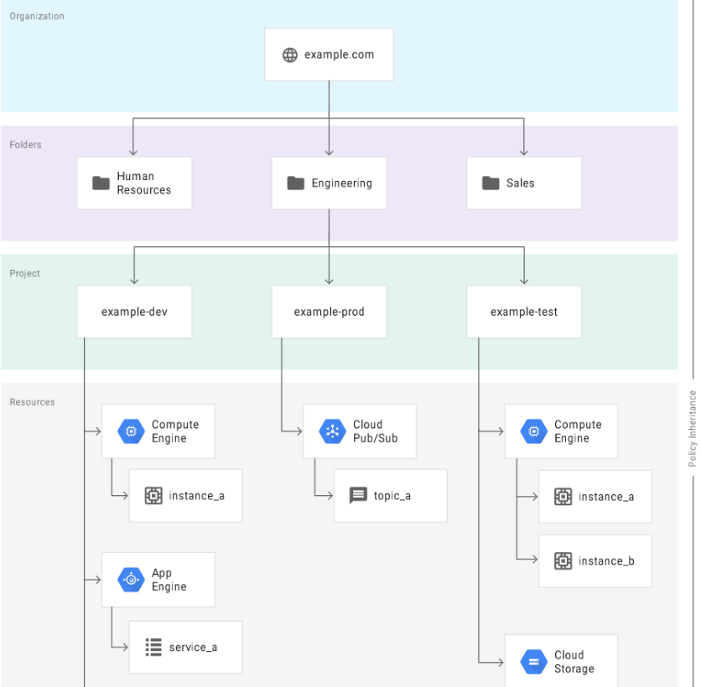

**Permissions**

How IAM works: <https://cloud.google.com/iam/docs/overview>

Understanding Roles: <https://cloud.google.com/iam/docs/understanding-roles>

Understanding Custom Roles: <https://cloud.google.com/iam/docs/understanding-custom-roles>

Predefined Roles List: <https://cloud.google.com/iam/docs/understanding-roles#predefined_roles>

**Permissions**

* A Permission allows you to perform a certain action
* Each one follows the form **service.resource.verb**
* Usually correspond to REST API methods
* Examples:
  + **pubsub.subscriptions.consume**
  + **pubsub.topics.publish**

**Roles**

* A role is a collection of Permissions to use or manage GCP resources (each service has an administrator role)
* Primitive Roles – Project-level and often too broad
  + Viewer is read-only
  + Editor can view and change things (can read and write)
  + Owner can also control access & billing (can do everything Viewer and Editor can do)
* Predefined Roles – Give granular access to specific GCP resources
  + **e.g.: roles/bigquery.dataEditor, roles/pubsub.subscriber**
  + Read through the list of roles for each product! Think about why each exists* (exam tip)
* Custom Role – Project or Org-level collection you define of granular permissions

Predefined Role Examples – App Engine

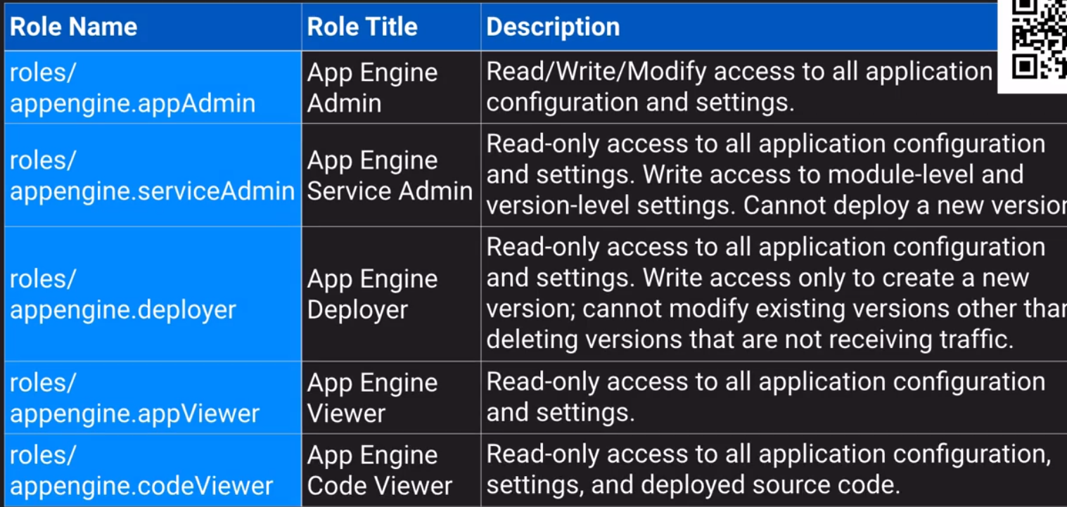

IAM Breakdown

**Members**

* A Member is some Google-known identity
* Each Member is identified by a unique email address
* Can be:
  + **User**: Specific Google account
    - G Suite, Cloud Identity, Gmail, or validated email
  + **serviceAccount**: Service account for apps/services
  + **group**: Google group of users and service accounts
  + **domain**: Whole domain managed by G Suite or Cloud Identity
  + **allAuthenticatedUsers** – ANY Google account or service account
  + **allUsers** – Anyone on the Internet (Public) / Anonymous access

Group should be your default group – ALWAYS

Groups

* “A Google group is a named collection of Google accounts and service accounts.”
* “Every group has a unique email address that is associated with the group”
* You never act as the group
  + But a membership in a group can grant capabilities to individuals
* Use them for everything!
* Can be used for owner when within an organization
* Can nest groups in an organization
  + Example: one group for each department, all those in group for all staff

**IAM Breakdown – Policies (Bindings)**

IAM Overview - <https://cloud.google.com/iam/docs/overview>

Granting, changing and revoking access to resources - <https://cloud.google.com/iam/docs/granting-changing-revoking-access>

Docs for gcloud’s add-iam-policy-binding (many different resources) <https://www.google.com/search?q=gcloud+add-iam-policy-binding+site%3Acloud.google.com>

Policies

* A **POLICY** binds **MEMBERS** to **ROLES** for some scope of **RESOURCES**
* Answers: WHO can do WHAT to WHICH THING(S)
* Attached to some level in the RESOURCE HIERARCHY
  + Organization, Folder, Project, Resource (these are all places you could attach a POLICY)
* **ROLES** and **MEMBERS** listed in **POLICY**, but **RESOURCES** identified by attachment
* Always additive (“ALLOW”) and never subtractive (no “DENY”)
  + “Child policies cannot restrict access granted at a higher level.”

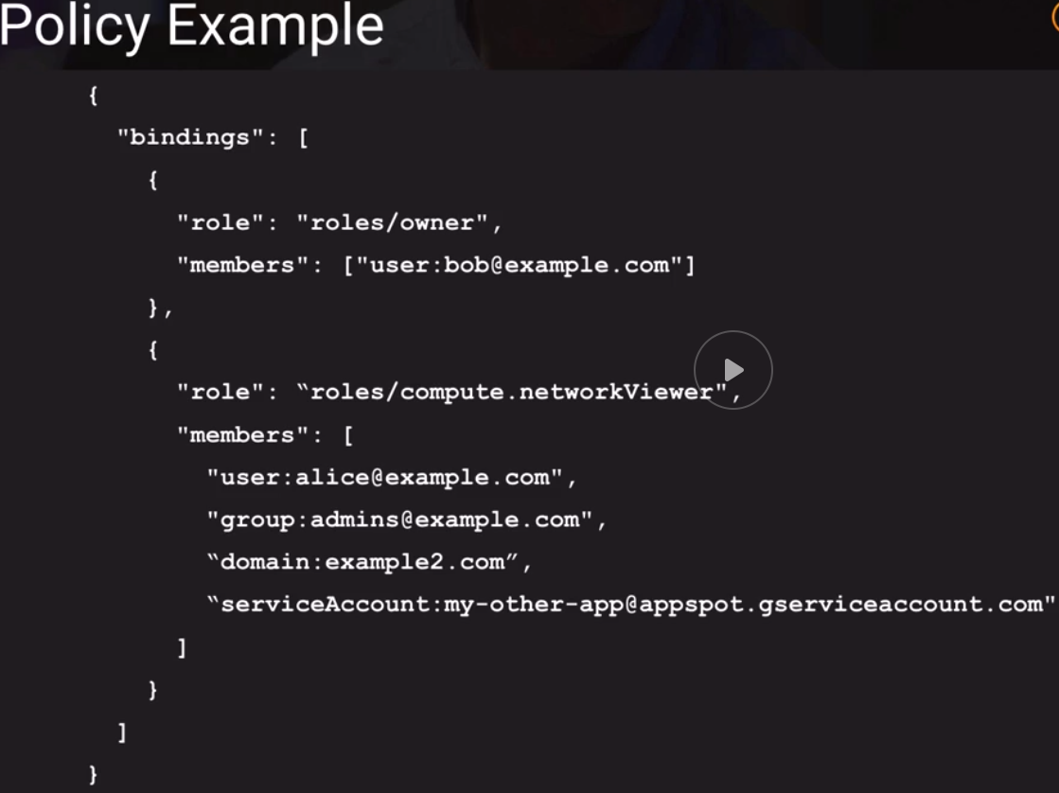

Policies

* One policy per resource
* Max 1500 member bindings per policy
  + Ridiculously high max
  + Anywhere close and “you’re doing it wrong!”
  + User GROUPS instead!
    - Not kidding/Don’t forget this
* You should use GROUPS!
* Usually takes less than 60 seconds to apply changes (both granting and revoking)
* “May take up to 7 minutes for… changes to fully propagate across the system.

Managing Policy Bingings

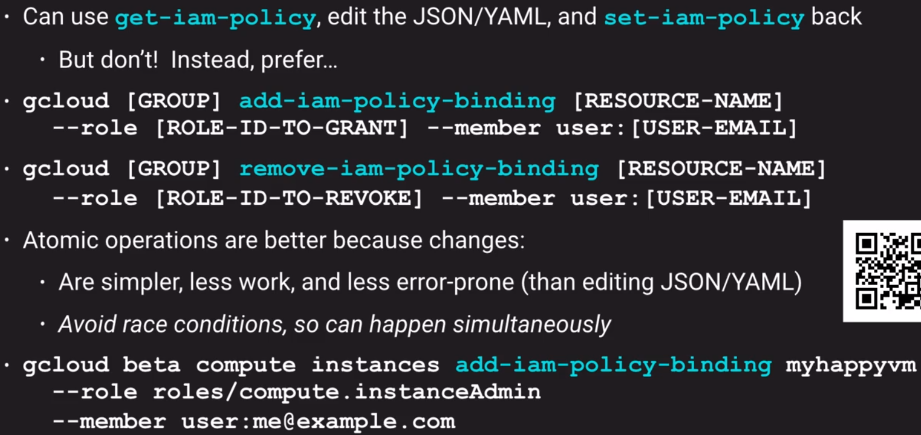

IAM Breakdown – Wrap-Up

IAM Overview Documentation - <https://cloud.google.com/iam/docs/overview>

IAM FAQ - <https://cloud.google.com/iam/docs/faq>

Using IAM securely / Best practices - <https://cloud.google.com/iam/docs/using-iam-securely>

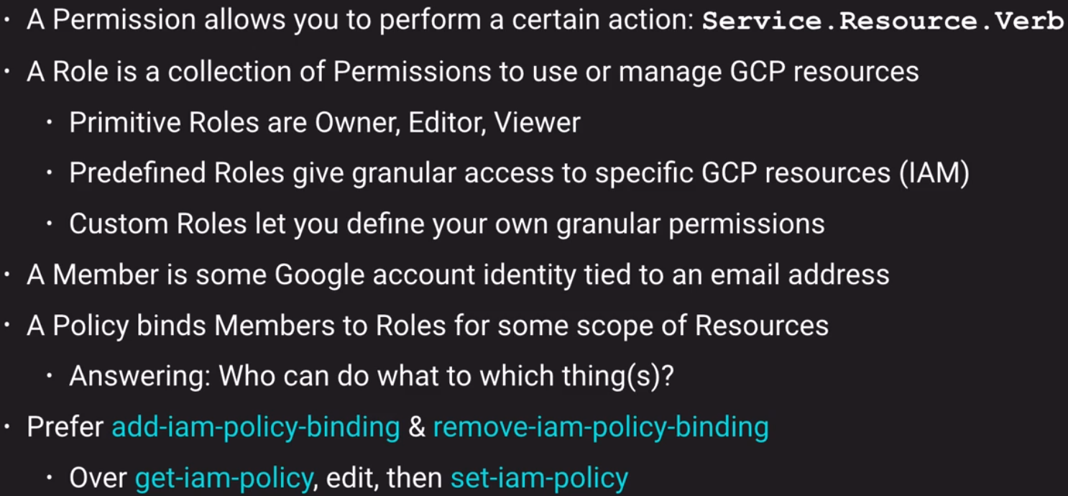



**Billing Access Control**

Overview of Billing Access Control: <https://cloud.google.com/billing/docs/how-to/billing-access>

Invoiced Billing: <https://cloud.google.com/billing/docs/how-to/invoiced-billing>

Billing Accounts

* A billing account represents some way to pay for GCP service usage
* Type of Resource that lives outside of PROJECTS
* Can belong to an ORGANIZATION (i.e. be owned by it)
  + Inherits Org-Level IAM policies
* Can be linked to projects
  + But does not own them
    - No impact on project IAM

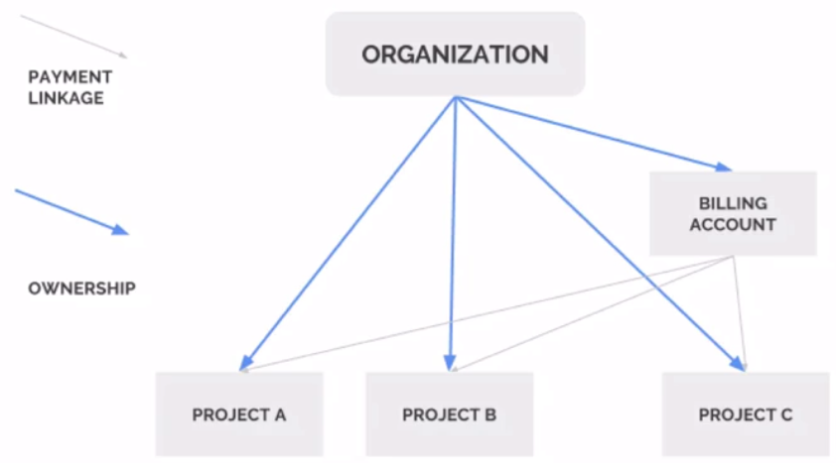

A single project is only ever linked to a single billing account

Role: Billing Account User

Purpose: Link projects to billing accounts

Level: Organization or billing account

Use Case: This role has very restricted permissions so you can grant it broadly, typically in a combination with Project Creator. These 2 roles allow a user to create new projects linked to the billing account on which the role I granted.

Billing IAM Roles

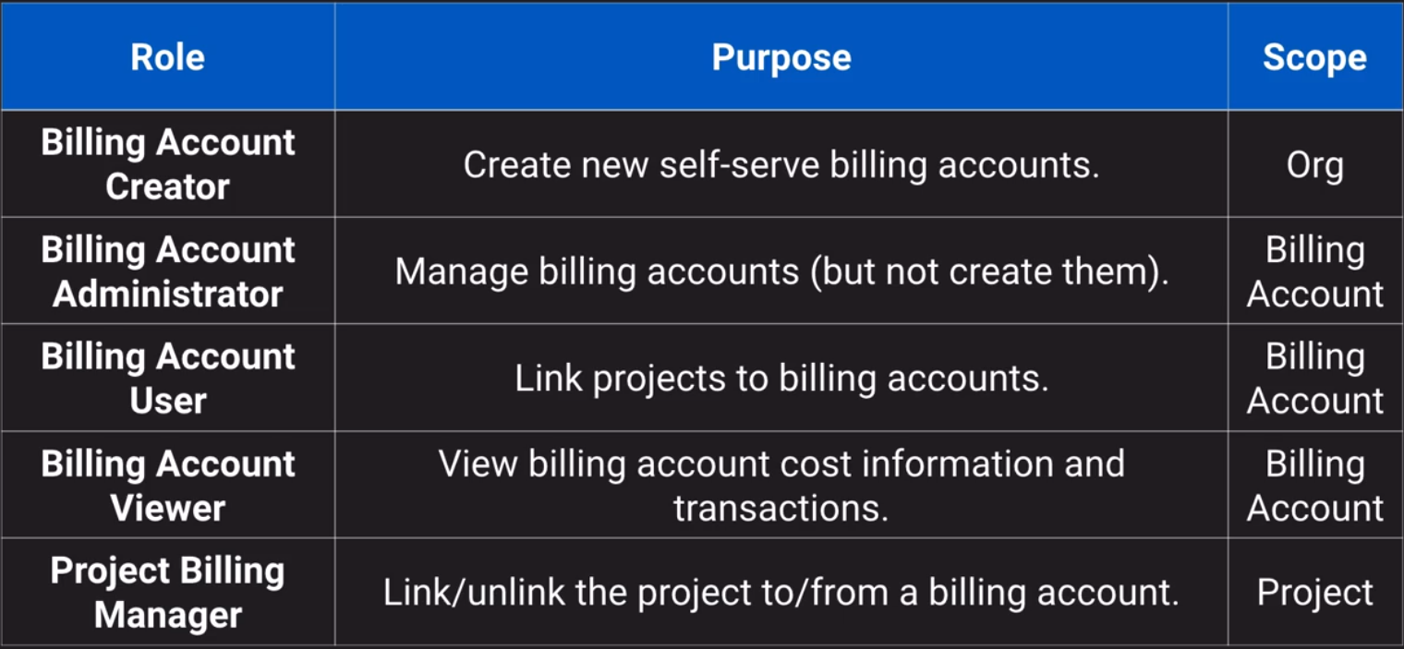

Monthly Invoiced Billing

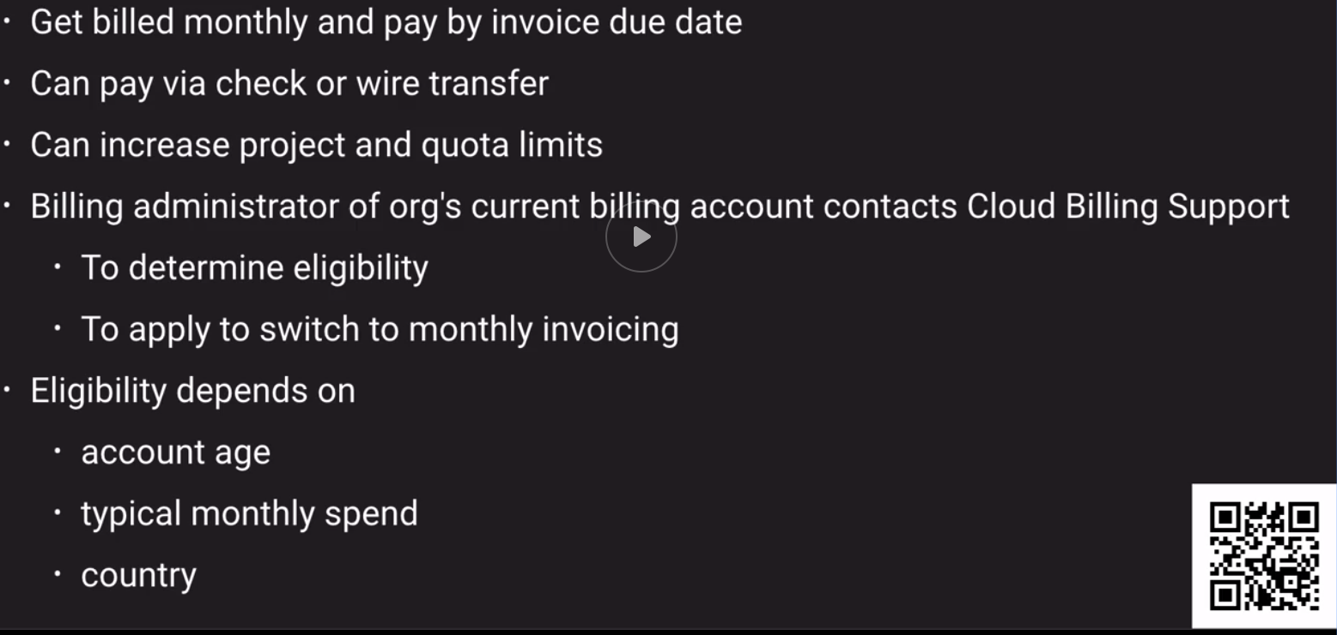

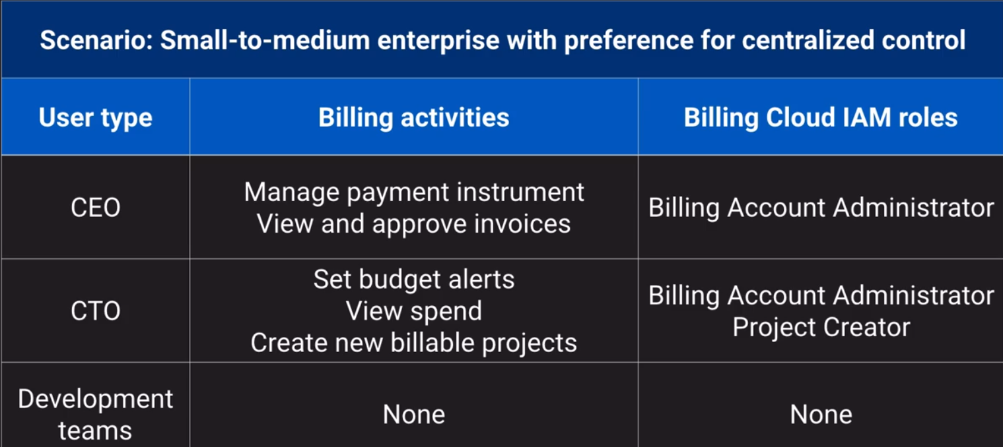

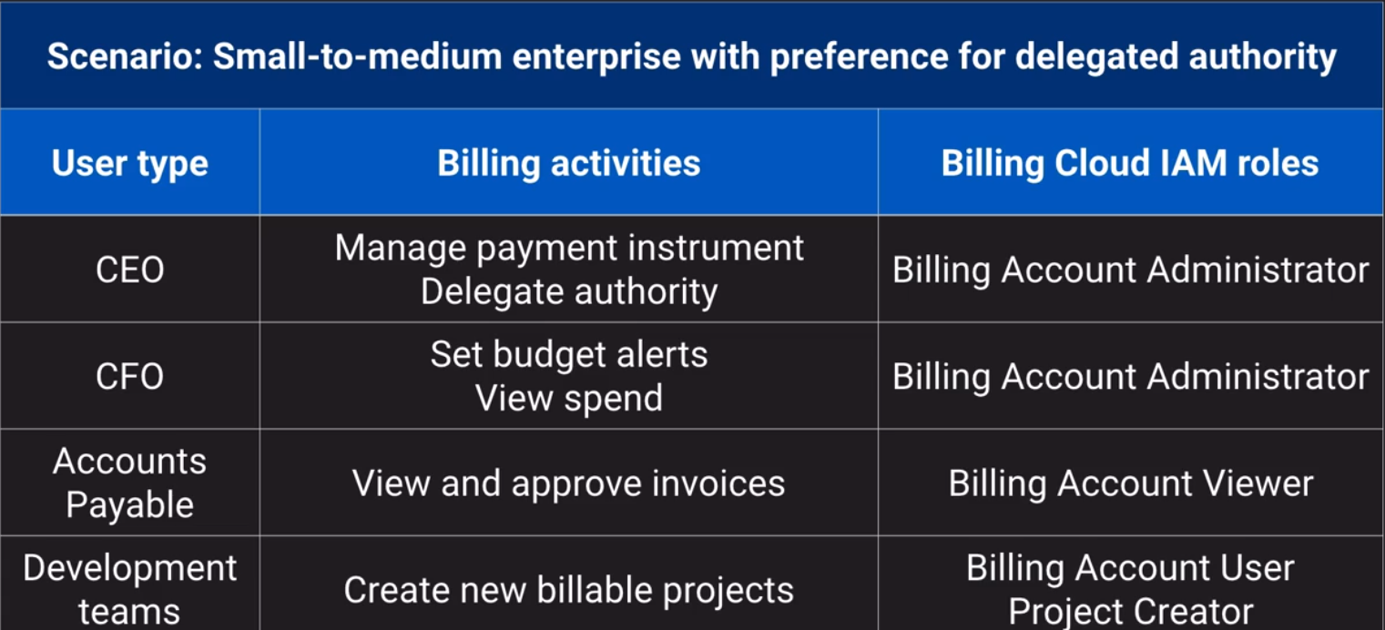

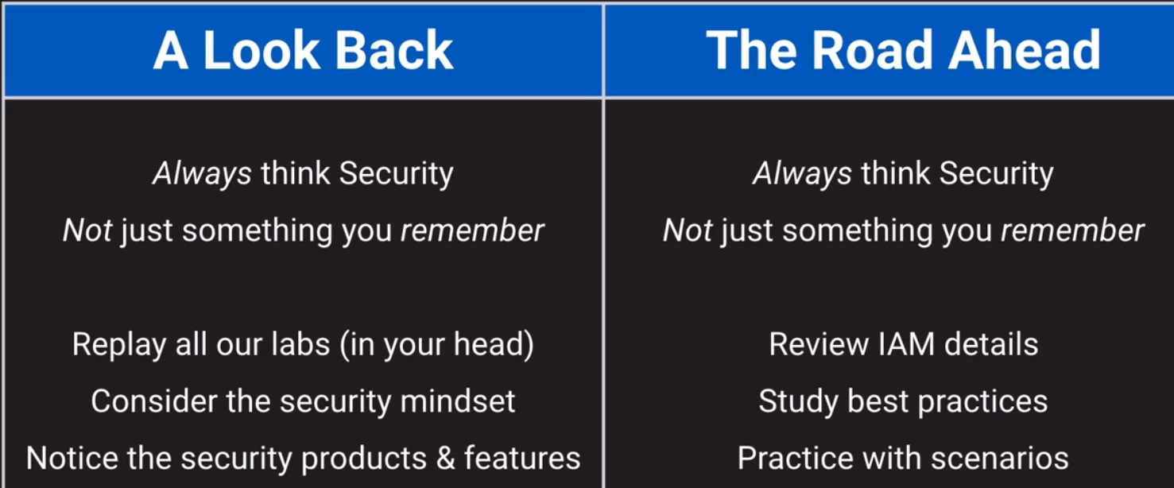

NETWORKING

Routing

Routing Overview

OSI Model: <https://www.webopedia.com/quick_ref/OSI_Layers.asp>

Routing: <https://en.wikipedia.org/wiki/Routing>

* About Software-Defined Networking (SDN)
* More-General than the OSI 7-layer model of networking
* Not about any particular routing scheme (Unicast versus Anycast for example)
* only setting the stage for routing tables / routes

What is it?

* Routing is about deciding where data should go next.
* Making decisions about where to pass along data

Where does it happen?

On the way to Google’s network

On the way to the right resource

On the way from one resource to another

There and Back again

Routing – To Google’s Network (Premium Routing Tier)

Premium routing Tier Blog Post - <https://cloud.google.com/blog/products/gcp/introducing-network-service-tiers-your-cloud-network-your-way>

Hot-Potato and Cold-Potato Routing - <https://en.wikipedia.org/wiki/Hot-potato_and_cold-potato_routing>

Getting data to Google’s network

(this is where VPC routing tier comes in).

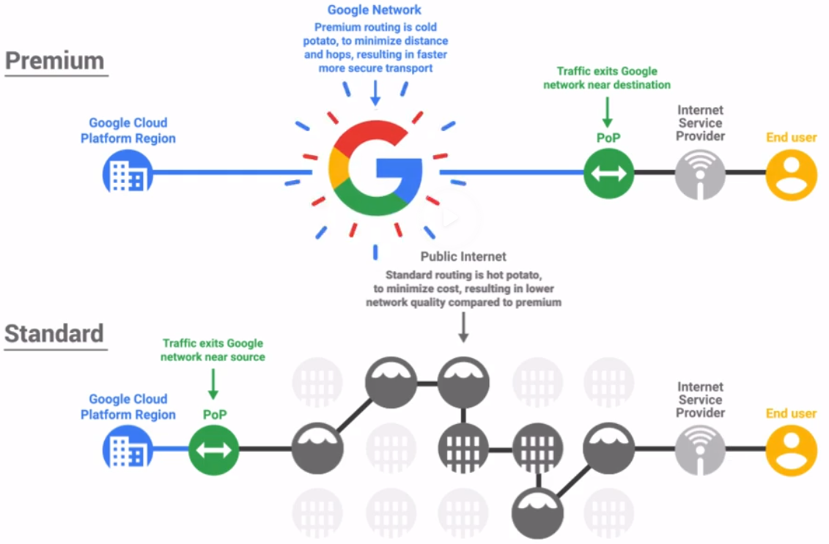

Hot Potato routing – someone else’s responsibility to get data/session/user where they need to go.

Cold Potato routing – Google (for example) owns the responsibility to get data/session/user where they need to go.

Routing to the right resource

Load Balancing in GCP: <https://cloud.google.com/load-balancing/docs/load-balancing-overview>

Getting data to the right resource

* **Latency reduction (Cross-Region Load Balancing with Global Anycast IPs)**
  + Use servers physically close to clients
* **Load balancing (Cloud Load Balancer – all types, internal and external)**
  + Separate from auto-scaling
* **System design (HTTP(s) load balancer with URL map)**
  + Different servers may handle different parts of the system
  + Especially when using microservices (instead of monolith)



Unicast versus Anycast

Unicast – There is only one UNIque device in the world that can handle this; send it there.

Anycast – There are multiple devices that could handle this; send it to ANY one – but ideally the closest.

Layer 4 vs. Layer 7

* TCP (of TCP/IP) is usually called layer 4 (L4)
  + It works soley with IP Addresses
* HTTP and HTTPS work at Layer 7 (L7)
  + These know about URLs and paths
* Each layer is built on the one below it
* Therefore:
  + To route based on URL paths, routing needs to understand L7
  + L4 cannot route based on URL paths defined in L7

What about DNS?

* Name resolution (via the Domain Name System) can be the first step in routing
* But that comes with a number of problems:
  + Layer 4 – Cannot route L4 based on L7’s URL paths
  + Chunky – DNS queries often cached and reused for huge client sets
  + Sticky – DNS lookup “locks on” and refreshing per request has high cost
    - Extra latency because each request includes another round trip
    - More money for additional DNS request processing
  + Not Robust – Relies on the client always doing the right thing
    - Spoiler: They don’t
* Premium tier “cold potato” routing with global anycast IPs avoids these problems

**Routing – Among Resources (VPC)**

Classless Inter-Domain Routing (CIDR) Blocks – Wikipedia

<https://en.wikipedia.org/wiki/Classless_Inter-Domain_Routing>

RFC1918 Private Networks - <https://en.wikipedia.org/wiki/Private_network>

* VPC (global) is Virtual Private Cloud – your private SDN space in GCP
  + Not just resource to resource – Also manages the doors to outside & peers
* Subnets (regional) create logical spaces to contain resources
  + All subnets can reach all others – globally, without any need for VPNs
* Routes (global) define “next hop” for traffic based on destination IP
  + Routes are global and apply by Instance-level Tags, not by subnet
  + No route to the internet gateway means no such data can flow
* Firewall Rules (global) further filter data flow that would otherwise route
  + All Firewall Rules are global and apply by Instance-Level Tags or Service Acct.

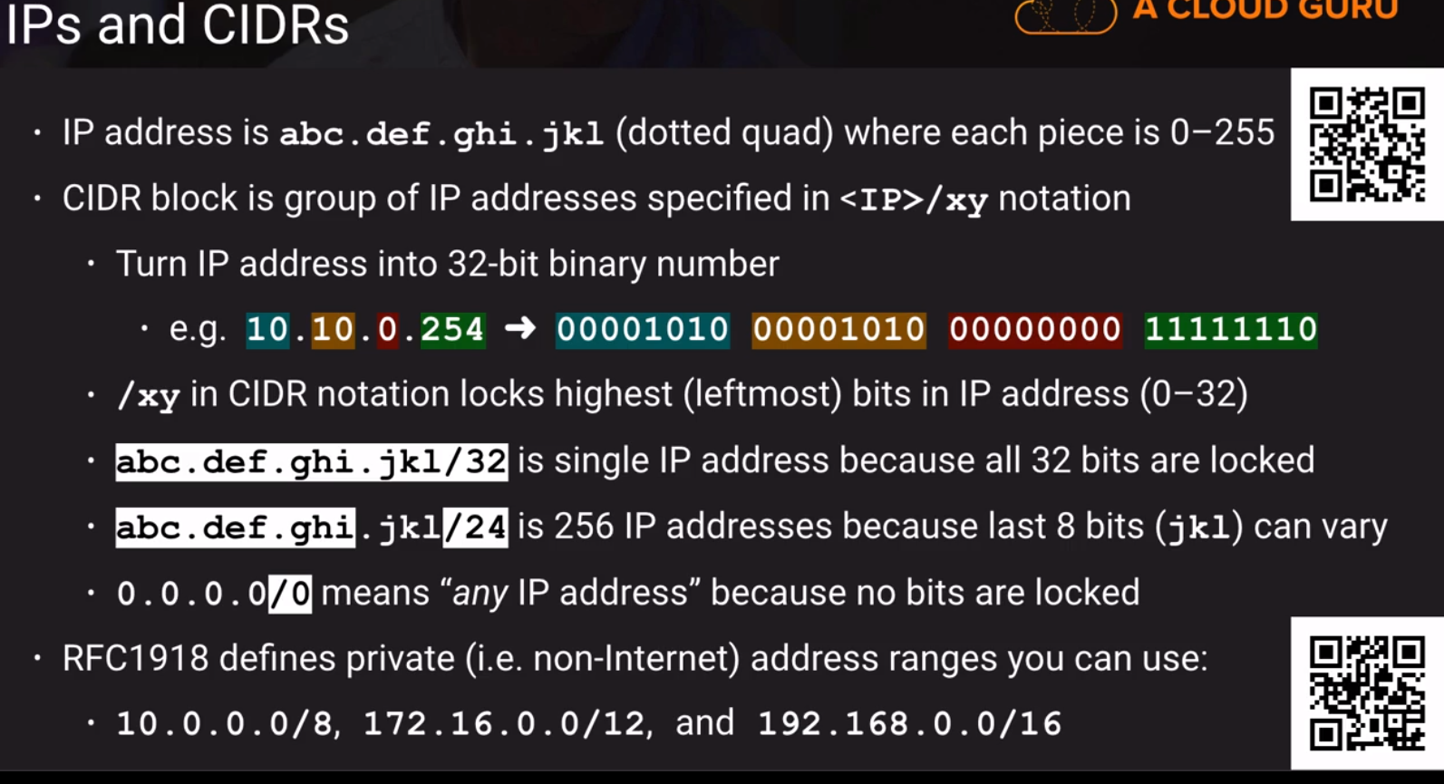

Creating Auto-Mode VPCs (Lab)

VPC Creation - <https://cloud.google.com/vpc/docs/vpc#subnet-ranges>

### Custom-Mode VPCs (Lab) - Part 1 - Creating the VPC

Chapter 11.6

VPC Overview Docs (comprehensive)

<https://cloud.google.com/vpc/docs/vpc>

Part 1 – creating the VPC

Part 2 – Creating the Custom Role and Service Account

Understanding IAM Custom Roles - <https://cloud.google.com/iam/docs/understanding-custom-roles>

Creating and Managing Custom Roles - <https://cloud.google.com/iam/docs/creating-custom-roles>

Service Accounts Overview - <https://cloud.google.com/compute/docs/access/service-accounts>

Creating and enabling service accounts - <https://cloud.google.com/compute/docs/access/create-enable-service-accounts-for-instances>

Part 3 – Using the VPC and Configuring Firewall Rules

Firewall Rules Overview - <https://cloud.google.com/vpc/docs/firewalls>

Configuring Network Tags - <https://cloud.google.com/vpc/docs/add-remove-network-tags>

Filtering by Service Account vs. Network - <https://cloud.google.com/vpc/docs/firewalls#service-accounts-vs-tags>

Updating Managed Instance Groups (e.g. Rolling Replace) - <https://cloud.google.com/compute/docs/instance-groups/rolling-out-updates-to-managed-instance-groups>

Having trouble editing the instance in the web console? Read this thread! - <https://acloud.guru/forums/gcp-certified-associate-cloud-engineer/discussion/-LX_K01iaNGvgD6ICp_p/cannot_edit_instance_in_group>

Chapter 11.9

Custom-Made VPCs – Challenge Lab

Desired Result – Setup

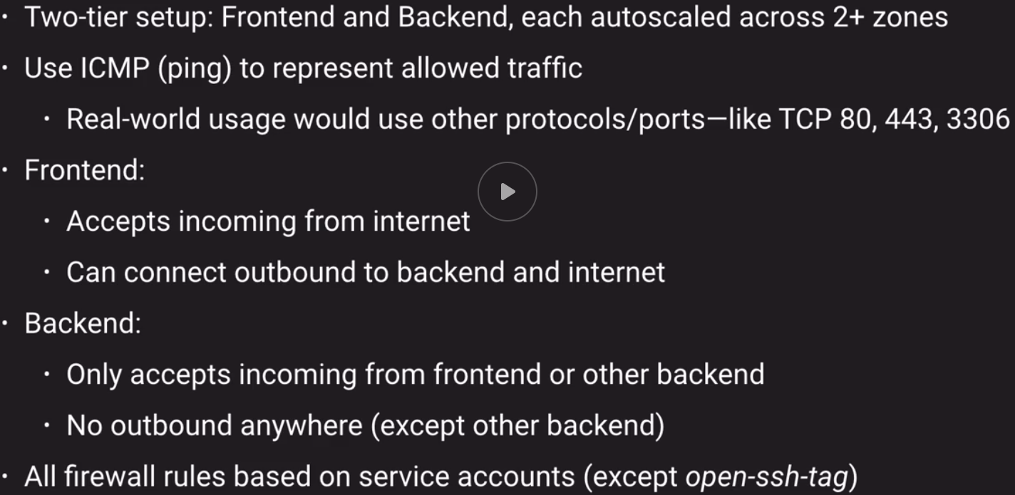

Desired Result - Validation

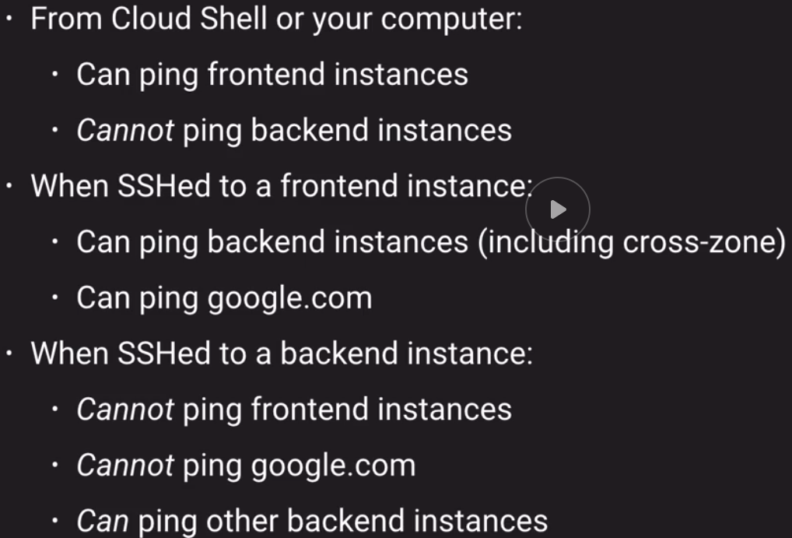

Tips

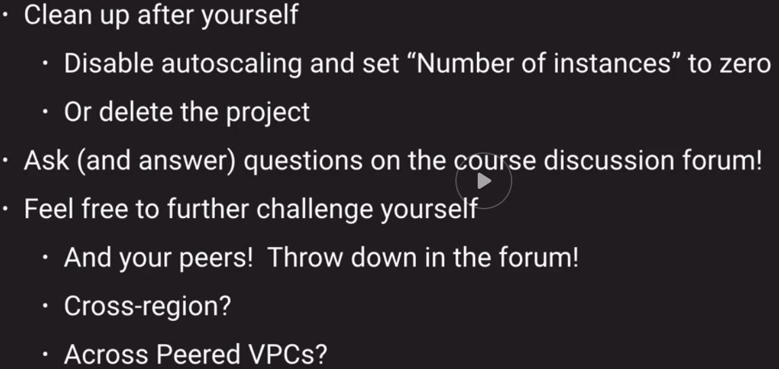

**Create custom VPC**

Choose region

Assign IP address range such as: 192.168.0.0/24

Choose “Global” routing mode

No firewall rules set at this point…

**Create a CUSTOM ROLE and SERVICE ACCOUNT**

Go to IAM section>go to ROLES SECTION / show writer role (roles **Logs Writer** and **Monitoring Metric Writer**) / create role from selection / creating a “BASE GCE ROLE” when you create role

Filter on “writer” by choosing TITLE. Denoted by **Title:*writer”**

Update the ROLE ID to match its title, in this case “BASE GCE ROLE”

Delete base service account

Create a NEW SERVICE ACCOUNT

For FRONTEND, create something like “frontend-sa”

Assign privileges (BASE GCE ROLE), update policy

Using VPC and configuring firewall

In GCE, create an INSTANCE TEMPLATE

Micro image

Assign service account

Switch to NETWORKING tab

Choose subnet we created (example Oregon subnet)

Set network tags (open-ssh-tag) / is this done

Make a MANAGED INTANCE GROUP from the INSTANCE TEMPLATE we just created

Choose MULTIPLE ZONES in the same region as your subnet (check all zones)

Min instances (2) Max instances (3)

Create

Try to ping / ping doesn’t work because we need to create firewall rules

ADD FIREWALL RULE for example (allow-incoming-to-frontend-fwr)

Specify direction of traffic (ingress, egress) and action on match (allow, deny)

(all instances in the network? Specified target tags? Specified Service account?)

Give source IP ranges (0.0.0.0/0 and “other protocols” in this case ICMP)

Can we add (open-ssh-tag) here? / network tag needs to get added in at template stage

**CHAPTER 11.10**

Custom-Mode VPCs - Challenge Lab Solution - Main Setup

I didn’t really do this correctly…

Should have created 2 separate subnets

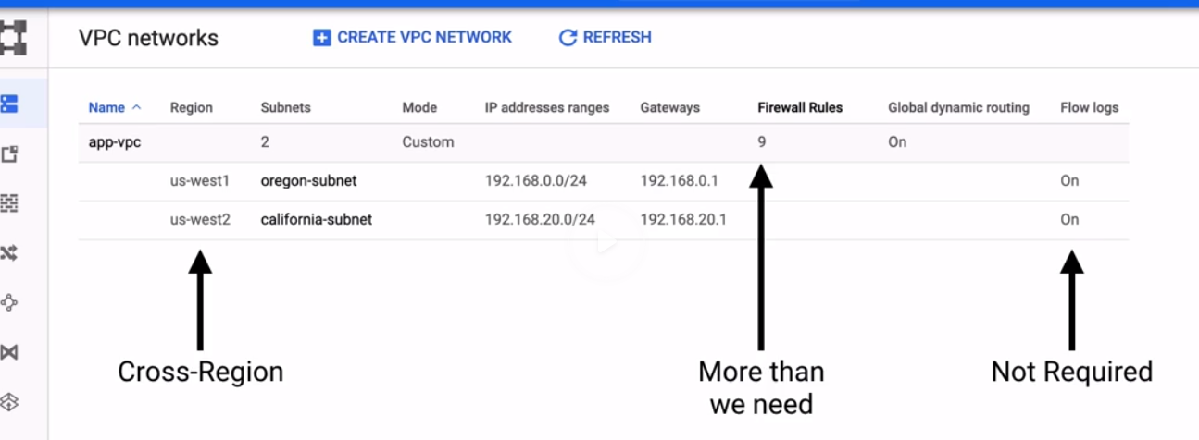

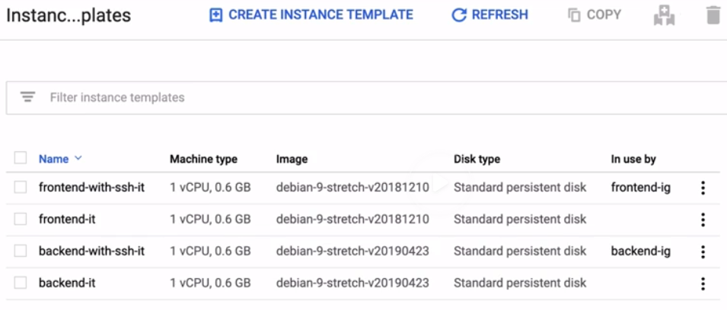

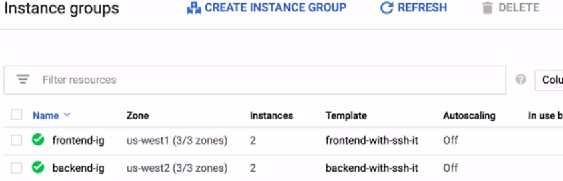

### Custom-Mode VPCs - Challenge Lab Solution - Firewall Rules

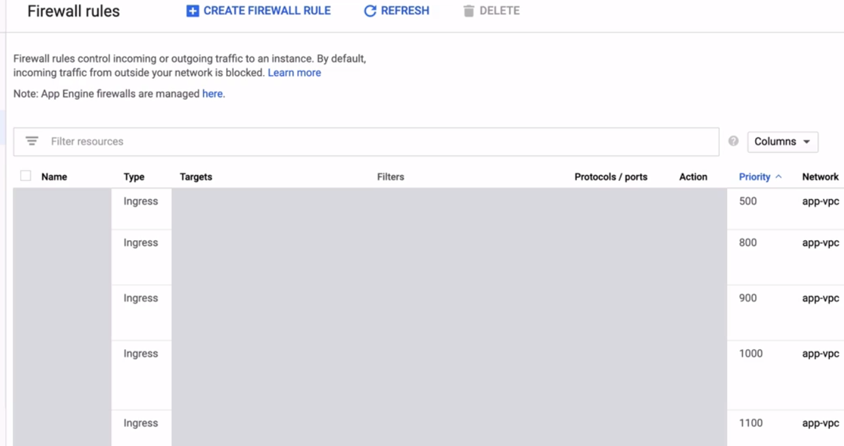

Rules breakdown by ingress versus egress and then lowest # first as in above.

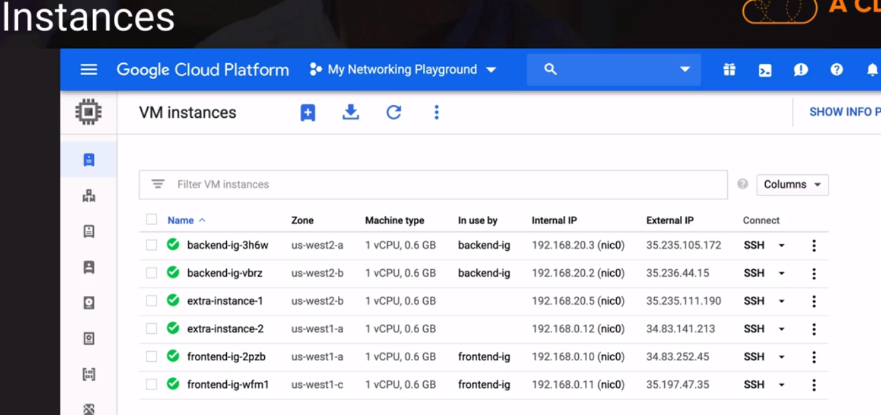

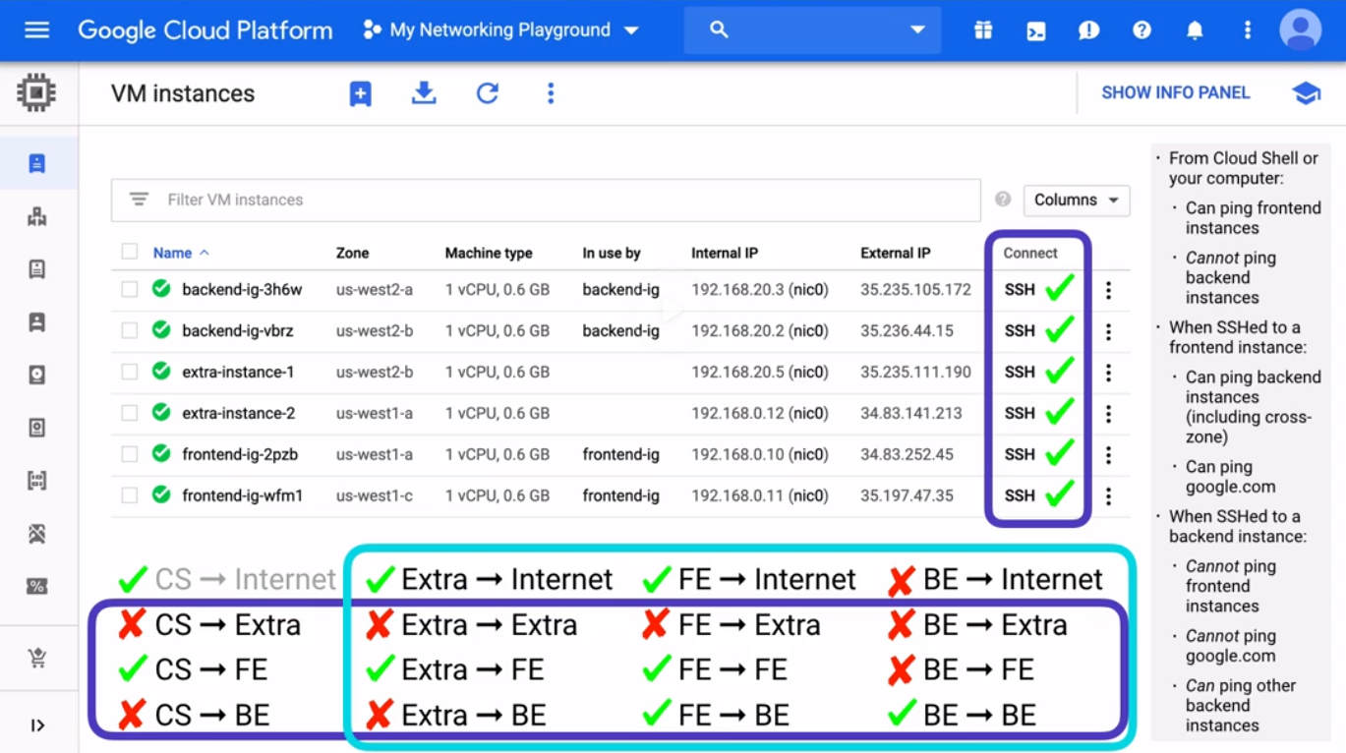

Teal box represents the connections that originate within the VPC and will be affected by the EGRESS FW rules

Blue are INGRESS or TERMINATE WITHIN THE VPC

Implied rule is to DENY ALL INGRESS / this happens if none of the rules are met.

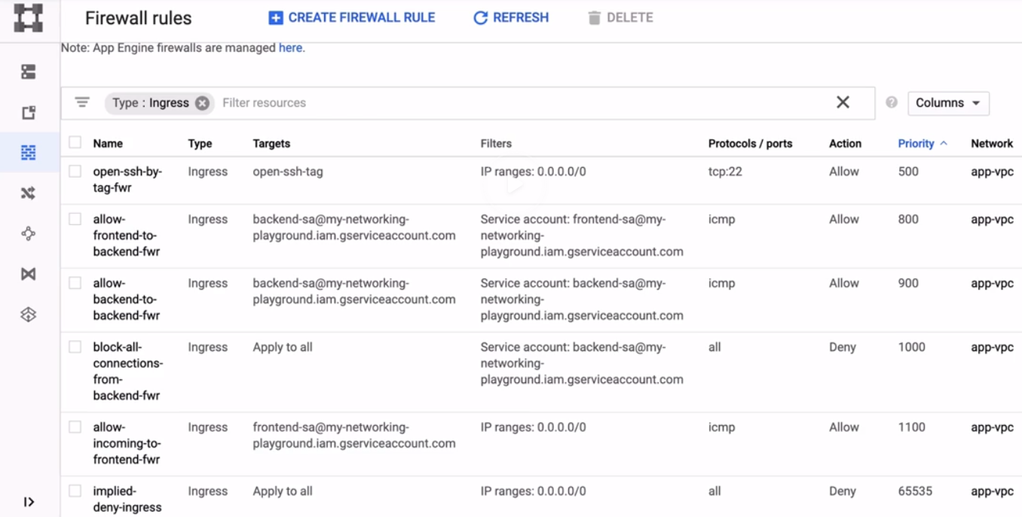

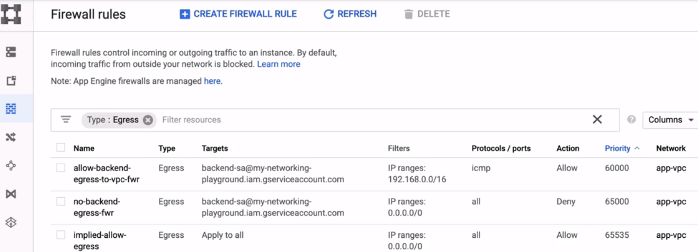

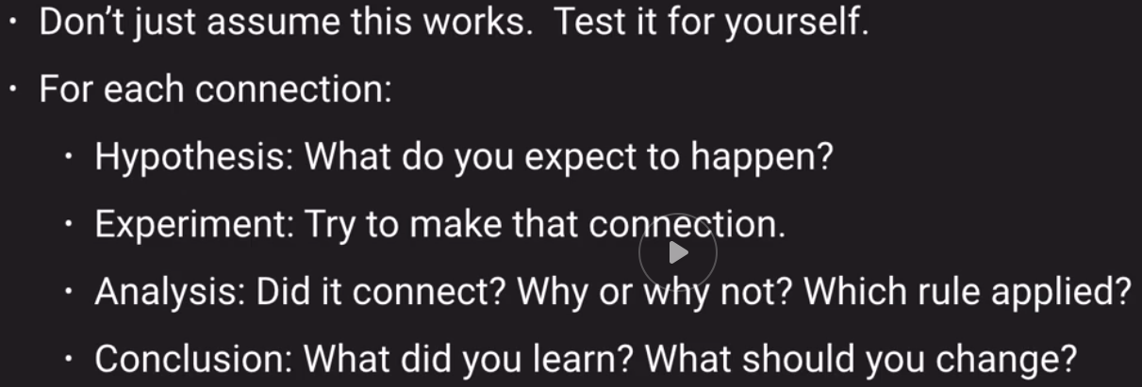

Networking Exam Tips

<https://cloud.google.com/vpc/docs/shared-vpc>

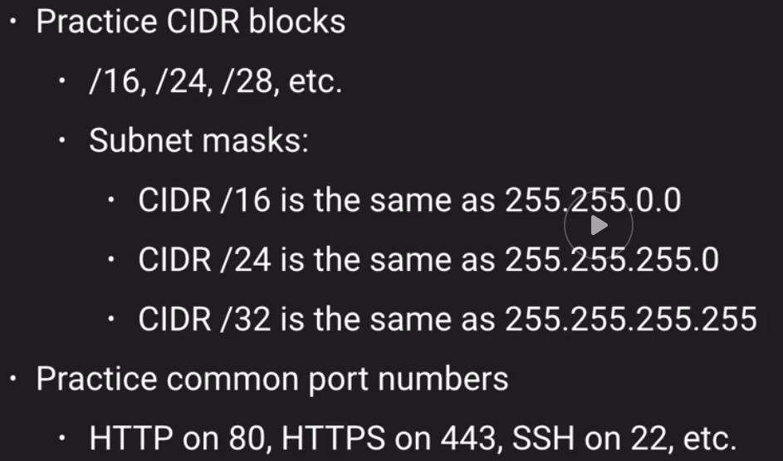

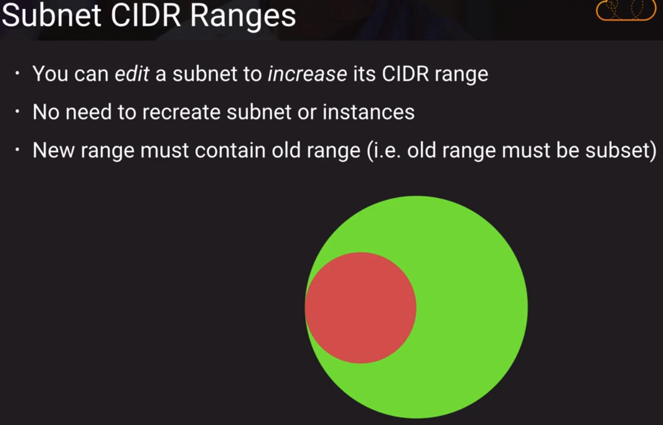

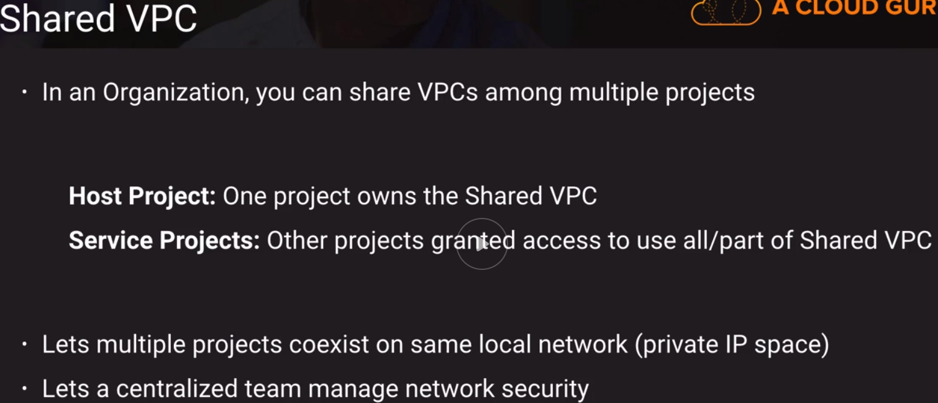

GKE – Everything you need

Deep dive with Nigel Poulton - <https://acloud.guru/learn/kubernetes-deep-dive>

(I’ve already done this)

He recommends this heavily so the exam should cover a lot of K8s.

Very important and highly relevant.

GKE Overview - <https://cloud.google.com/kubernetes-engine/docs/concepts/kubernetes-engine-overview>

GKE Concepts - <https://cloud.google.com/kubernetes-engine/docs/concepts/>

Cluster Architecture - <https://cloud.google.com/kubernetes-engine/docs/concepts/cluster-architecture>

Pods - <https://cloud.google.com/kubernetes-engine/docs/concepts/pod>

Deployments - <https://cloud.google.com/kubernetes-engine/docs/concepts/deployment>

StatefulSets - <https://cloud.google.com/kubernetes-engine/docs/concepts/statefulset>

DaemonSets - <https://cloud.google.com/kubernetes-engine/docs/concepts/daemonset>

Services and Servicetypes - <https://cloud.google.com/kubernetes-engine/docs/concepts/service>

HTTP(s) load balancing with ingress - <https://cloud.google.com/kubernetes-engine/docs/concepts/ingress>

GKE Storage - <https://cloud.google.com/kubernetes-engine/docs/concepts/storage-overview>

After all this… Ask yourself:

* Do you know how a DaemonSet works and why you might want to use one?
* Do you understand the structure of the Cloud Load Balancer that GKE created?
* Did you note how underlying GCE instances behaved as you did different things?

**App Engine – Lab Challenge**

Codelabs - <https://codelabs.developers.google.com/?cat=Cloud>

Qwiklabs - <https://google.qwiklabs.com/catalog?price%5B%5D=free&per_page=50>

What is it?

* In Scope of the exam (a couple of questions)
* Different
* The Original Google cloud service
* Fairly Easy to learn the basics
* A good test of my independence
* Deeper than it first seems
* Powerful

Homework Time – 2+ Labs

* Choose lab environment:
  + At least one Codelab (to do in your trial account)
  + At least one Qwiklab (make an account, these GAE labs should be free)
* Choose deployment:
  + At least one non-container lab (GAE Standard: just code)
  + At least one container lab (GAE Flexible: hint: check Codelabs) / look for App Engine Flexible
* Choose at least two different programming languages

Expectations:

* Make a brand new project
* Pay attention to
  + What you’re doing
  + What GCP asks you
  + What GCP reports (i.e. messages)
  + What GCP does
    - Poke around the console to see
* You will learn about valuable lab resources
* You may discuss this on the course forum
  + Not cheating / this is expected

Changing Gears to Breadth

Chapter 14.1

Google Product Lists Page: <https://cloud.google.com/products/>

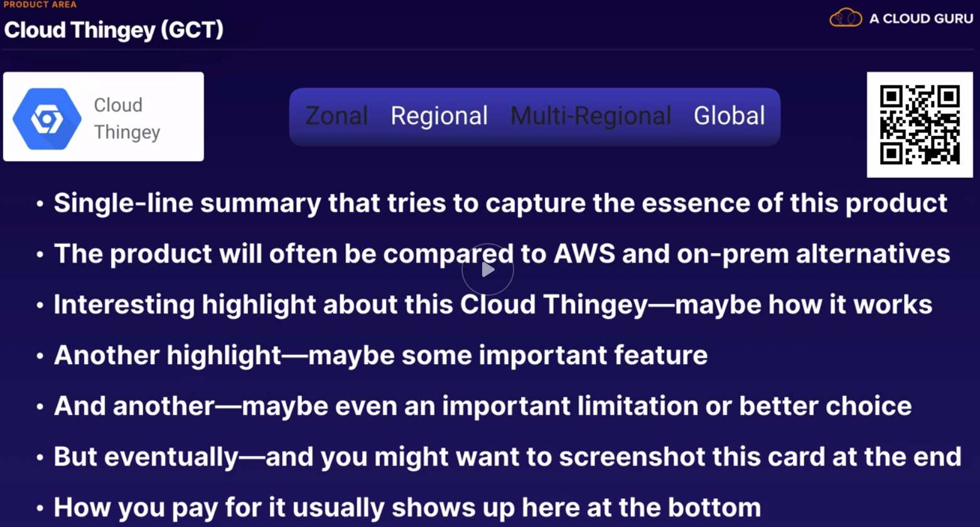

Compute Engine (GCE) - <https://cloud.google.com/compute/>

Kubenetes Engine (GKE) - <https://cloud.google.com/kubernetes-engine/>

App Engine (GAE) - <https://cloud.google.com/appengine/>

Cloud Functions (GCF) - <https://cloud.google.com/functions/>

Compute Engine (GCE)

Run anything on these that you want.

These are like EC2 instances or VMware vm’s.

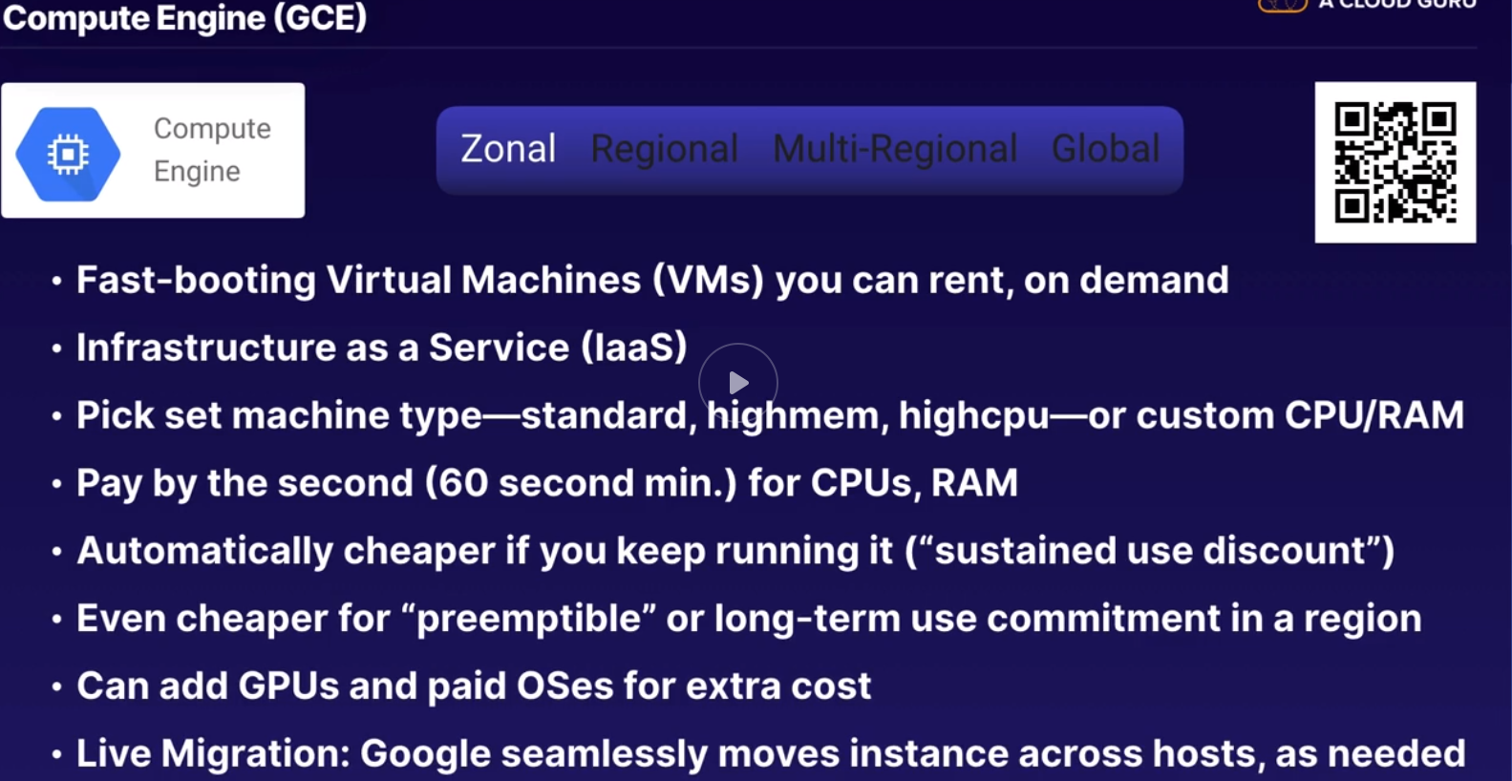

Kubernetes Engine (GKE)

Compares to ECS and EKS / Docker Enterprise

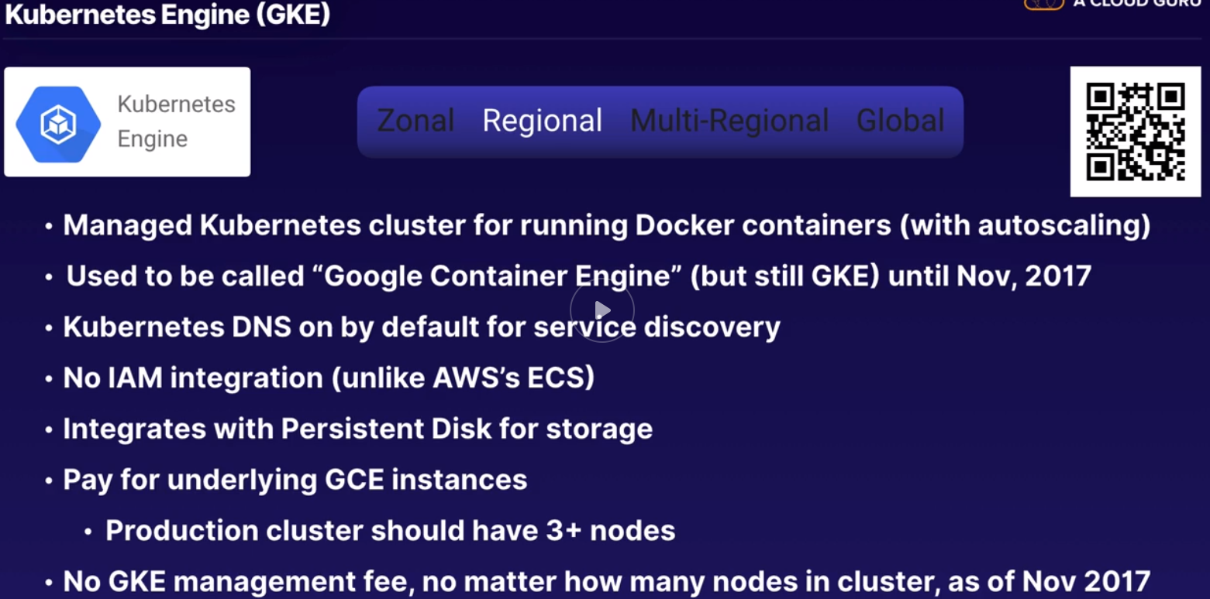

Google App Engine

Like Elastic Beanstalk in AWS

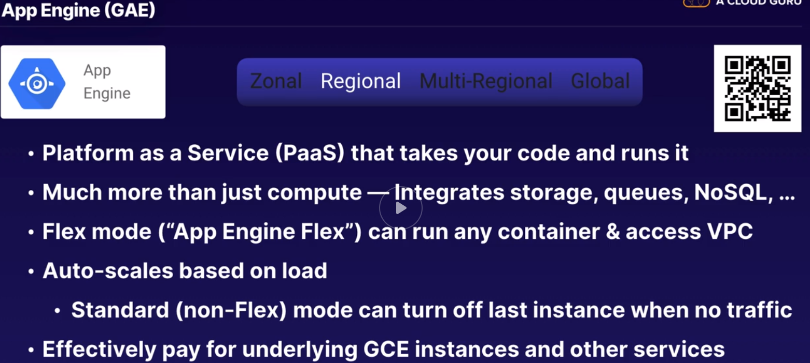

Cloud Functions (GCF) – functions as a service / like Lambda in AWS

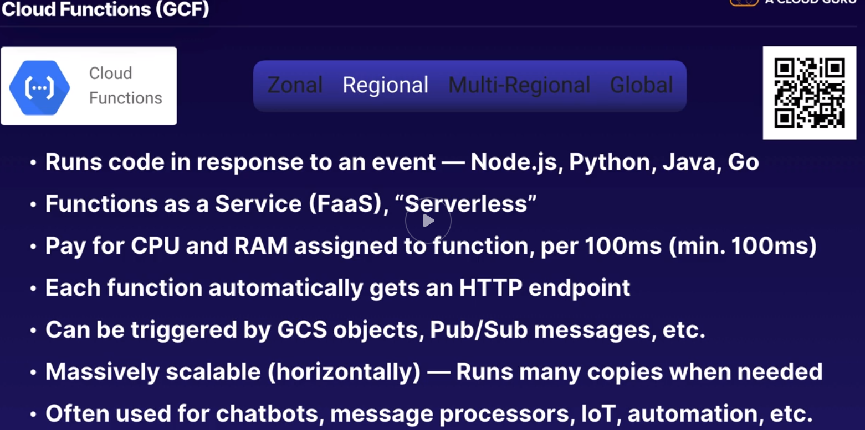

There was an error while loading [/home/dashboard?project=codelabswordpress](https://console.cloud.google.com/home/dashboard?project=codelabswordpress).

###### **You are missing at least one of the following required permissions:**

Project

resourcemanager.projects.get

Check that the project ID is valid and you have permissions to access it. [Learn more](https://cloud.google.com/iam/help/overview)

[Troubleshoot](https://console.cloud.google.com/iam-admin/troubleshooter;principal=timkeatinggcpuser@gmail.com;resource=%2F%2Fcloudresourcemanager.googleapis.com%2Fprojects%2Fcodelabswordpress;permission=resourcemanager.projects.get?project=codelabswordpress)

<https://codelabs.developers.google.com/codelabs/cloud-wordpress-on-flex/index.html?index=..%2F..index#1>

“running wordpress on App Engine Flexible Environment

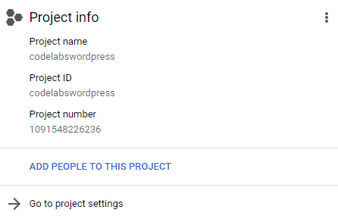

Remember the project ID, a unique name across all Google Cloud projects (the name above has already been taken and will not work for you, sorry!). It will be referred to later in this codelab as PROJECT_ID.

Running through this codelab shouldn't cost you more than a few dollars, but it could be more if you decide to use more resources or if you leave them running (see "cleanup" section at the end of this document). Prices are documented here: [App Engine Flexible Environment](https://cloud.google.com/appengine/pricing#flexible-environment-instances), [Cloud SQL](https://cloud.google.com/sql/pricing) & [Cloud Storage](https://cloud.google.com/storage/pricing)

New users of Google Cloud Platform are eligible for a [$300 free trial](https://console.developers.google.com/billing/freetrial?hl=en).

**Using Google Cloud Shell**

While you can use your laptop, in this codelab we will be using [Google Cloud Shell](https://cloud.google.com/cloud-shell/), a command line environment running in the Cloud.

This Debian-based virtual machine is loaded with all the development tools you'll need. It offers a persistent 5GB home directory, and runs on the Google Cloud, greatly enhancing network performance and authentication. This means that all you will need for this codelab is a browser (yes, it works on a Chromebook).

To activate Google Cloud Shell, from the developer console simply click the button on the top right-hand side (it should only take a few moments to provision and connect to the environment):

Credentialed AccountsACTIVE ACCOUNT* timkeatinggcpuser@gmail.comTo set the active account, run: $ gcloud config set account `ACCOUNT`timkeatinggcpuser@cloudshell:**~**$ gcloud config list project[core]project = codelabswordpressYour active configuration is: [cloudshell-11437]timkeatinggcpuser@cloudshell:**~**$

Cloud SQL instance:

Instance ID: wp

Password: cqA3pFna83HzcdF5

Service account: [p1091548226236-s5l6zm@gcp-sa-cloud-sql.iam.gserviceaccount.com](mailto:p1091548226236-s5l6zm@gcp-sa-cloud-sql.iam.gserviceaccount.com)

Storage bucket link: <https://console.cloud.google.com/storage/browser/my-wordpress-bucket-keating>

Link for gsutil: gs://my-wordpress-bucket-keating

This project didn’t work!

Chapter 14.3

Storage

Local SSD - <https://cloud.google.com/compute/docs/disks/#localssds>

Persistent Disk - <https://cloud.google.com/persistent-disk/>

Cloud Filestore - <https://cloud.google.com/filestore/>

Cloud Storage - <https://cloud.google.com/storage/>

Data is always encrypted at rest – EVERYWHERE

**Local SSD**

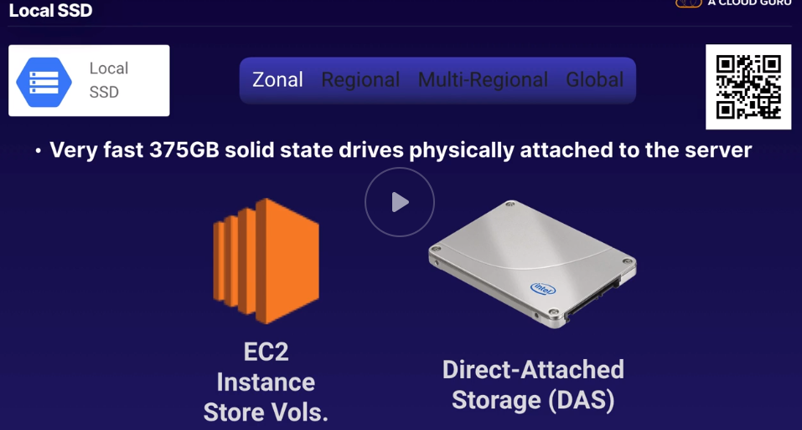

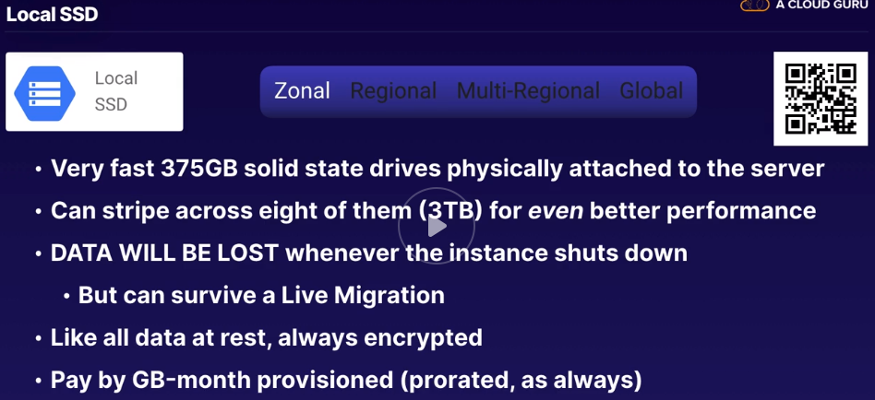

**Persistent Disk (PD)**

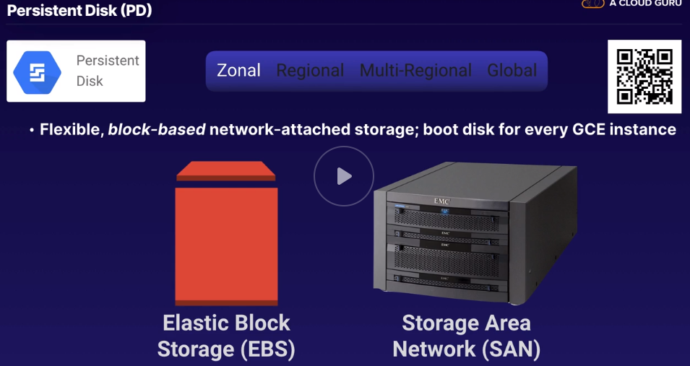

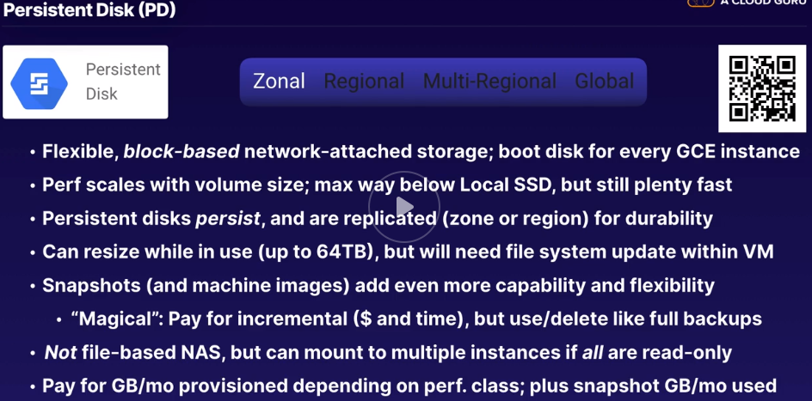

**Cloud Filestore**

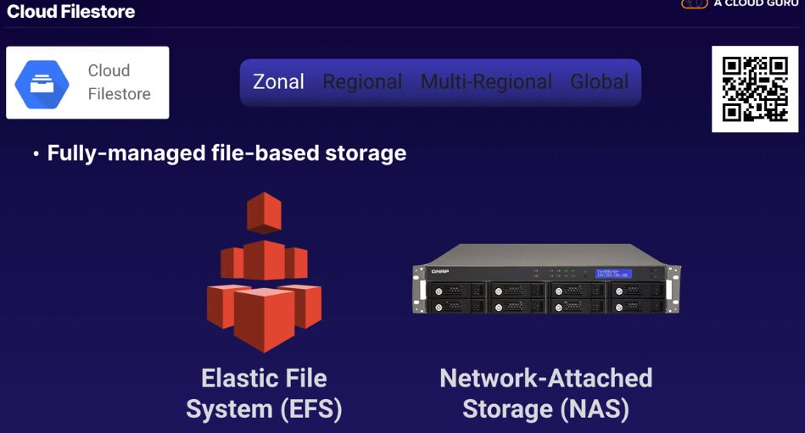

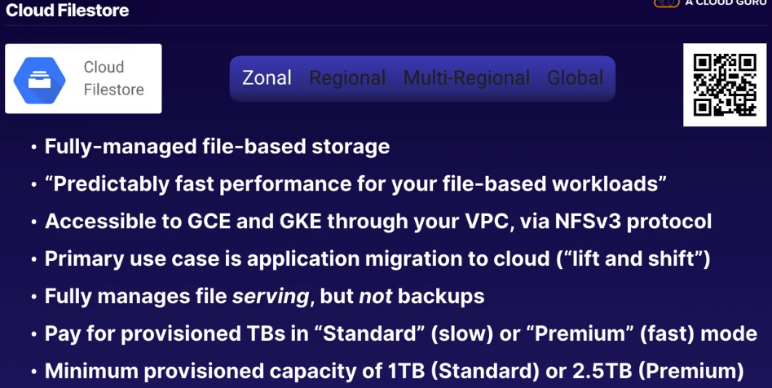

Standard Tier – up to 5,000 i/o per second / transfer between 1-200MB / second for reads

Premium – 60,000 iops / 1,200MB per second reads

What if you need more? You need to use CLOUD STORAGE

GCS – Google Cloud Storage – OBJECT STORAGE / like AWS S3

Bucket/ lives in a region or multi-region / 2 or more physical locations sep by at least 100 miles

Like S3 or Glacier

Supports built in and custom metadata per object/ can do prefix to emulate a folder structure

Can conditionally update based on versions / object change notification so you can link it to other services by webhook/

Can set up lifecycle changes

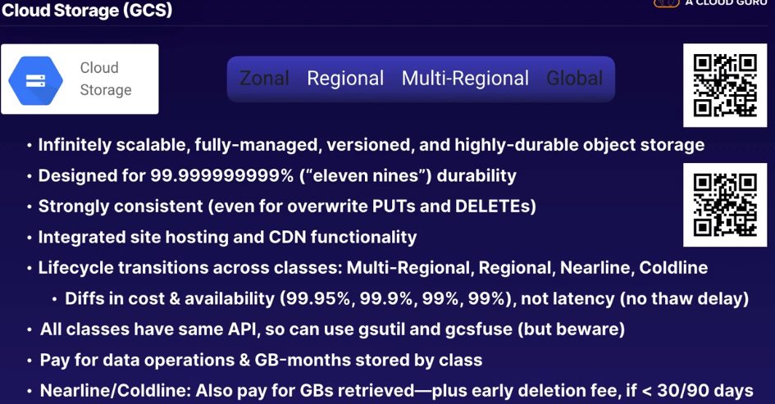

**Databases**

Cloud SQL – <https://cloud.google.com/sql/>

Cloud Spanner – <https://cloud.google.com/spanner/>

Cloud Spanner Instance Configurations and Nodes – <https://cloud.google.com/spanner/docs/instances>

BigQuery – <https://cloud.google.com/bigquery/>

BigQuery Under the Hood – <https://cloud.google.com/blog/products/gcp/bigquery-under-the-hood>

Bigtable – <https://cloud.google.com/bigtable/>

Cloud Datastore – <https://cloud.google.com/datastore/>

Cloud Datastore Queries – <https://cloud.google.com/datastore/docs/concepts/queries>

Firebase DBs - <https://firebase.google.com/docs/database/rtdb-vs-firestore>

**Structured Data / still always encrypted**

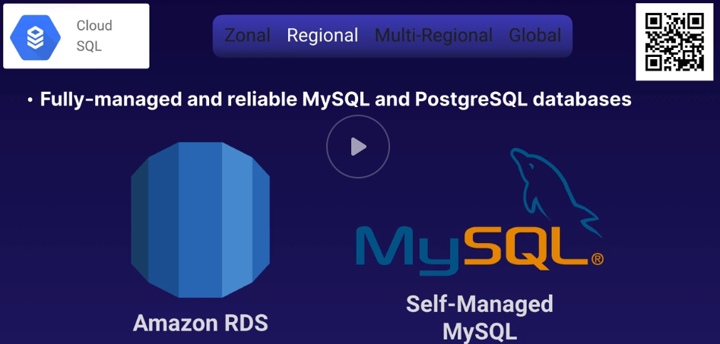

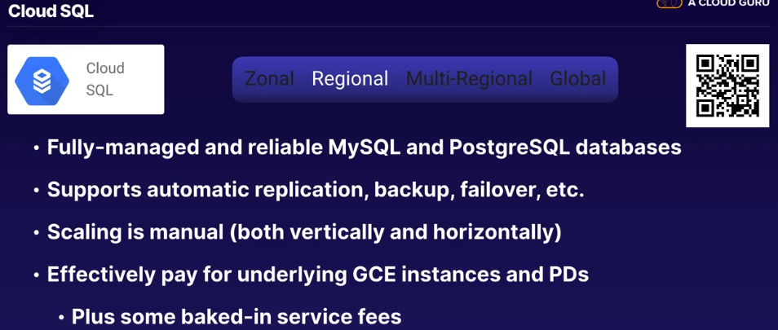

What if you need more? If you’ve outgrown, you might use CLOUD SPANNER.

If you were doing this on your own, you might use sharded MYSQL or Cockroach DB

What are ACID guarantees for databases?

Atomicity, Consistency, Isolation, Durability

Stale reads are stronger than eventual consistency you might get from a NOSQL database

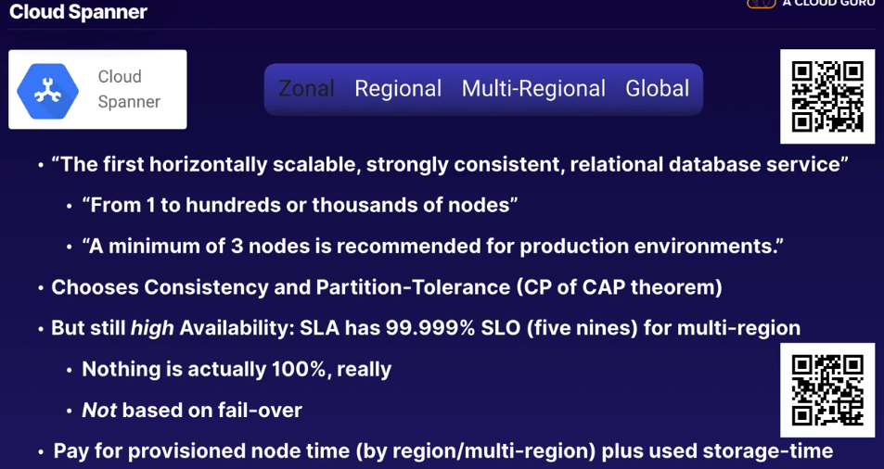

Production, mult-region is 10’s of thousands of $ per month

Big Query

Some people say that it’s the MOST SIGNIFICANT service in GCP.

It is similar (not the same) as Amazon Redshift

Big Query is SERVERLESS

**Athena (AWS) is a copy of Big Query/ based on PRESTO**

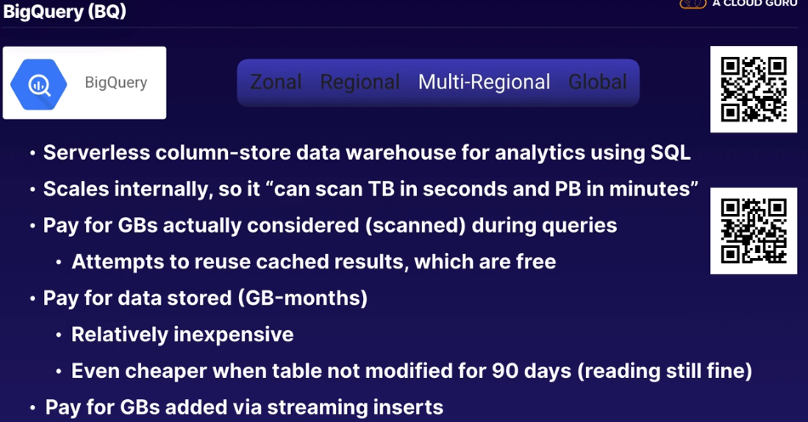

Cloud Big Table

NoSQL DB

Think of AWS Dynamo DB or Cassandra or Apache HBase

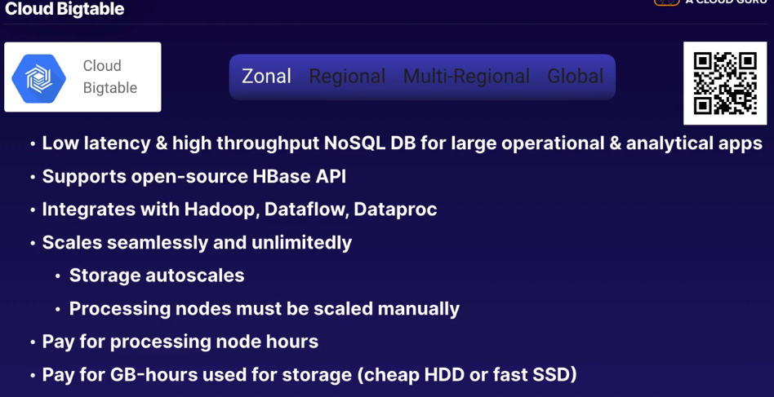

Cloud Datastore

Compares to DynamoDB or MongoDB

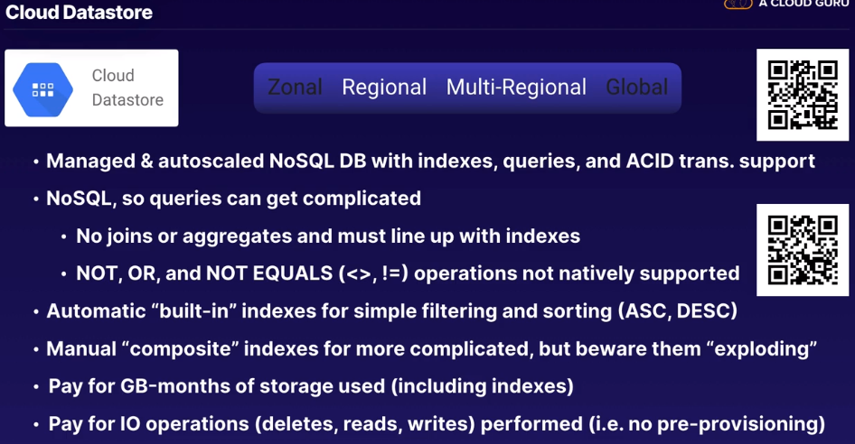

Firebase Realtime DB & Cloud Firestore

Might compare to DynamoDB or MongoDB

Would need a lot more componentry to make the same thing such as EC2 and Socket.io

Plus ELB or Nginx

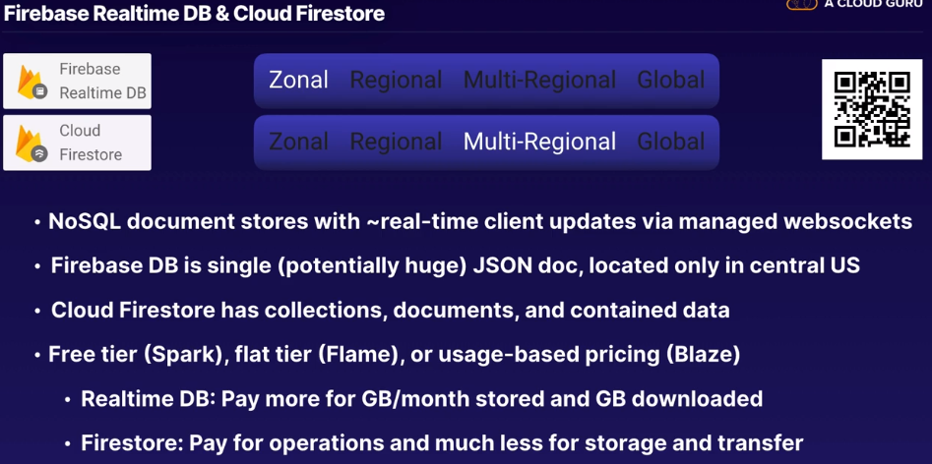

**Data Transfer**

Chapter 14.5

Data Transfer Appliance - <https://cloud.google.com/transfer-appliance/>

Storage Transfer Service - <https://cloud.google.com/storage-transfer-service>

Data Transfer Appliance – like an AWS Snowball

100TB or 480TB versions

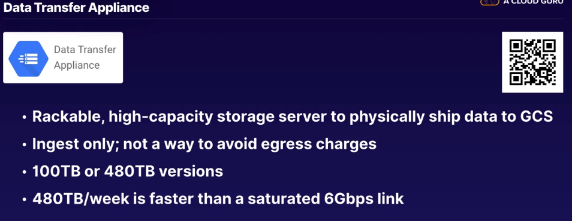

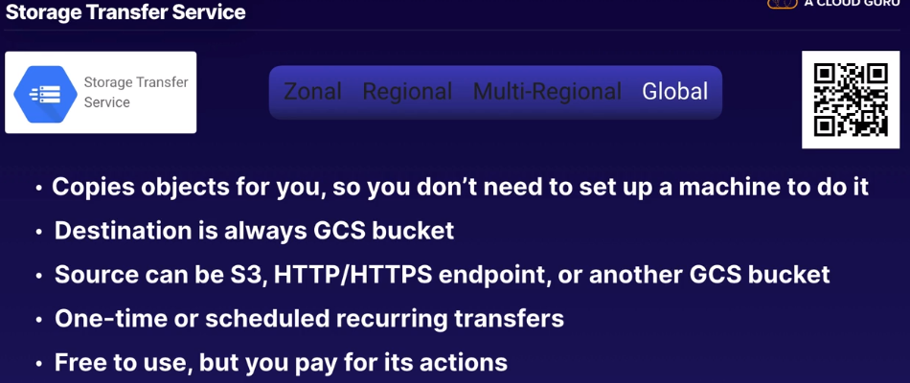

External Networking

Chapter 14.6

Google Domains - <https://domains.google/#/>

Cloud DNS – <https://cloud.google.com/dns/>

Static IPs – <https://cloud.google.com/compute/docs/ip-addresses/reserve-static-external-ip-address>

Cloud Load Balancing (CLB) – <https://cloud.google.com/load-balancing/>

Cloud CDN - <https://cloud.google.com/cdn/>

**Google Domains**

Google’s registrar for domain names – Think of Rt 53 or GoDaddy

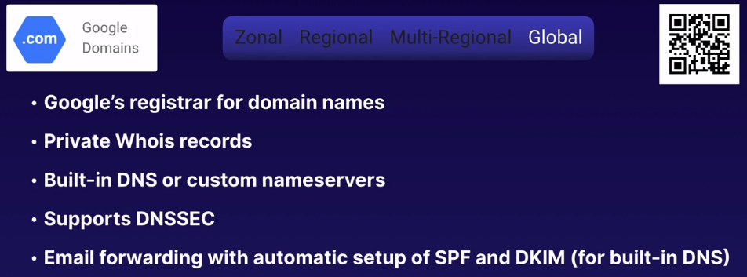

**Cloud DNS**

Think of AWS Rt 53 or DYN

This is Global

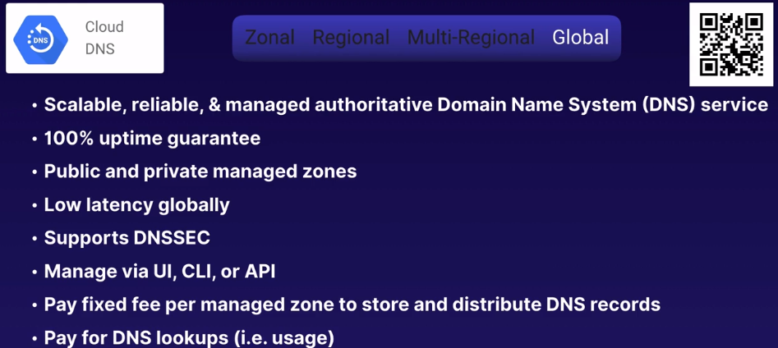

**Static IP Addresses**

Think of AWS Elastic IP Address

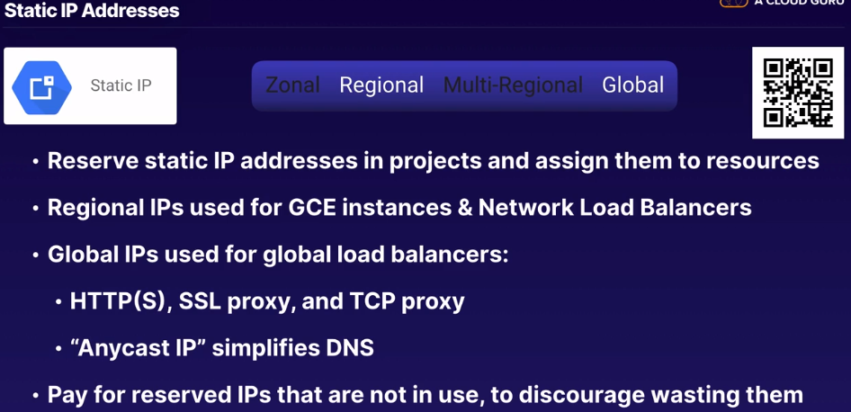

**Cloud Load Balancing (CLB)**

Think of AWS Elastic Load Balancing (ELB), HA Proxy or NGINX

Built on Google Andromeda which is Google’s networking system

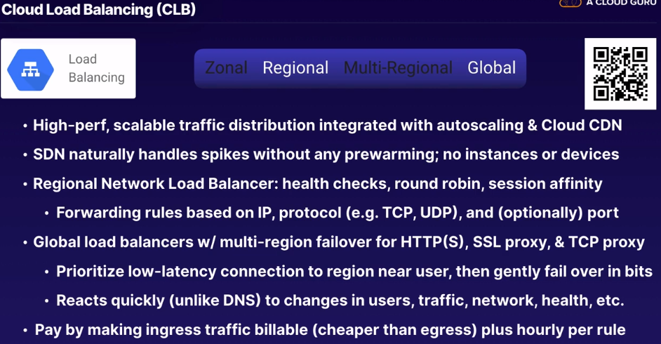

**Cloud CDN**

Think AWS Cloudfront, Akamai or Cloudflare

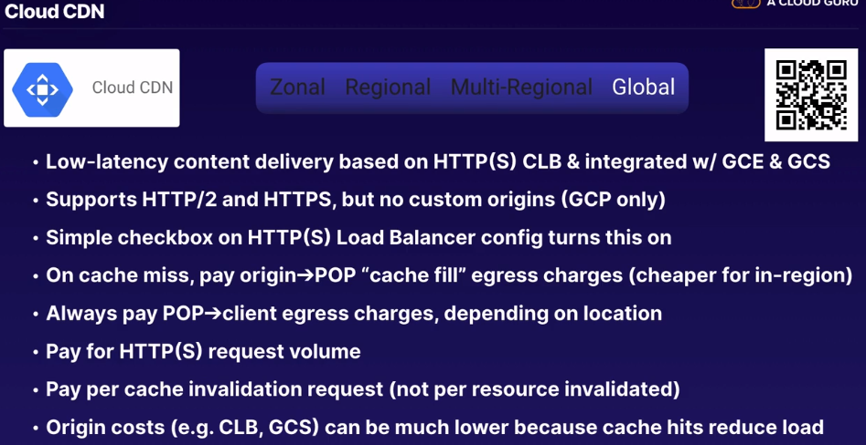

Internal Networking

Chapter 14.7

Virtual Private Cloud (VPC) - <https://cloud.google.com/vpc/>

Cloud Interconnect – <https://cloud.google.com/hybrid-connectivity>

Cloud VPN – <https://cloud.google.com/vpn/docs/concepts/overview>

Dedicated Interconnect – <https://cloud.google.com/interconnect/docs/concepts/dedicated-overview>

Cloud Router – <https://cloud.google.com/router/docs/>

CDN Interconnect - <https://cloud.google.com/interconnect/docs/how-to/cdn-interconnect>

VPC – Core of all Internal Networking in GCP

Compares to Amazon VPC or Openflow

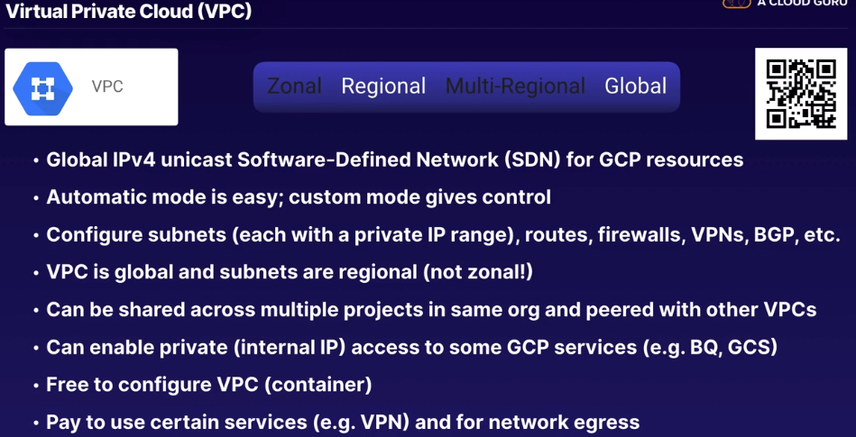

**Cloud Interconnect**

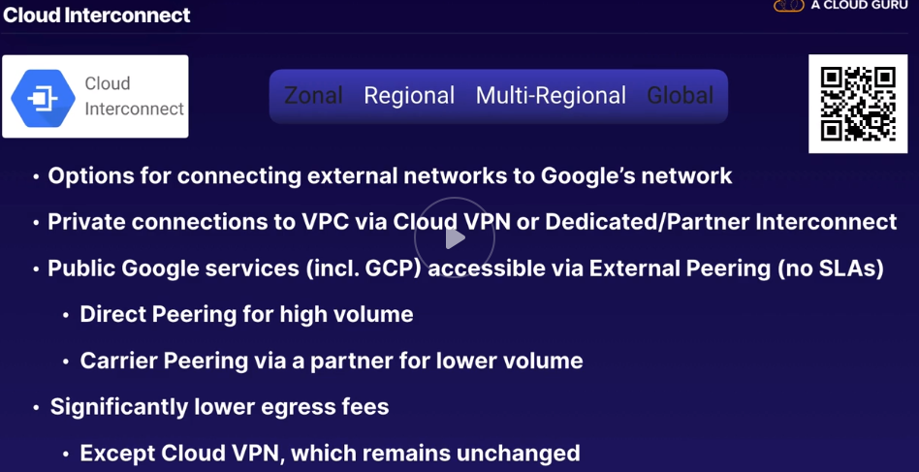

**Cloud VPN**

Compare to VPN or OpenVPN

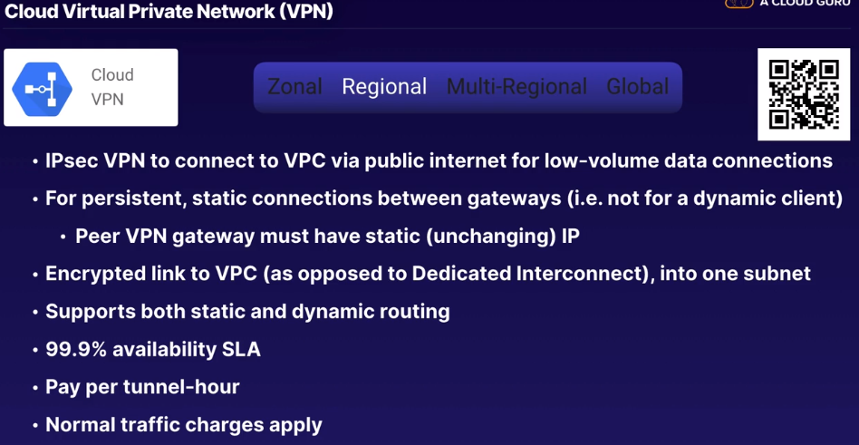

**Dedicated Interconnect**

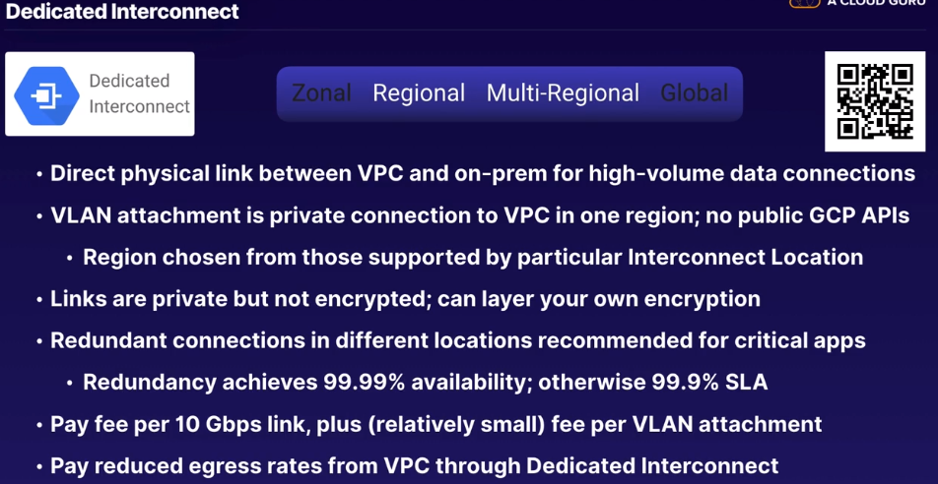

**Cloud Router**

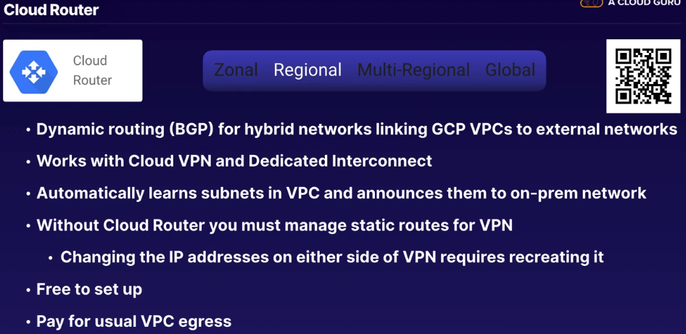

**CDN Interconnect**

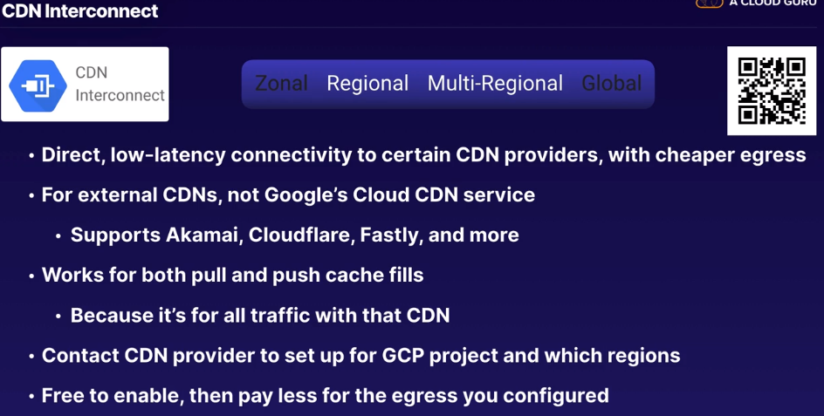

Machine Learning / AI

Chapter 14.8

Cloud Machine Learning Engine – <https://cloud.google.com/ai-platform>

My Coke Rewards Case Study – <https://developers.googleblog.com/2017/09/how-machine-learning-with-tensorflow.html>

Cloud Vision API – <https://cloud.google.com/vision/>

Cloud Speech API – <https://cloud.google.com/speech-to-text/>

Cloud Natural Language API – <https://cloud.google.com/natural-language/>

Cloud Transition API – <https://cloud.google.com/translate/>

Dialogflow – <https://cloud.google.com/dialogflow/>

Cloud Video Intelligence API – <https://cloud.google.com/video-intelligence/>

Cloud Job Discovery - <https://cloud.google.com/solutions/talent-solution>

**Cloud Machine Learning (ML) Engine**

Think of Amazon SageMaker, TensorFlow or Apache MXNet

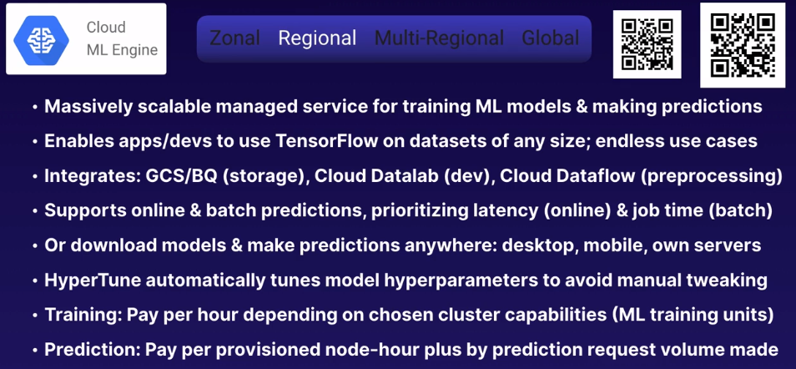

**Cloud Vision API**

Think of AWS Rekognition

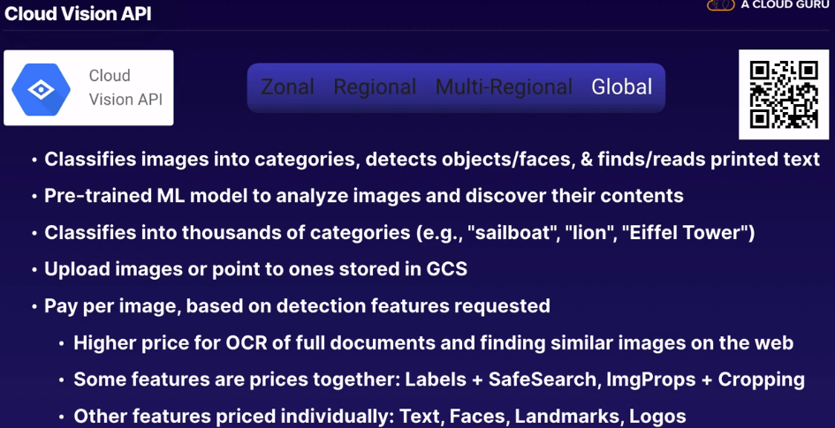

**Cloud Speech API**

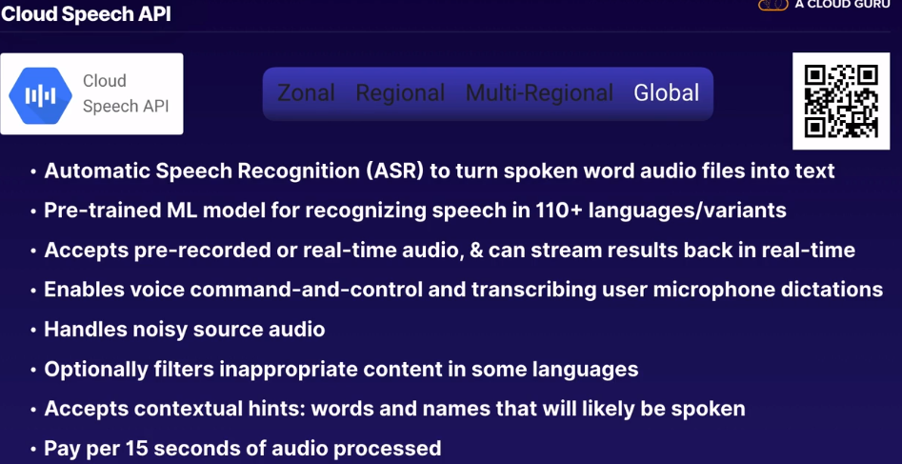

**Cloud Natural Language API**

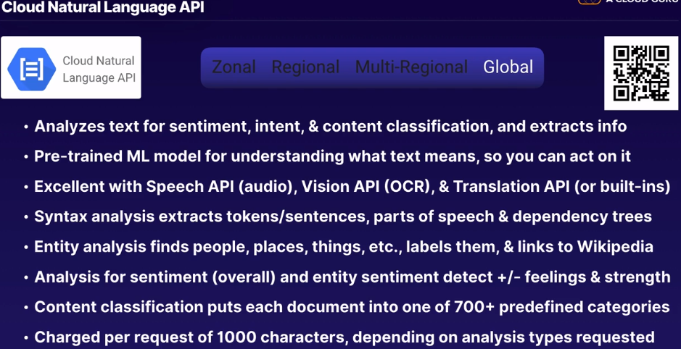

**Cloud Translation API**

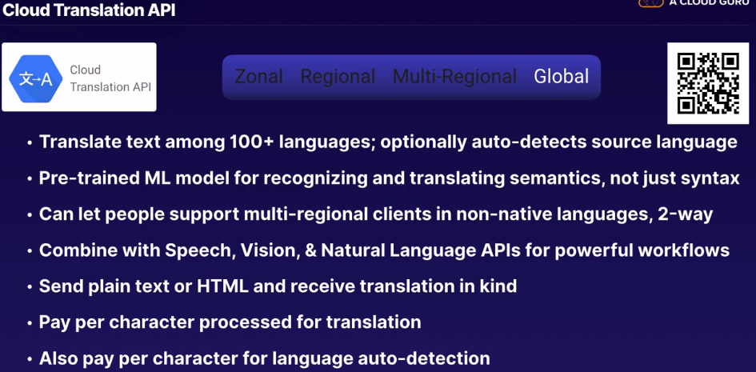

**Dialogflow**

Compare to Amazon Lex

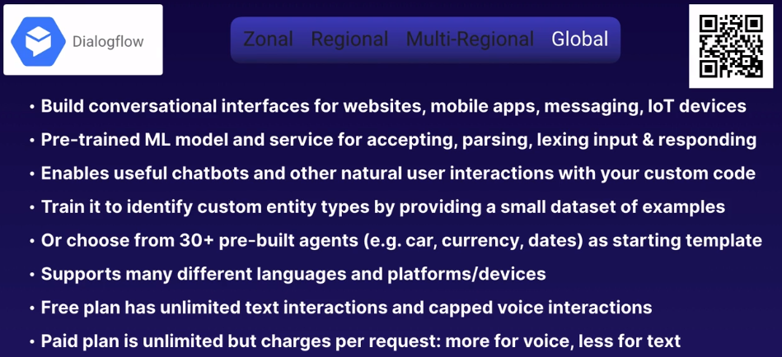

**Cloud Video Intelligence API**

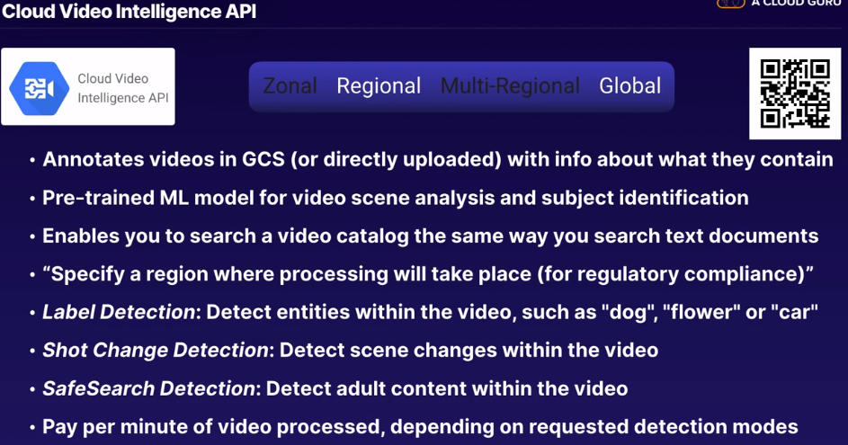

**Cloud Job Discovery**

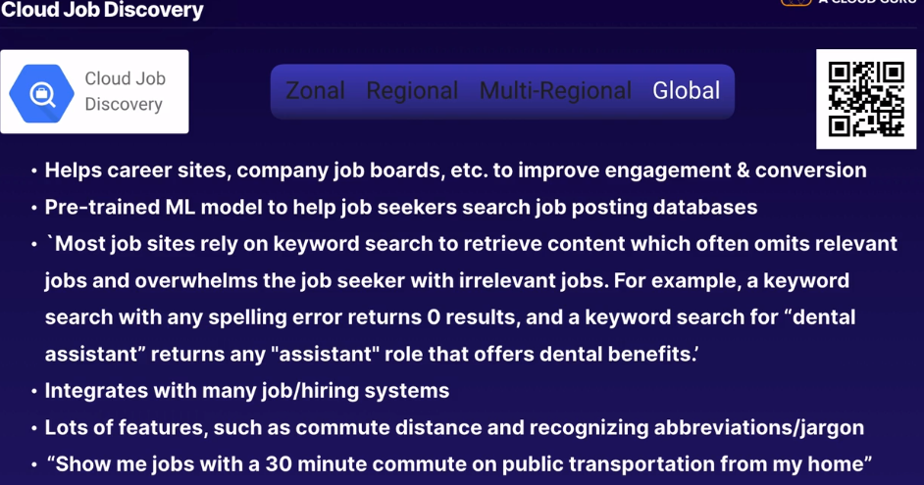

**BIG DATA & IoT**

Chapter 14.9

Big Data Lifecycle – <https://cloud.google.com/solutions/data-lifecycle-cloud-platform>

Cloud Internet of Things (IoT) Core – <https://cloud.google.com/iot-core/>

Cloud Pub/Sub – <https://cloud.google.com/pubsub/>

Cloud Dataprep – <https://cloud.google.com/dataprep/>

Data Wrangling vs ETL – <https://tdwi.org/articles/2017/02/10/data-wrangling-and-etl-differences.aspx>

Cloud Dataproc – <https://cloud.google.com/dataproc/>

Cloud Dataflow – <https://cloud.google.com/dataproc/>

Dataflow Shuffle – <https://cloud.google.com/blog/products/gcp/introducing-cloud-dataflow-shuffle-for-up-to-5x-performance-improvement-in-data-analytic-pipelines>

Cloud Datalab – <https://cloud.google.com/datalab/>

Jupyter Notebook – <https://jupyter.org/>

Cloud Data Studio – <https://cloud.google.com/solutions/business-intelligence>

Cloud Genomics - <https://cloud.google.com/life-sciences>

Big Data Lifecycle

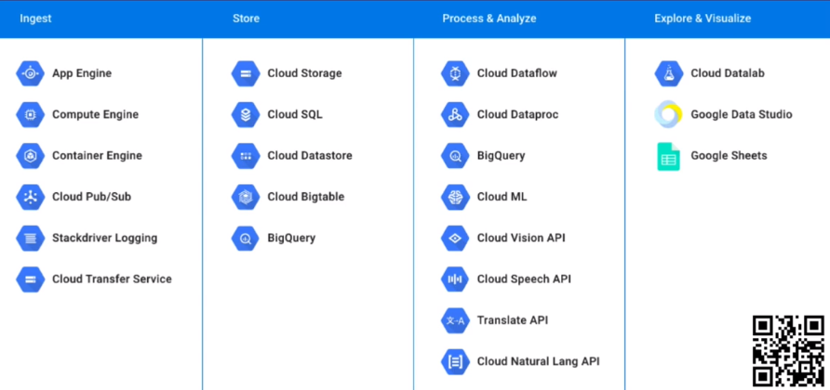

**Cloud Internet of Things (IoT) Core**

Compare to AWS IoT

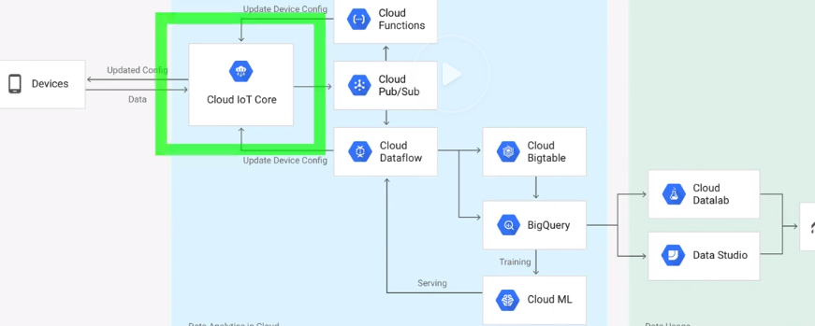

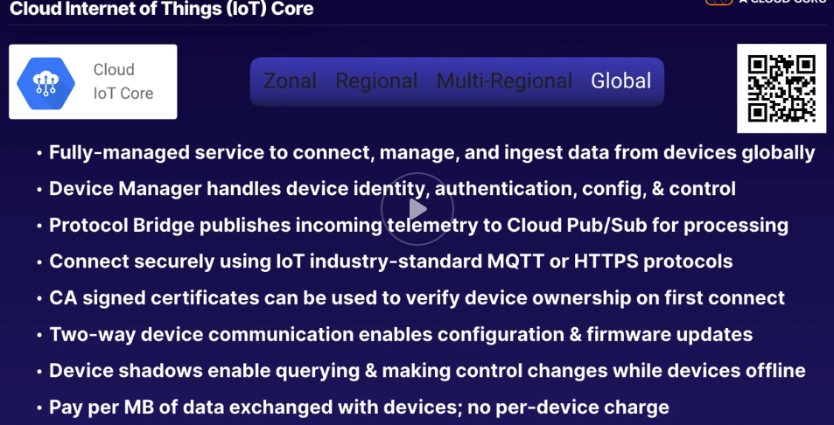

**Cloud Pub/Sub**

“Publish / Subscribe” – Think of Amazon SNS (push) or SQS (pull) also something like RabbitMQ

Amazon Kinesis / Apache Kafka

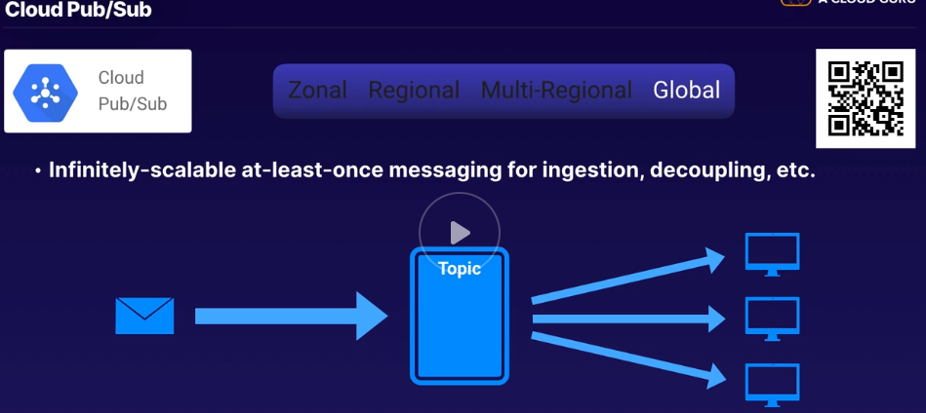

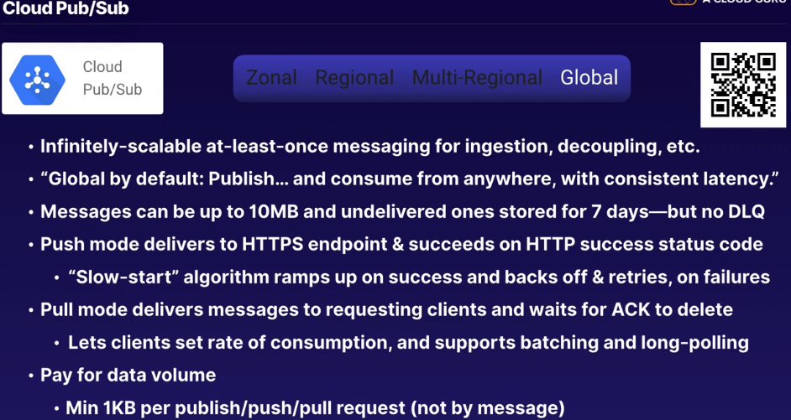

**Cloud Dataprep**

Compare to AWS Glue or Informatica PowerCenter but not really

More like OpenRefine or Matalab or Excel

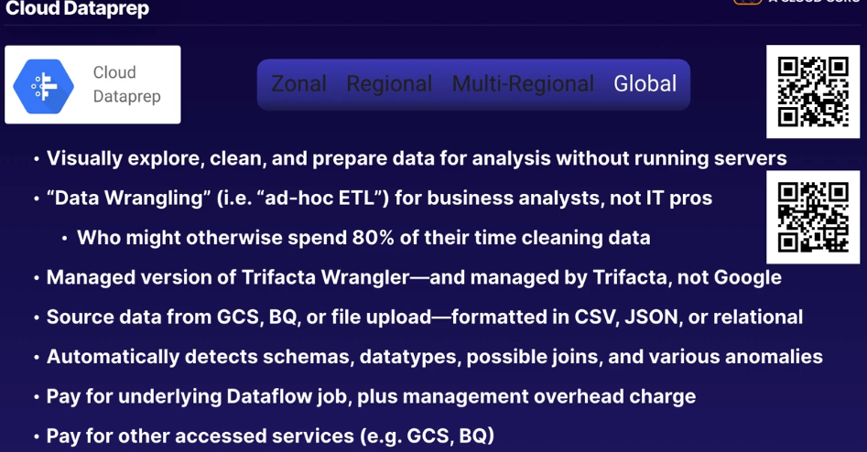

**Cloud Dataproc**

Compare to Amazon EMR, Spark or Hadoop

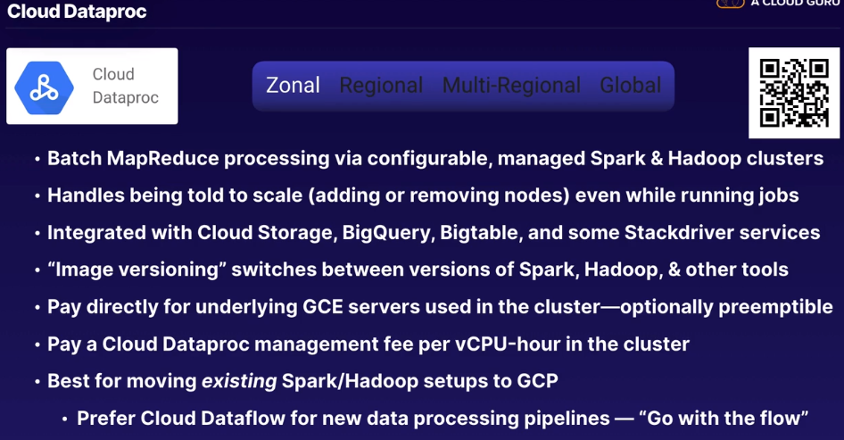

**Cloud Dataflow**

Think of Amazon EMR, Hadoop or Spark or even Apache Beam

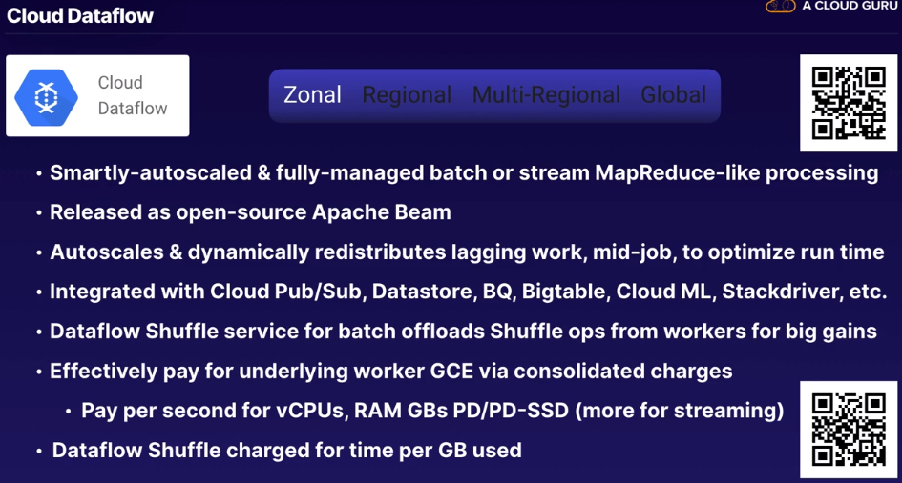

**Cloud Datalab**

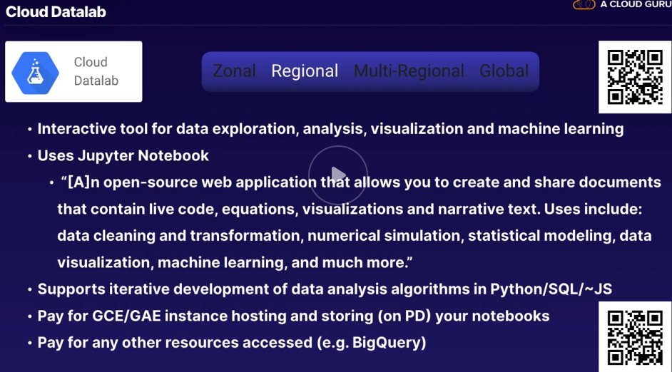

**Cloud Data Studio**

Compare to Amazon QuickSight or Tableau

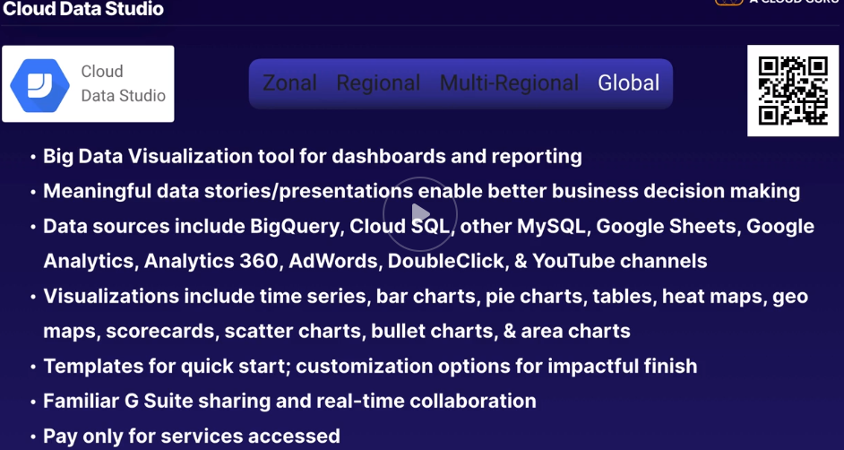

**Cloud Genomics**

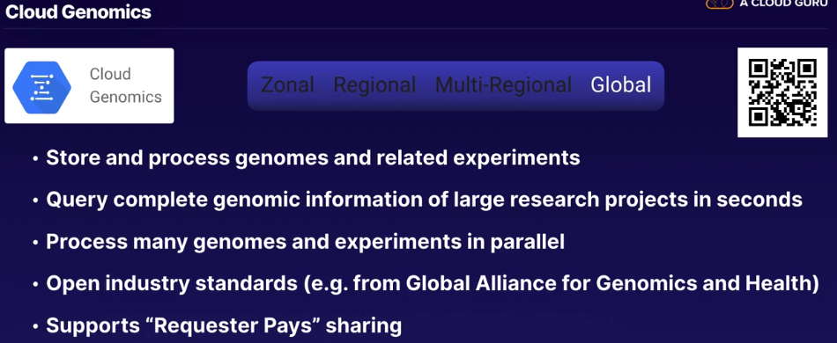

**Identity and Access – Core Security**

Hierarchical Access Control – <https://cloud.google.com/iam/docs/resource-hierarchy-access-control>

Service Accounts – <https://cloud.google.com/iam/docs/understanding-service-accounts>

Cloud Identity - <https://support.google.com/cloudidentity/answer/7319251?visit_id=637199026923254705-2440951759&rd=1>

Security Key Enforcement – <https://cloud.google.com/security-key/>

Resource Manager – <https://cloud.google.com/resource-manager/>

Resource Manager Hierarchy – <https://cloud.google.com/resource-manager/docs/cloud-platform-resource-hierarchy>

Cloud Identity-Aware Proxy (IAP) – <https://cloud.google.com/iap/>

Cloud Audit Logging - <https://cloud.google.com/logging/docs/audit/>

**Triple A model of security- Authentication, Authorization and Accounting (or Auditing)**

**Authentication = Who is this?**

**Authorization = what are they allowed to do?**

**Accounting = what did they do and when?**

**Roles-**

Googles Roles are more like AWS Policies

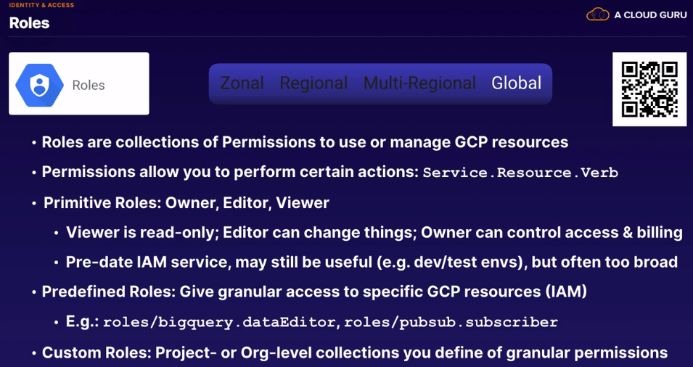

**Cloud Identity and Access Management (IAM)**

Like IAM in AWS

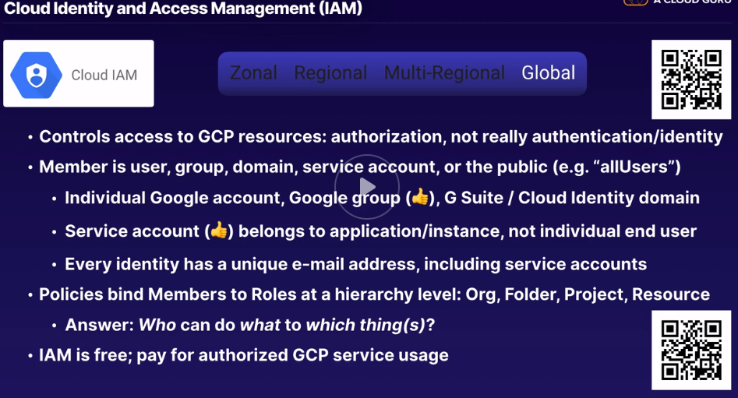

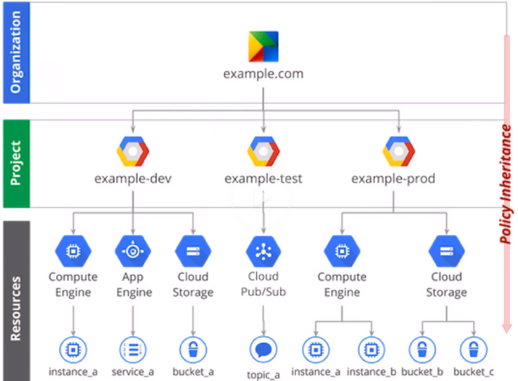

**Service Accounts**

These compare to AWS IAM Roles / apply to an application, not an end user

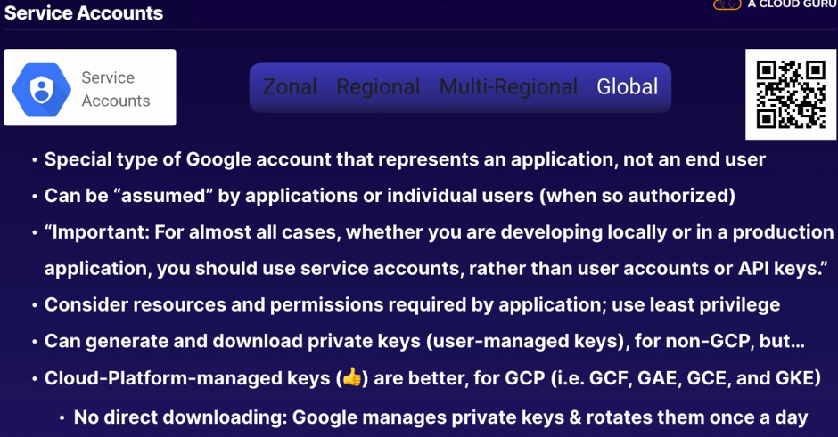

**Cloud Identity**

Managing Users and Groups

Does fall within responsibility of AWS IAM for example

If you were using GCP without Cloud Identity, it might be because you’re using G Suite or a series of Gmail, Google accounts or Active Directory.

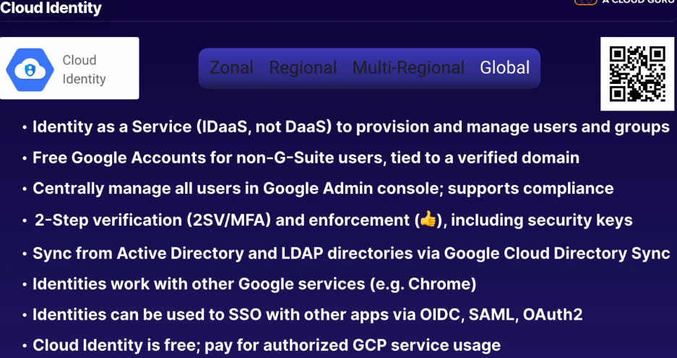

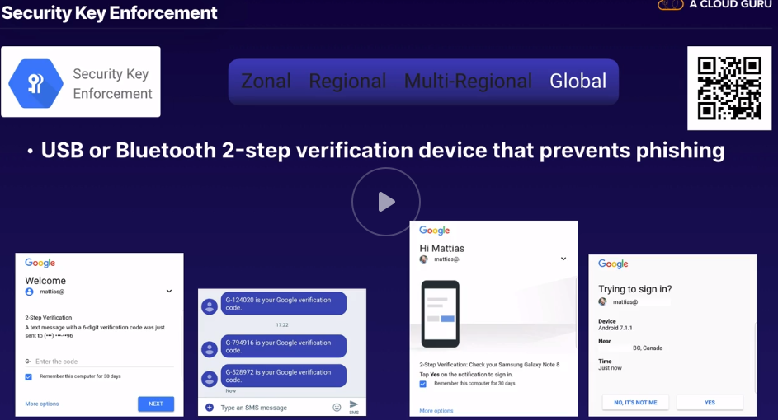

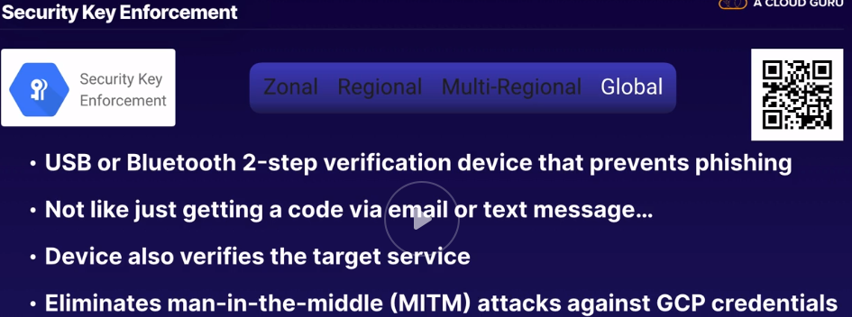

**Cloud Resource Manager**

Similar to AWS Organizations

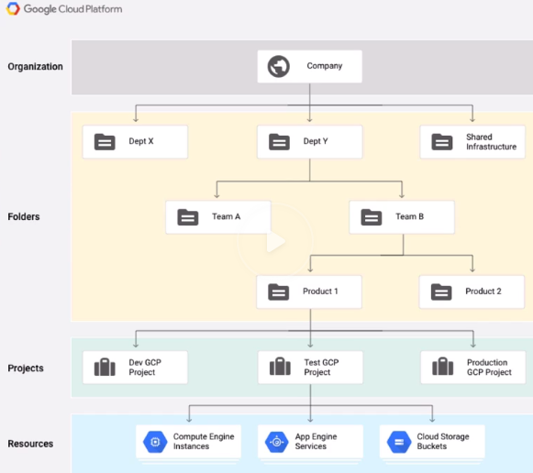

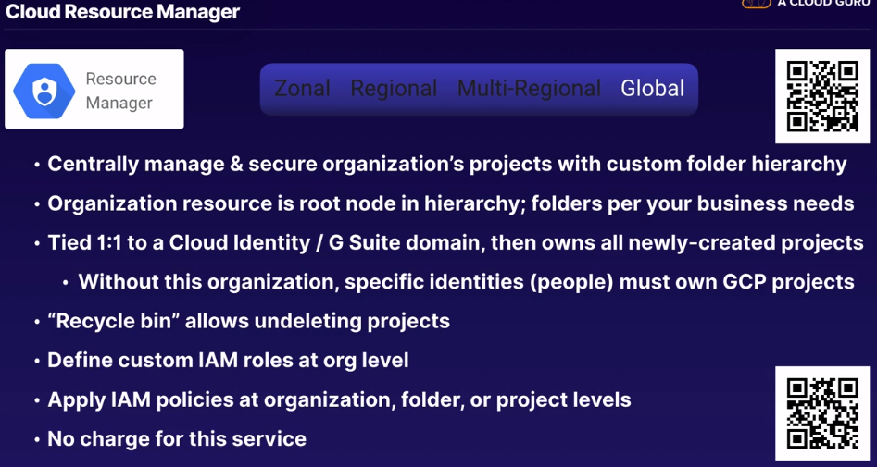

**Cloud Identity-Aware Proxy (IAP)**

This is similar to Amazon API Gateway

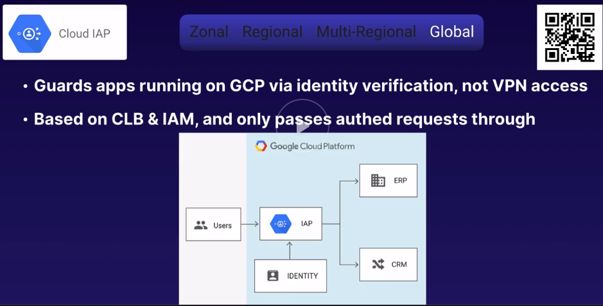

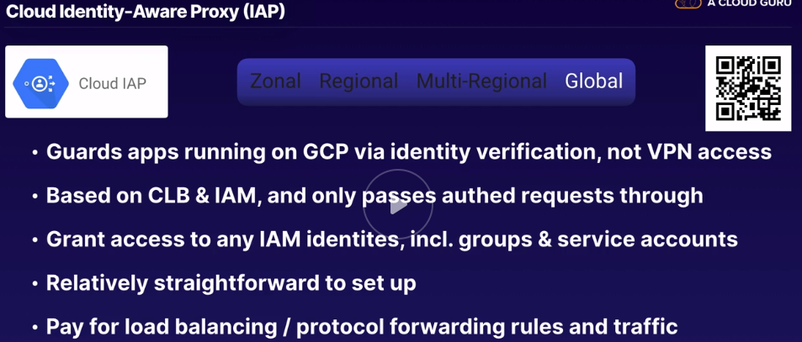

**Cloud Audit Logging**

Who did what, where and when? Within GCP projects

This is like Amazon CloudTrail

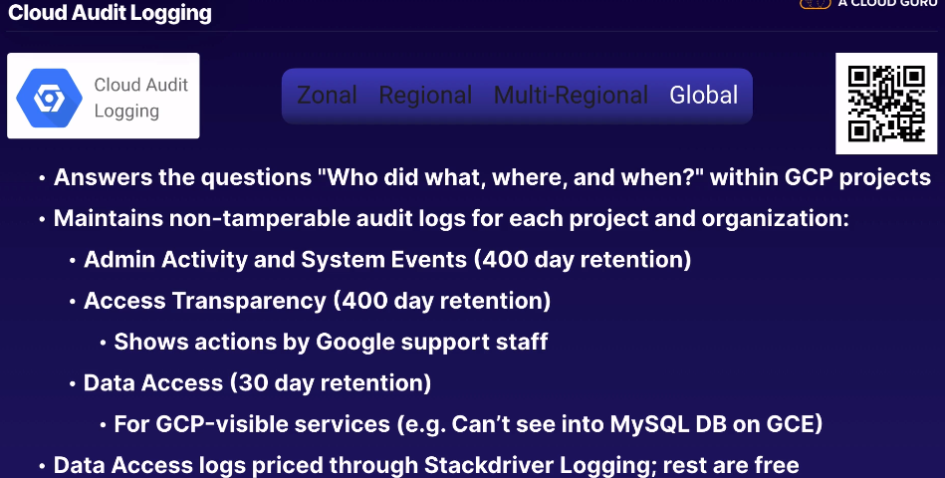

**Security Management – Monitoring and Response**

Chapter 14.11

Cloud Armor – <https://cloud.google.com/armor/>

Cloud Security Scanner – <https://cloud.google.com/security-scanner/>

Cloud Data Loss Prevention (DLP) API – <https://cloud.google.com/dlp/>

Event Threat Detection (ETC) – <https://cloud.google.com/event-threat-detection/>

Cloud Security Command Center (SCC) – <https://cloud.google.com/security-command-center/>

Getting started with Cloud SCC (Blog Post) – <https://cloud.google.com/blog/products/identity-security/getting-started-with-cloud-security-command-center>

What is SIEM? (youtube) - <https://www.youtube.com/watch?v=ZuLazPgFtBE&feature=youtu.be>

Security Information & Event Management

Cross correlation of data

A SIEM is more than…

* Log Aggregation
* IDS/IPS
* Machine Learning Systems

Most Important Reasons to have a SIEM:

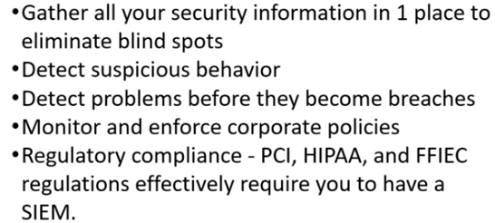

**Cloud Armor**

Compare to AWS Shield and AWS WAF

Only available when you’re using a GLOBAL HTTPS Load Balancer!

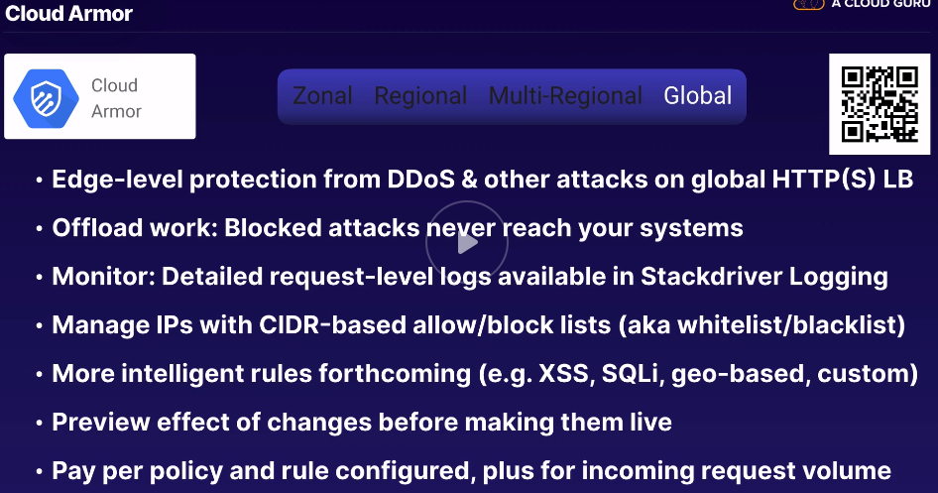

**Cloud Security Scanner**

Loosely compared to Amazon Inspector (agent based as opposed to crawler based like Security Scanner)

More like Trustwave App Scanner or Qualys Web Application Scanning

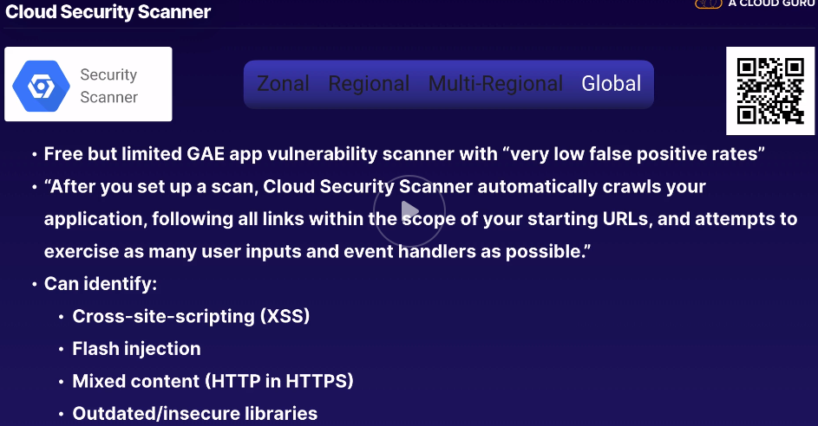

**Cloud Data Loss Prevention API (DLP)**

Compare to AWS Macie

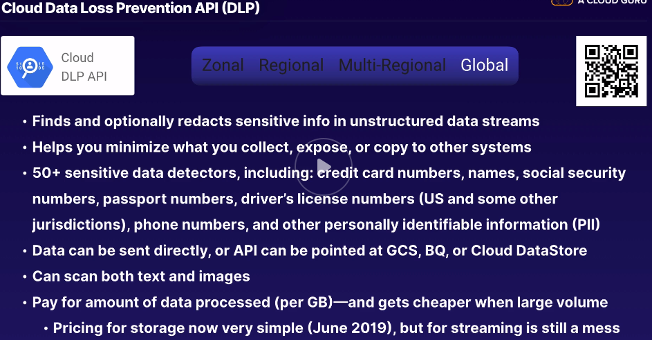

**Event Threat Detection**

Compare to Amazon GuardDuty / Splunk can also do this

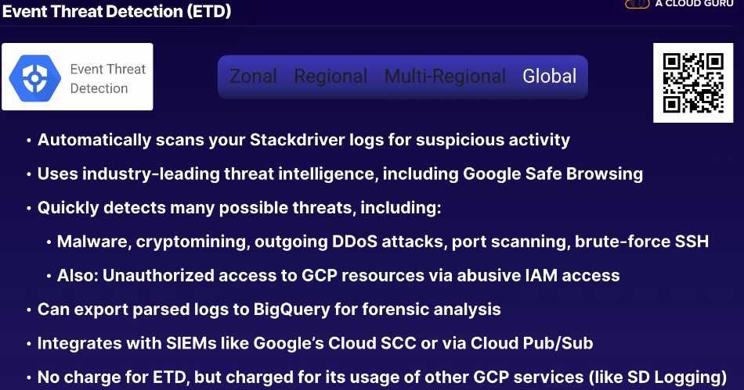

**Cloud Security Command Center (SCC)**

Directly compares to AWS Security Hub / More well-known products are Splunk Enterprise Security and Sumo Logic

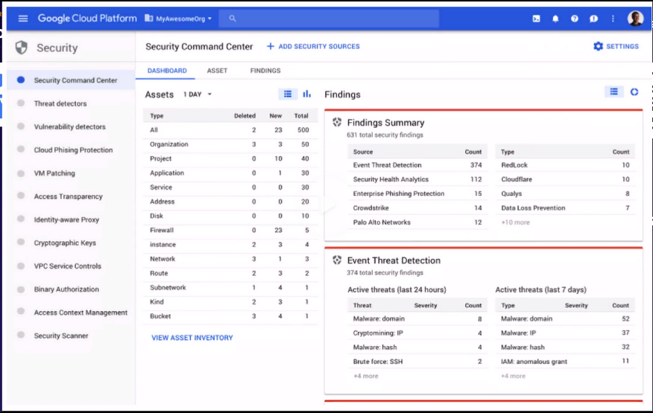

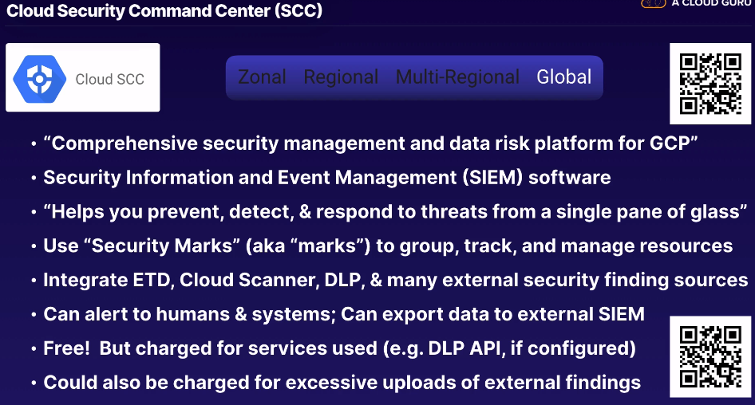

**Encryption Keys – Chapter 14.12**

Cloud Key Management Service (KMS) - <https://cloud.google.com/kms/>

Cloud Hardware Security Module (HSM) - <https://cloud.google.com/hsm/>

**Cloud Key Management Service (KMS)**

Compare to AWS KMS or Hashicorp Vault

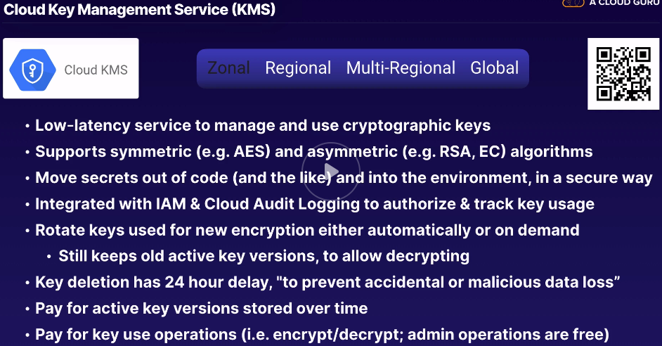

**Cloud Hardware Security Module (HSM)**

Compare to AWS Cloud HSM or SafeNet HSM

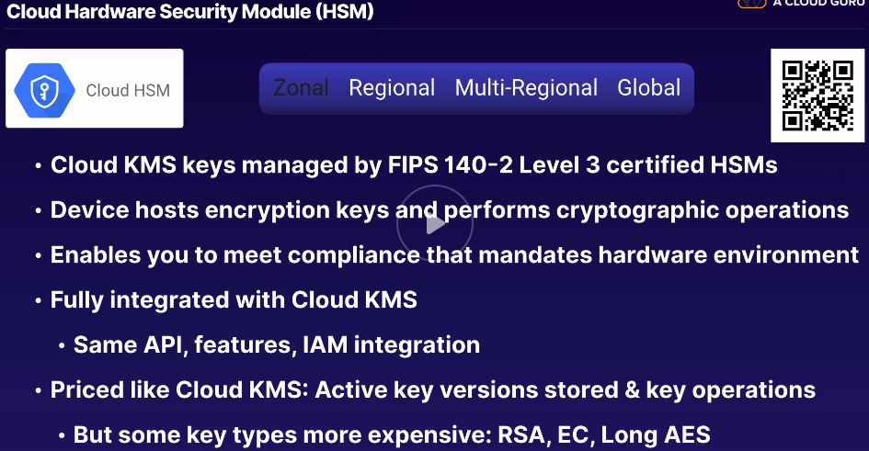

**Operations & Management – Chapter 14.13**

Google Stackdriver – <https://cloud.google.com/products/operations>

Stackdriver Monitoring – <https://cloud.google.com/monitoring/>

Stackdriver Logging – <https://cloud.google.com/logging/>

Stackdriver Error Reporting – <https://cloud.google.com/error-reporting/>

Stackdriver Trace – <https://cloud.google.com/trace/>

Stackdriver Debugger – <https://cloud.google.com/debugger/>

Stackdriver Profiler – v <https://cloud.google.com/profiler/>

Cloud Deployment Manager – <https://cloud.google.com/deployment-manager/>

Cloud Billing API - <https://cloud.google.com/billing/docs/>

Similar to AWS CloudWatch

Automatically integrated into Google App Engine

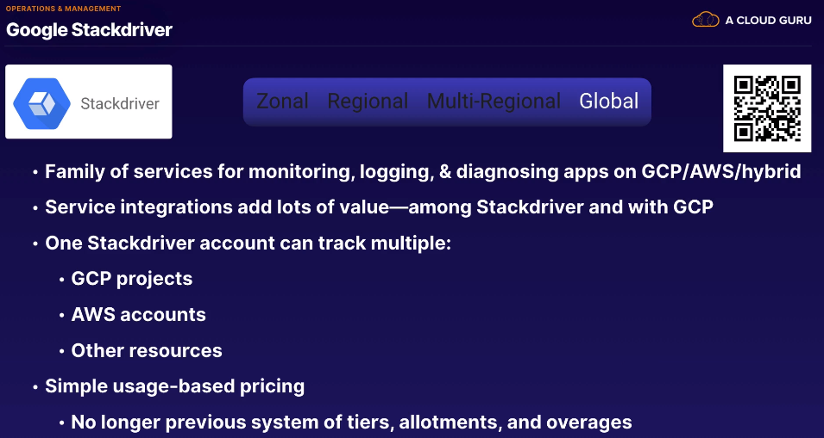

Stackdriver Monitoring

Compare to CloudWatch Metrics & Dashboards, Datadog or Collectd

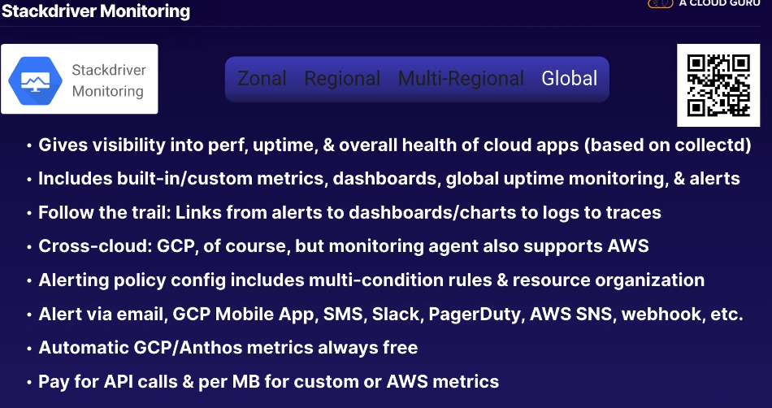

Stackdriver Logging

Compare to CloudWatch Logs, Splunk or Fluentd

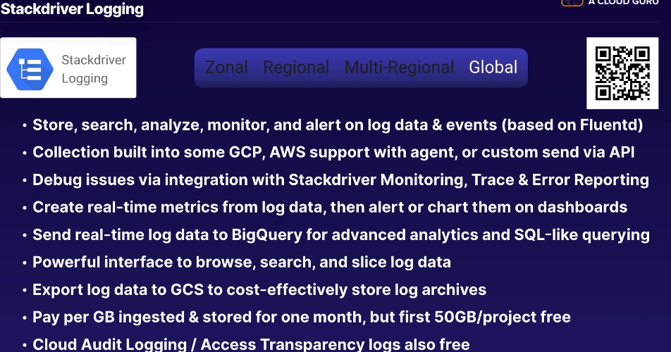

Stackdriver Error Reporting

Compare to Rollbar or Bugsnag

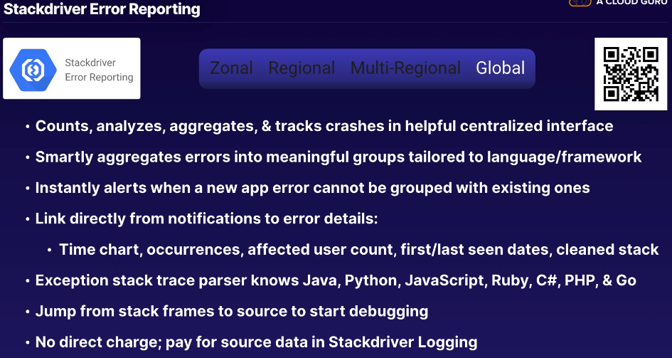

Stackdriver Trace

Compare to AWS X-Ray, Zipkin or OpenTracing

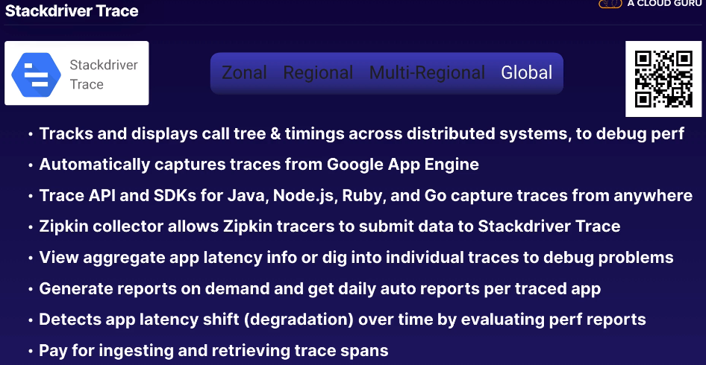

Stackdriver Debugger

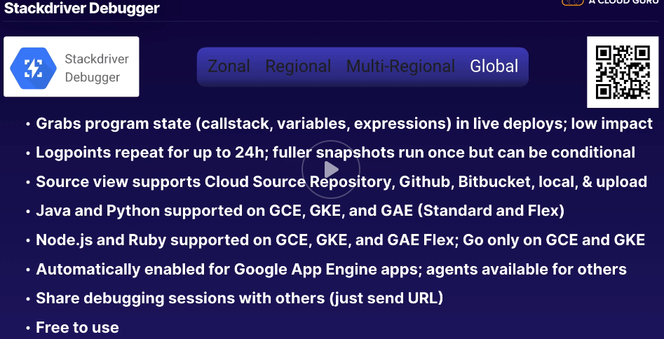

Stackdriver Profiler

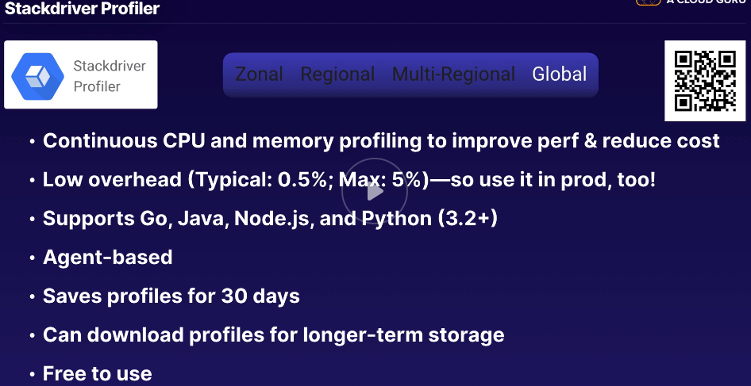

Cloud Deployment Manager

AWS CloudFormation or Hashicorp Terraform

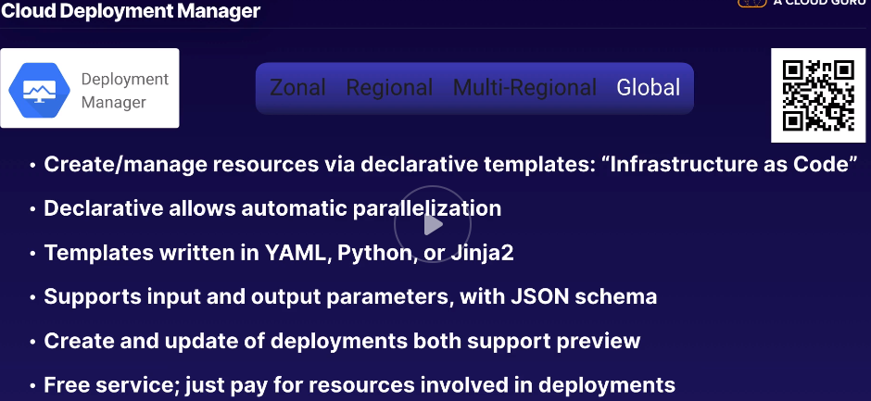

Cloud Billing API

Compares to AWS Billing API or something manual, like Excel

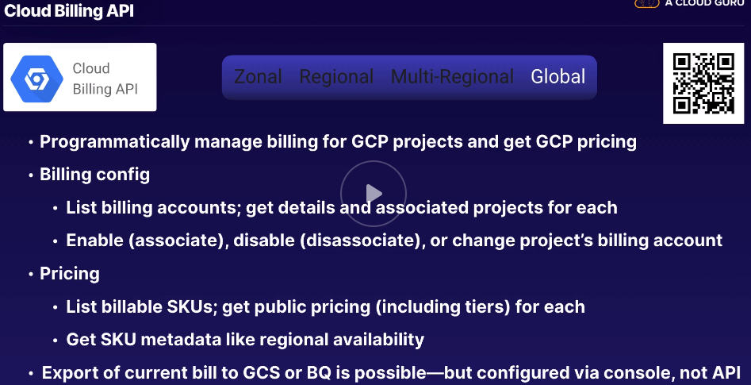

**Development and APIs – Chapter 14.14**

Cloud Source Repositories – <https://cloud.google.com/source-repositories/>

Cloud Build (Renamed from Container Builder) – <https://cloud.google.com/cloud-build/>

Container Registry (GCR) – <https://cloud.google.com/container-registry/>

Cloud Endpoints – <https://cloud.google.com/endpoints/>

Cloud Endpoints Architecture – <https://cloud.google.com/endpoints/docs/openapi/architecture-overview>

Cloud Endpoints gRPC Transcoding – <https://cloud.google.com/endpoints/docs/grpc/transcoding>

Apigee API Platform – <https://cloud.google.com/apigee>

Test Lab for Android - <https://firebase.google.com/docs/test-lab/>

**Cloud Source Repositories**

Compare to AWS Codecommit or GitHub

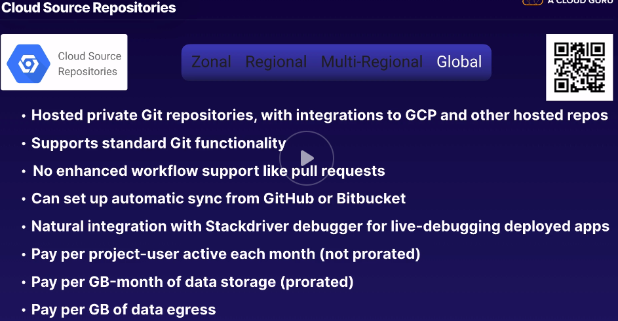

**Cloud Build**

Compares to AWS CodeBuild, TravisCI or Jenkins

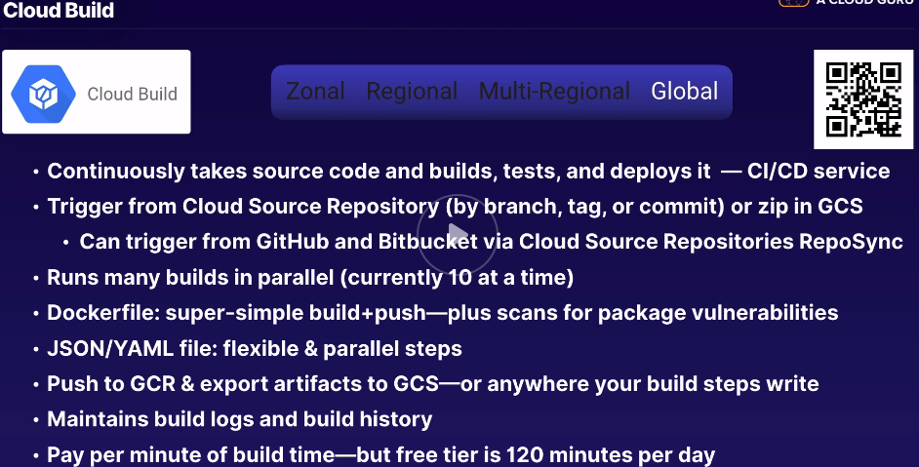

**Container Registry (GCR)**

Compares to Amazon ECR or Docker Hub

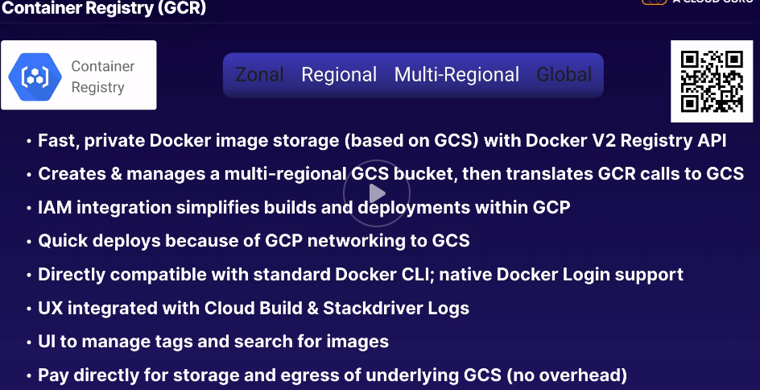

**Cloud Endpoints – Think superfast <1MS performance**

Compare to AWS API Gateway / based on NGINX

Uses JSON Web Tokens or JWTs

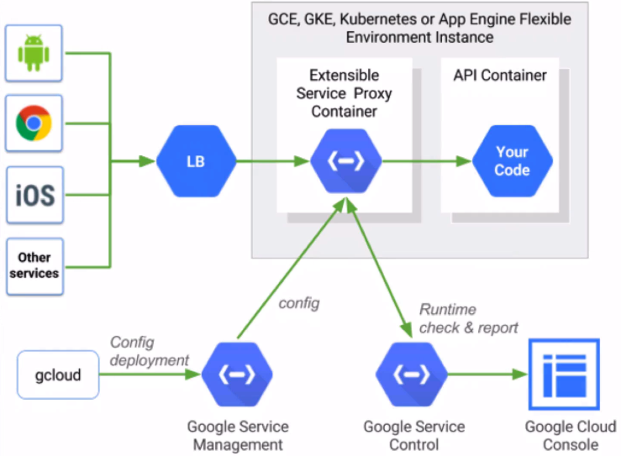

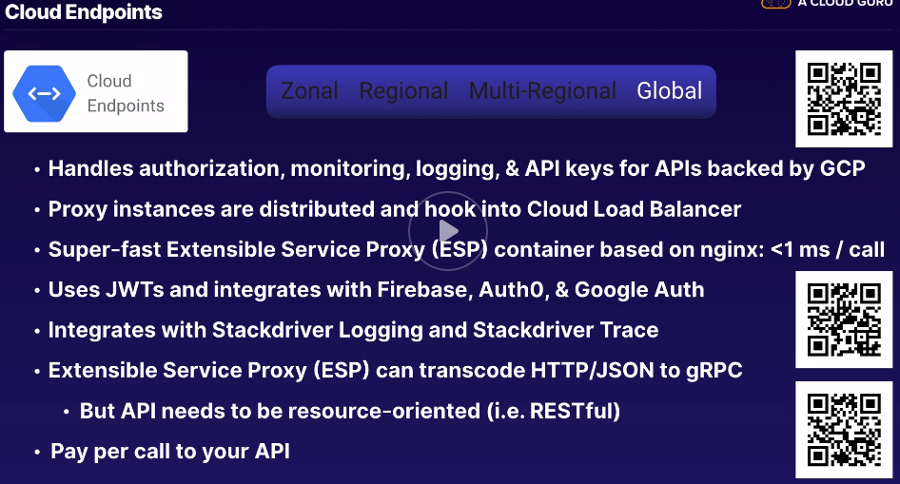

**Apigee API Platform**

Compare to AWS API Gateway combined with AWS Shield but on the whole, it’s more like Computer Associates API Gateway

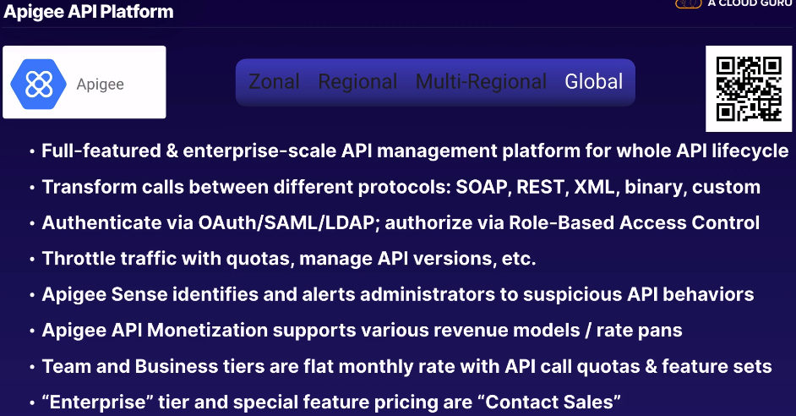

**Test Lab for Android**

Compare to AWS Device Farm, Xamarin Test Cloud Sauce Labs Mobile Testing

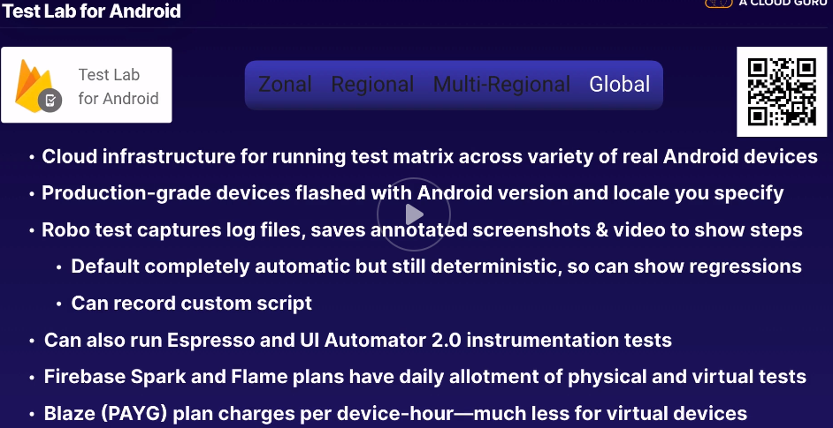

**Putting it all Together – Chapter 15.1**

Project Treehouse – GCP Solutions – <https://gcp.solutions/>

API Hosting – <https://gcp.solutions/diagram/API%20Hosting>

Jenkins on Kubernetes – <https://gcp.solutions/diagram/Jenkins%20on%20k8s>

Log Processing – <https://gcp.solutions/diagram/Log%20Processing>

Live Streaming – <https://gcp.solutions/diagram/Live%20Streaming>

Shopping Cart Analysis - <https://gcp.solutions/diagram/Shopping%20Cart%20Analysis>

Example Systems

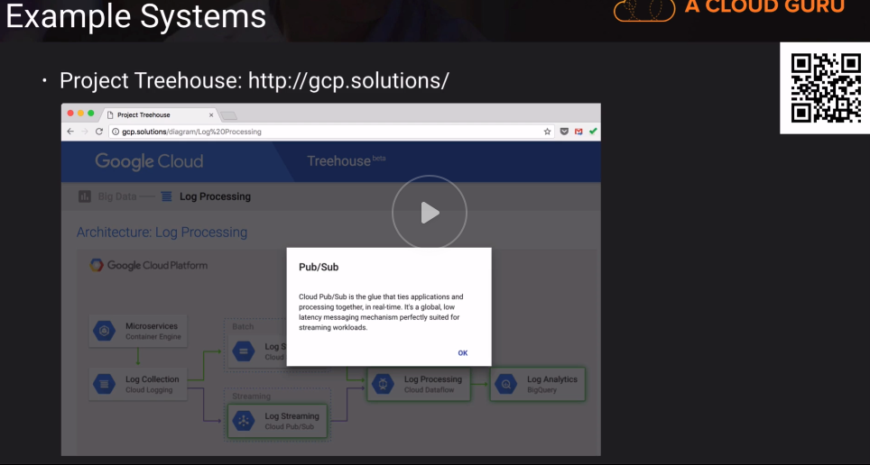

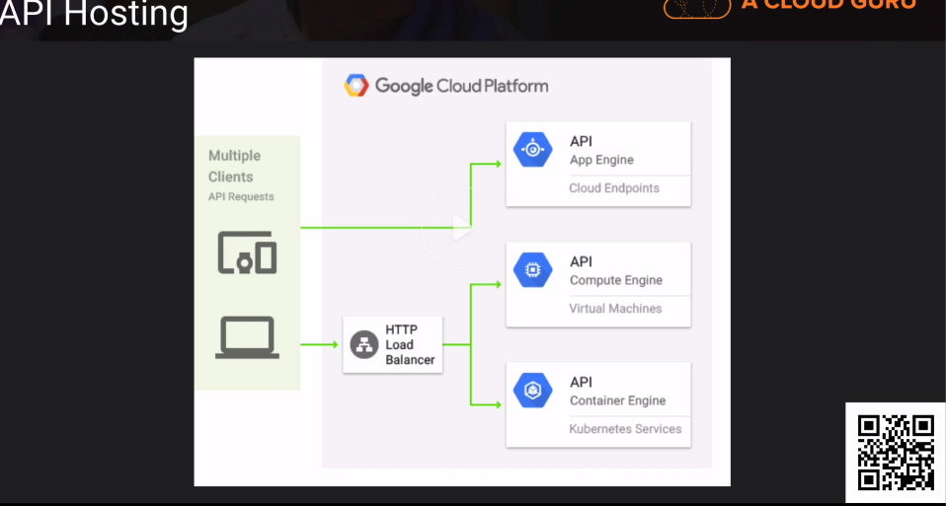

**Jenkins on K8s**

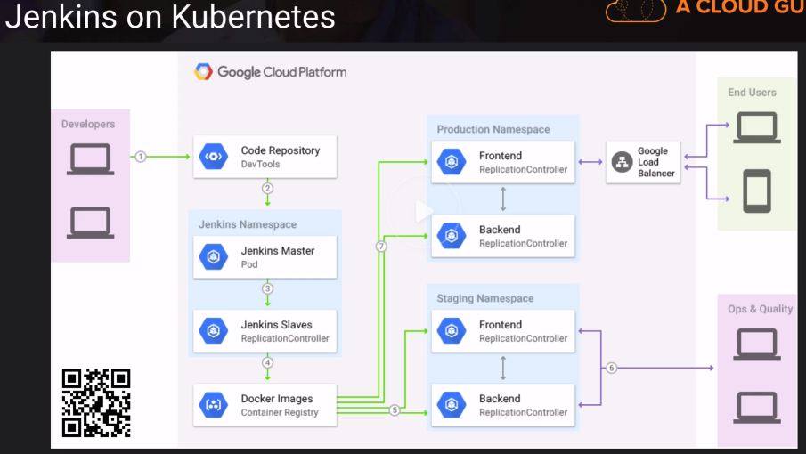

**Log Processing**

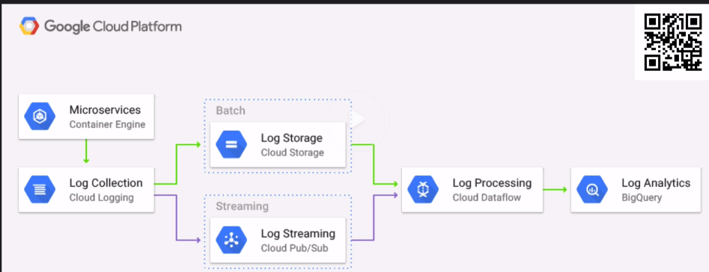

**Live Streaming**

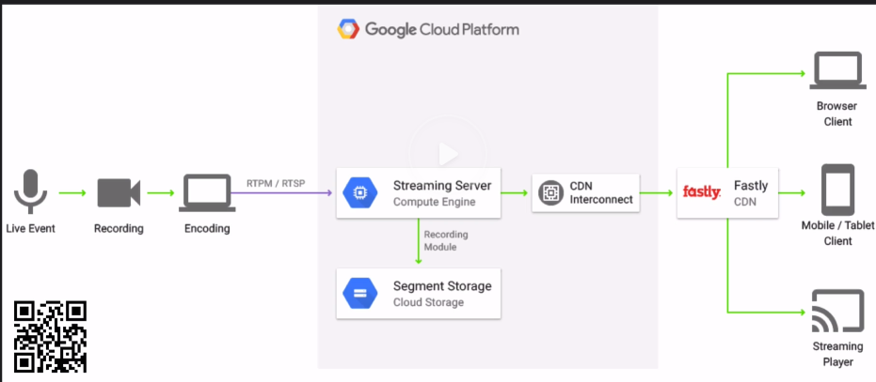

**Shopping Cart Analysis**

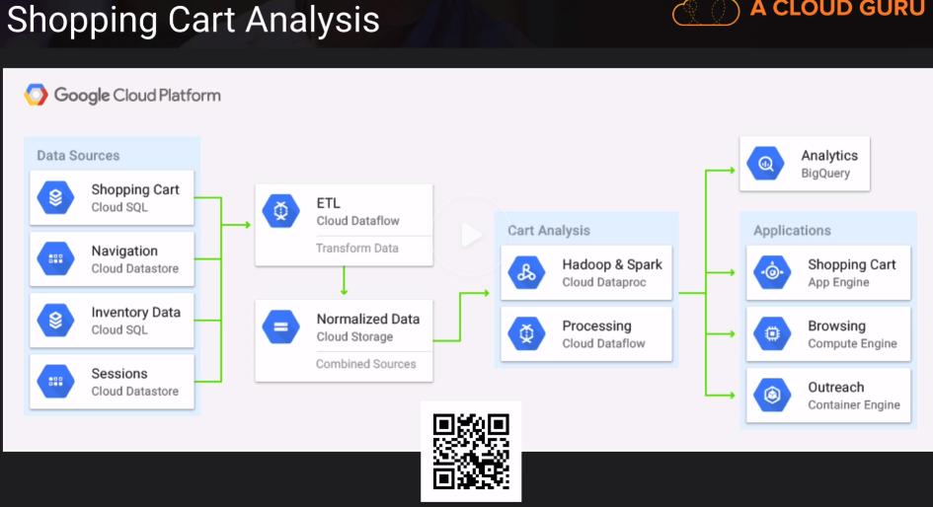

**Milestone: Almost There!**

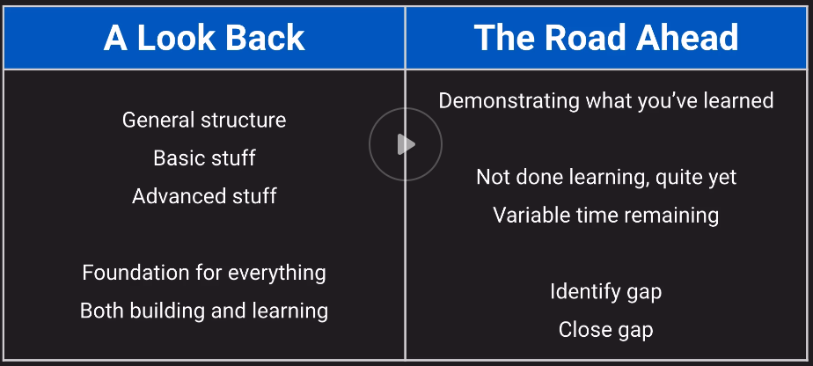

**Exam Logistics**

Main Cert Page – <https://cloud.google.com/certification/cloud-engineer>

Official Practice Exam – <https://cloud.google.com/certification/practice-exam/cloud-engineer>

Google Cloud Link to Kryterion Webassessor – <https://www.webassessor.com/wa.do?page=publicHome&branding=GOOGLECLOUD>

Google Cloud Certification FAQs - <https://cloud.google.com/certification/faqs/>

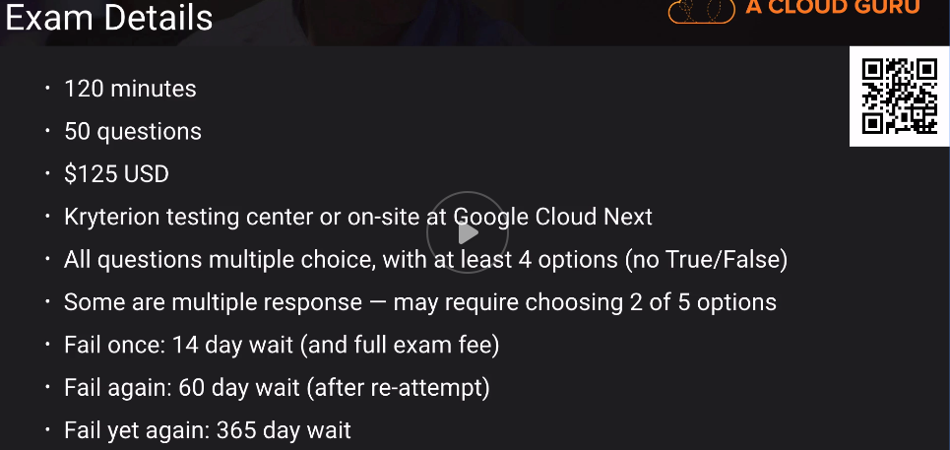

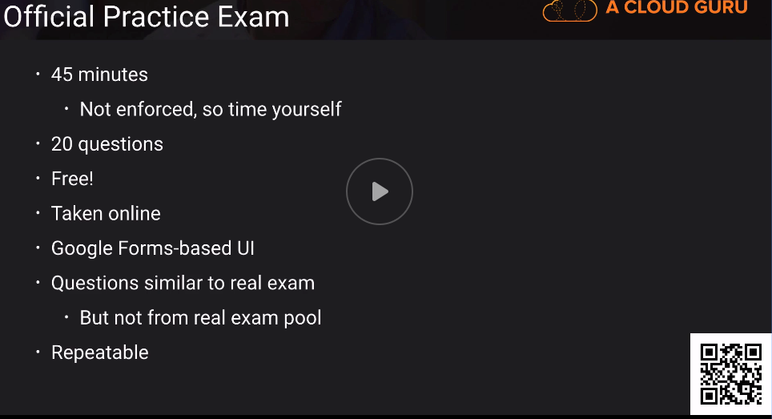

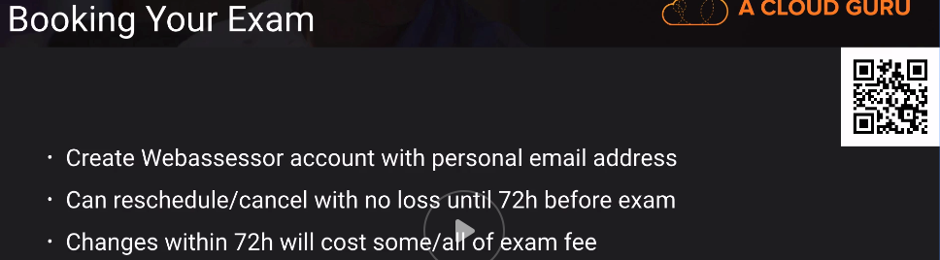

Exam Day

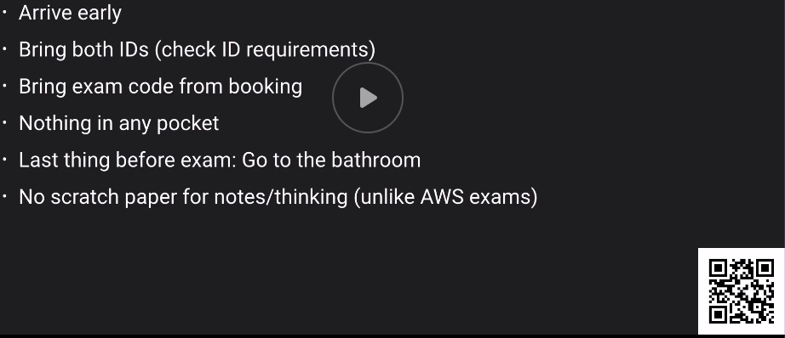

Exam software

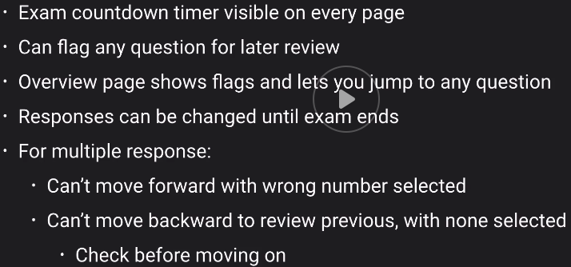

Recertification

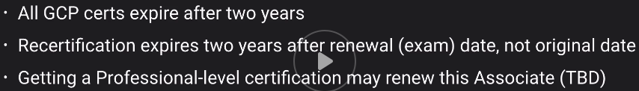

**Final Prep – Exam Tips**

Kubernetes Deep Dive Course on ACG – <https://acloud.guru/learn/kubernetes-deep-dive>

Best Practices for Enterprise Organizations – <https://cloud.google.com/docs/enterprise/best-practices-for-enterprise-organizations>

Best Practices for Operating Containers – <https://cloud.google.com/solutions/best-practices-for-operating-containers>

Security Principles (by OWASP) – <https://wiki.owasp.org/index.php/Security_by_Design_Principles>

List of IAM Roles – <https://cloud.google.com/iam/docs/understanding-roles>

Pricing Calculator – <https://cloud.google.com/products/calculator/>

Cloud Audit Logging – <https://cloud.google.com/logging/docs/audit/>

ACE Exam Guide – <https://cloud.google.com/certification/guides/cloud-engineer/>

Google Cloud Minute youtube Playlist – <https://www.youtube.com/playlist?list=PLIivdWyY5sqIij_cgINUHZDMnGjVx3rxi>

Exam Simulator (repeat this!) - <https://acloud.guru/exam-simulator/start?courseId=gcp-certified-associate-cloud-engineer>

Codelabs from Google - <https://codelabs.developers.google.com/?cat=Cloud>

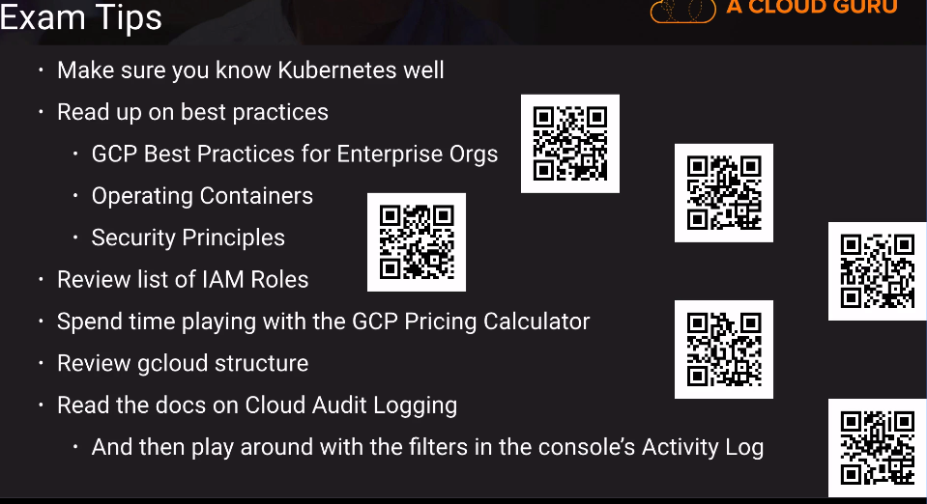

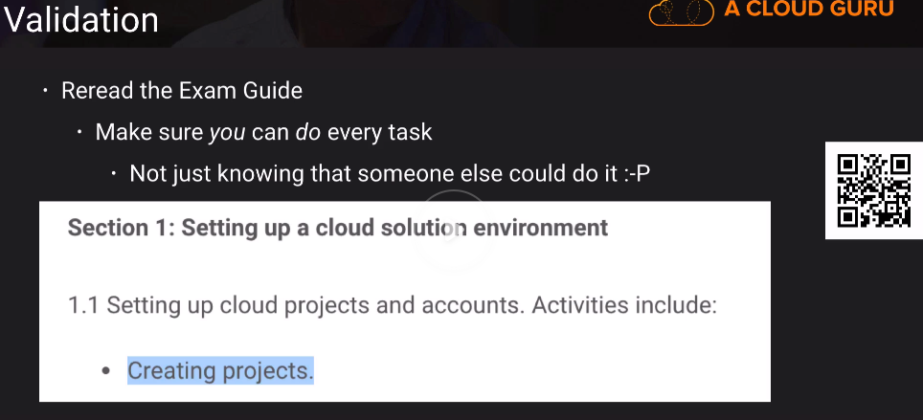

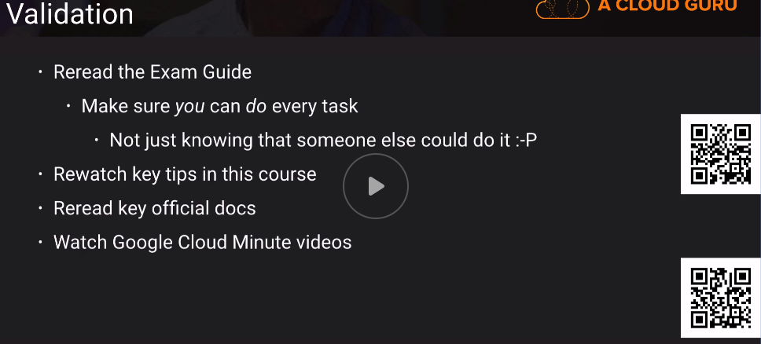

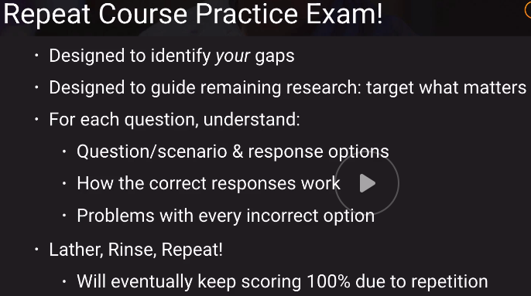

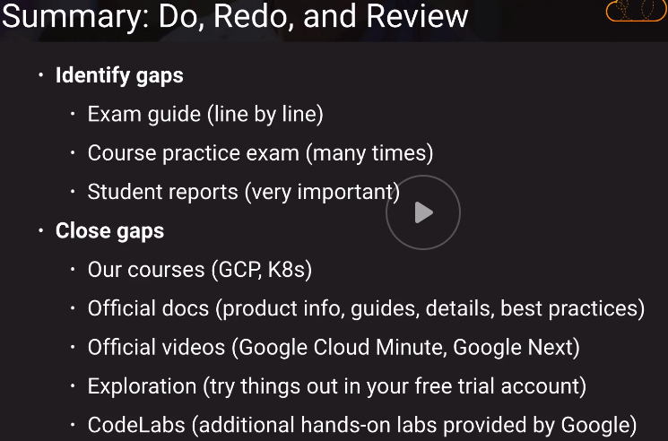

How to upload cert:

<https://acloud.guru/certifications/step0>

#1

Hello, I passed the exam on 2/14/2020. My background is that I have a C.S. Masters Degree and all the AWS Certifications along with 5 years+ of AWS Experience. My prep consisted of the following:

* A few months of hands-on work experience with GCP
* This course
* The linux academy course
* Several pluralsight courses.
* I took the official practice exam (and got all but one question correct)
* I took the acloudguru exam simulator. (This was an excellent simulator imo and among the best prep available).

Know the following:

* What gcloud commands make it possible create a project?
* Know BigTable external data sources
* Read over a lot of the role names and functions, espeically those for iam, compute, project roles, primitive roles
* Know when you would use a DaemonSet in k8s (do this when you want the same pod running on every node (including new nodes)
* Know when to use google groups (pretty much always)
* Know the google cloud storage tier options. Know the minimum number of storage days per tier and how to apply this to a use case.
* Know that you can use regional cloud storage buckets for compliance reasons as far as where the data resides

#2

I passed on the GCP ACE exame this week after two months of study and practice. Even though I have experience with GKE and GCS, the exame is widely and it requires you other products besides the flagship ones.

**Preparation**

the course and the labs were fundamental, but I strongly recommend you to go beyond and use your free trial credits to explore the products present in the exam's blue print.

Also, I read most of the documentation posted in [this thread](https://acloud.guru/forums/gcp-certified-associate-cloud-engineer/discussion/-Ln4gZJVvDvYIbbHY6kp/passed_google_ace_exam).

I only felt confident to book the exame after scoring 85% on the simulator. However, the actual exame questions were a little bit harder for me because it didn't focus much in Kubernetes, which I have experience. Most of questions focused in GAE, GCE, Storage, IAM, Logging and Monitoring.

**Exam**

GCE: auto scaling principals and health checks are required.

The exame had plenty of questions about GAE: change region, deploy from dev to prod, and app's versions.

Also, it had questions about CIDR and subnet, so I recommend to study: how to calculate the number of host addresses given a CIDR block.

And last but not least, make sure you know Google-recommended practices for IAM (ssh key, service accounts, groups, least privilege, etc).

#3

Today I passed GCP Associate Cloud Engineer.

The accumulated 15Y experience mainly with linux and other technologies including networking really helped.

I did took ACloudGuru course first, then LinuxAcademy and Coursera courses as a complement, this one is the more complete to a large extent to the time dedicated to Kubernetes Deep Dive

About the exam.

This exam is similar to AWS but I found that in many cases 2 or 3 answers were valid, so you may pick the "best".

Took me 1:05 hours to complete all the 50 questions, then another 10-12 minutes to review 13 questions marked, and another 20 minutes to review all 50 once again. Clicked Submit with still 25 minutes on the clock.

* No questions regarding gsutils or bq
* No questions regarding Logging or Stackdriver
* 7/8 of questions on Kubernetes and AppEngine
* 6/7 questions regarding IAM
* 6/7 questions on projects/configurations or Google best practices

This may be 1/3 of the exam.

Multiple tricky networking questions, CIDR, netmask, VPC, VPC sharing , VPN and accesing resources from ProjectA to ProjectB

I miserably failed multiple times the final exam at ACloudGuru and it still feels different from the real exam. Mainly questions on logging the applications (java on container vs java on GCE), the operations order while launching and instance on GCE. Failing this make me reschedule one time and make me felt insecure. The LinuxAcademy final exam gave me a closer look/feel. What I'm trying to say is even if you score 66% on this course exam simulator you may pass your certification. This is the downside.

#4

I took my ACE exam last week and was really pleased to achieve the certification!

Some key points from my experience:

* Many of the questions were quite deep, particularly those relating to Kubernetes, IAM and networking
* Still plenty of the "Which product is appropriate in situation XYZ?" questions - know the +'s and -'s of each of the major tech
* Most of my prior tech experience has been centred around data and analytics, very limited networking / architecture hands on exposure

Key learning materials:

* The Kubernetes course in the middle was a huge help and very valuable
* I bought the kindle version of the ACE study guide - this was great for practice questions on top of ACG and the official test
* Do lots of labs, coursera's google courses have tonnes as part of their specialisations and generally a free week. These helped me get to know my way around and play with the commands (not great for independent problem solving though!)

**Megathread**

<https://acloud.guru/forums/gcp-certified-associate-cloud-engineer/discussion/-LHq7ia97ot7POrc6Nw7/ace_exam_report_mega-thread_(p>

**Certified Professional Cloud Architect:**

<https://acloud.guru/learn/gcp-certified-professional-cloud-architect>